COMHAIRLE CONTAE ATHA CLIATH THEAS

SOUTH DUBLIN COUNTY COUNCIL

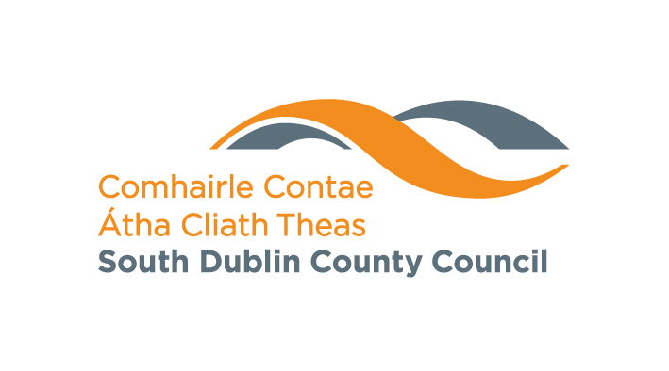

MONDAY 16th JUNE 2008

TALLAGHT AREA COMMITTEE (1)

HEADED ITEM NO: 3
July 2008
Branch | Events |  | Date
Castletymon | English for Foreign Nationals All Welcome. | Mondays at 10am
 | Improvers Irish Conversation Class. Booking Necessary | Tuesdays at 10am
 | Computer Class  Booking Necessary. | Wednesdays from 10am – 12pm
 | Story time for 3-6 year olds. All Welcome. | Wednesdays at 3.30pm
 | Tour of Library & Storytime Booking necessary | Thursday Mornings
 | Arts and Crafts with Sinead for 8 – 12 year olds.  Booking Necessary | Thursdays at 3.30pm
 | Spanish Conversation Group. All Welcome. | Fridays at 10am
For further information contact 4524888

July 2008
Branch | Events | Date
Tallaght | Watercolour Exhibition by Yuliga Awbajo | 1st -25th July
 | Photographic Exhibition by Tallaght Youth Service | July 28th – 30th August
 | Billy Bonkers Mad Cap Magic Show | Monday 30th June at 3pm
 | A World of Stories - Storytime for 5-8 year olds | Tuesday 1st July at 11am
 | Creative Writing for Young Teens for ages 10-13 years | Tuesday 1st July at 2.30pm
 | Ceramics workshop for ages 6-10 years | Tuesday 1st July at 2.30pm
 | Teddy Bear - Storytime for Tots n’ Toddlers Age - preschool. Bring your Teddy if you like! | Wednesday 2nd July at 11am
 | Lambert Puppet Theatre | Wednesday 2nd July at 3pm
 | Teddy the Wonder Dog n’ Tricky Trickster for age 4 - 12 years | Thursday 3rd July at 3pm
 | Street Games for all the Family | Saturday 5th July at 2pm
 | A World of Stories - Storytime for 5-8 year olds. | Monday 7th July at 11am
 | Ceramics Workshop (session 2/cont’d from week one) for age 6-10 years | Monday 7th July at 2.30pm
 | Creative Writing for Young Teens Age 10-13 years | Tuesday 8th July at 2.30pm
 | Bracelet Making with Ronke for age 7-12 years | Wednesday 9th July 12noon
 | African Story-telling with Ronke for age 7-12 years | Wednesday 9th July 2pm
 | Teddy the Wonder Dog n’ Tricky Trickster - The Return for age 4 - 12 years | Thursday 10th July at 3pm
For further information contact 462 0073

