Litter Management Plan - Draft
South Dublin County Council

2007-2010

Litter Management Plan - Draft
South Dublin County Council
2007-2010

Table of Contents

Table of Contents 2
1. Introduction 3
1.1 South Dublin County Profile 3
Map of South Dublin County 4
1. 2 South Dublin County Council’s Corporate plan 4
1.3 The County Strategy – A Place for People 5
2. Litter legislation 5
2.1 Responsibilities 5
Local Authority 5
Businesses 6
Public 6
3. Current Position 6
4. Aim & Objectives of Litter Management Plan 8
4.1 Aim 8
4.2 Objectives Error! Bookmark not defined.
5 Implementation Strategy 8
6. Conclusion 17
7. Appendices 18
7.1 Consulting Process 18
7.2 . Litter Monitoring in South Dublin County 20
7.3 Recycling and waste disposal facilities 21

1. Introduction

1.1 South Dublin County Profile
The area of South Dublin covers 222.74 SQ kilometres, and lies about 10 miles south west of the Capital. It is bounded by the Dublin mountains to the south and stretches from the River Liffey at Lucan through Palmerstown, Clondalkin, south to Newcastle, Rathcoole, Saggart. It includes Tallaght West, South and Central and stretches east to Templeogue and Rathfarnham. (See map below).

- The population of the County is approximately 247,000 based on results of the 2006 census.

- The county has five electoral areas - Clondalkin, Lucan, Tallaght Central, Tallaght South and Terenure./Rathfarnham

- The number of households in South Dublin County increased by 19% between 1996 and 2002, while the population increased by 26% in the ten years since 1996 to 2006.

- In recent years, housing development in the County has occurred at an average rate of an additional 2,800 new dwellings per year.

- Lands zoned for residential purposes in the 2004 -2010 County Development Plan will yield at least an additional 18,446 homes in South Dublin by 2010.

Map of South Dublin County

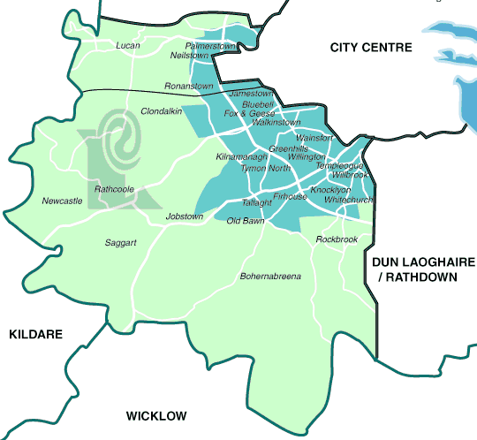

1. 2 South Dublin County Council’s Corporate plan
The Corporate Plan outlines the mission statement, organisational values and strategic goals of the Council.

South Dublin County Council’s mission statement is as follows
To provide open, effective, inclusive and participative local democratic processes together with best quality services, facilities and supports which sustain, improve and promote the social, environmental, cultural and economic fabric of South Dublin County for all who live, work and visit here.

The strategic goals states - ‘Promote the ‘polluter pays’ principle and sustainable waste management strategies in accordance with the principles of waste prevention, reduction, re-use, recycling, energy recovery and safe disposal’
Manage waste collection, movement and disposal, road sweeping and litter management operations to the highest possible standards.

1.3 The County Strategy – A Place for People
This is the vision for South Dublin County.
Within the section ‘a Place to Protect’ it states that ‘A county that promotes, enhances, develops and protects the natural environment contributing to greater awareness and appreciation of the value of a green county in the context of social, economic and environmental sustainability.

2. Litter legislation
The Litter Pollution Act (1997) provides for the prevention and control of litter pollution. It defines the responsibilities of various sectors and individuals and details enforcement procedures and penalties.

2.1 Responsibilities

Local Authority
The local authority shall take all practicable measures to prevent, control and dispose of litter. Other responsibilities include the following:-
Promote awareness of litter pollution and its effect.
Encourage participation of the public in preventing and overcoming litter pollution and in the collection and disposal of litter.
Provide facilities and arrange for regular emptying and cleaning.
Enforce the law and apply the penalties and legal sanctions

Businesses
An occupier of land and /or public place has a responsibility to keep the area litter free. Private land which is visible from a public place should be kept free of litter. In addition the area not exceeding 100m adjoining the premises should be kept free of litter.
There are additional responsibilities on persons owning, operating or in charge of mobile outlets and those who organise major events.
No placement of unauthorised advertisements or public notices in public places.
No placement of advertising flyers on cars
Ensure that transporting material does not cause litter and that the material is secured.

Public
No person shall create litter in a public place or a place visible from a public place.
Dog faeces should be removed from a public place disposed of properly.
Waste material is not disposed except in a waste receptacle or bin or in an authorised waste facility

3. Current Position
Litter management unit
The Litter Management Unit consists of 6 litter wardens.
Their duties include the following
- Investigation and prosecution of illegal dumping
- The removal of derelict or abandoned cars.).
- The issue of on-the-spot fines for litter offences
- The prosecution of serious offences through the courts
- Investigation and prosecution of illegal casual traders
Cleansing unit
The Cleansing unit deals with major clean-ups in the County and removal of material from fly tipping sites. They also operate the 5 yearly free junk collections in residential areas. In addition there 13 staff operating a hand cart service in village/town centres throughout the County.

Graffiti crew
In May 2006 a dedicated crew was established to deal with graffiti in public places throughout the County.

Road Sweeping service
An extensive road sweeping contract exists, which includes street cleansing, weed control, gully emptying and leaf clearance on main roads, industrial estates, housing estates and dual carriageways and motorways.

Environmental awareness
The environmental awareness programme includes promotion of National Spring Clean, Beautiful South Dublin County Awards and Pride of Place.
Also the running of the Green schools programme and an anti litter schools competition.

Recycling facilities (See appendix 7.3 )
Recycling facilities comprise of the Civic amenity site, Ballymount, Bring banks - recycling facilities for glass, plastic, cans and textiles, a Green waste centre.

Clondalkin Community Recycling
CCRI is a Community based scheme which arranges collection and recycling of WEEE – waste electrical, electronic equipment in the South Dublin County. This initiative is supported by Clondalkin Partnership, Pobal and South Dublin County Council.

4. Aim & Objectives of Litter Management Plan

4.1 Aim
The overall aim of the Litter Management Plan is to make South Dublin County a litter free County with the support, co-operation and involvement of the local authority, businesses, communities and individuals.

The following five cross cutting themes underpin the individual objectives of the Litter Management Plan:-
- Prevention
- Enforcement
- Awareness
- Partnership
- Cleansing

4.2 Objectives

- Develop programmes on the basis of targeting the various litter categories, blackspots and illegal means of disposing of waste/refuse

- Develop a customer focused litter complaints procedure in order to deal effectively and efficiently with complaints

- Continue to actively enforce litter pollution and waste management legislation, bye laws and standards

- Improve the litter disposal systems available to the public

- Expand the recycling opportunities within the County.

- Continue to monitor and review road cleansing service in order to provide an improved service.

- Develop a litter management programme for designated urban areas within the County – Tallaght city, Clondalkin town centre, Lucan town centre etc

- Prepare litter management, education and awareness programmes that promote community and business involvement, community identity and responsibility, personal responsibility, youth activity etc.

- Encourage active participation in Anti Litter Campaigns

- Develop a communications programme to promote a litter free County – including the promotion of the use of www.southdublin.ie and www.dublinwaste.ie

- Optimise the application of available technology in the enforcement and prevention of litter

- Utilise systematic data analysis systems to monitor and plan Litter management and decision making

- Continue to research and implement best practice models

- Ensure the provision of a litter management plan for all major events.

5 Implementation Strategy
To implement the objectives of the South Dublin County Council Litter Management Plan the Council will work with all the departments in the Council to ensure the objectives of the Litter Management Plan are achieved.
This will provide a coordinated approach to litter management in the County.

The sections involved are the Litter Management Unit, Cleansing, Environmental awareness, recycling, waste management service and also include the Roads, Community & Parks and Housing Departments.

The Council will work in partnership with the community to achieve the objectives of the Plan and will commit to support communities in their efforts.

 | Time | Theme
1.Develop programmes on the basis of targeting the various litter categories, blackspots and illegal means of disposing of waste/refuse

- Develop a programme to deal with specific litter types -  cigarette litter  packaging  gum litter  graffiti  mobile outlet litter  fast food litter  - Identify litter black spots and organise an operational plan to eliminate them.  - Using the 5 cross cutting themes prepare a programme to eliminate the illegal disposal of waste. | 2008  2008  2009 | E  A  C  Pr
- Develop a customer focused litter complaints procedure in order to deal effectively and efficiently with complaints

- Promote the customer care system to highlight litter complaints. | 2008 | Pr
3. Continue to actively enforce litter pollution and waste management legislation, bye laws and standards

- Implement a schedule of routine and non – routine inspections  - Continue to actively enforce the legislation with regard to litter pollution and waste management.  - Promote and enforce the waste bye-laws  - Publish litter enforcement statistics on a six monthly basis  - Publish names of those successfully prosecuted under the litter or waste management legislation  - Prepare an operational plan for the litter management section with targets and standards of cleanliness incorporated.  - Use the internet to publish details of litter fines and notices issued, details of those successfully prosecuted under the Name & Shame policy.  - Prepare an annual programme to highlight the responsibilities of sectors under the Litter Pollution Act. | Ongoing | E  Pr  A
- Improve the litter disposal systems available to the public

- Continue to research litter disposal system and prepare a programme to update existing units  - Instigate a continuous improvement programme. | Ongoing  2008
- Expand the recycling opportunities within the County.

- Implement the recommendations of the Recycling strategy. | 2008 | Pr  A  Pa
- Continue to monitor and review road cleansing service in order to provide an improved service.

- Monitor and review existing contract and produce a report to include measures to provide an improved service if required. | Ongoing
- Develop a litter management programme for designated urban areas within the County – Tallaght city, Clondalkin town centre and other designated areas

- Prepare a detailed operation programme to handle the specific demands of key town centres and other designated areas.  - Set targets and standards for the maintenance programme in such areas.  - Review standards in each area on a monthly basis | 2008 | Pr  C  Pa  A  E
- Prepare litter management, education and awareness programmes that promote community and business involvement, community identity and responsibility, personal responsibility, youth activity etc.

- Organise a green school network to highlight litter and its negative effect.  - Arrange a school competition with an emphasis on the elimination of litter  - Encourage all schools to register for the green schools programme  - Prepare a litter awareness training programme for litter wardens  - Develop a package of supports including notices, leaflets and advertising to highlight the obligations of dog owners.  - Continue to promote anti litter campaigns.  - Prepare a survey to highlight the attitude of various sectors to litter in the County and develop a programme with representatives of communities, groups and businesses to implement the goal of the plan - South Dublin County Council – a litter free County.  - Encourage community involvement in the achievement of a litter free County  - Engage with the organisations represented on the County Development Board to promote a litter free County as agreed in Priority Action 23  - Develop a community reward system for groups or communities who have litter free areas | 2008 | Pr  A  Pa
- Encourage active participation in Anti Litter Campaigns

- Promote anti litter campaigns i.e. National Spring Clean,
- Promote participation in competitions such as Tidy Towns competition, Pride of Place and Beautiful South Dublin County.
- Promote the anti litter campaigns using the website, Connect and local media.
- Encourage the participation of the communities, schools, groups and businesses in anti-litter campaigns
- Publicise and highlight the results of the anti litter campaigns.

- Develop a communications programme to promote a litter free County – including the promotion of the use of www.southdublin.ie and www.dublinwaste.ie

- Make use of the different medias  Newsletter  Website  Notices in local press  Press release  Photo shoots  advertising  - Highlight the anti litter message  - Prepare a yearly programme to target the various sectors within the County  - Develop the litter section of the website to ensure up to date information and constant development and improvement. | 2008 | Pr  A  E  Pa  C
- Optimise the application of available technology in the enforcement and prevention of litter

- Pilot available technology such as CCTV.  - Review pilot and plan to establish on a wider basis if effective | 2008 | Pr  E  A  Pa
- Utilise systematic data analysis systems to monitor and plan Litter management and decision making

- Continue to participate in and utilise the National Litter  - Monitoring Survey to ensure informed decision making.  - Continue to monitor the reports from IBAL  - Review data on a quarterly basis  - Update operational plan and actions based on review | ongoing | Pr  A  E
- Continue to research and implement best practice models

- Examine initiatives in other local authorities and countries  - Instigate a programme of continuous improvement with regard to litter management and control | ongoing | Pr  E  A  C  Pa
- Ensure the provision of a litter management plan for all major events.

- Communicate the need for a litter management plan for all major events and enforce the conditions. | Ongoing

6. Conclusion

The Litter Management Plan for South Dublin County will extend form January 2007-2010. Progress on the implementation of the Plan will be reported to the South Dublin County Council on an annual basis.

7. Appendices

7.1 Consulting Process
2 submissions received

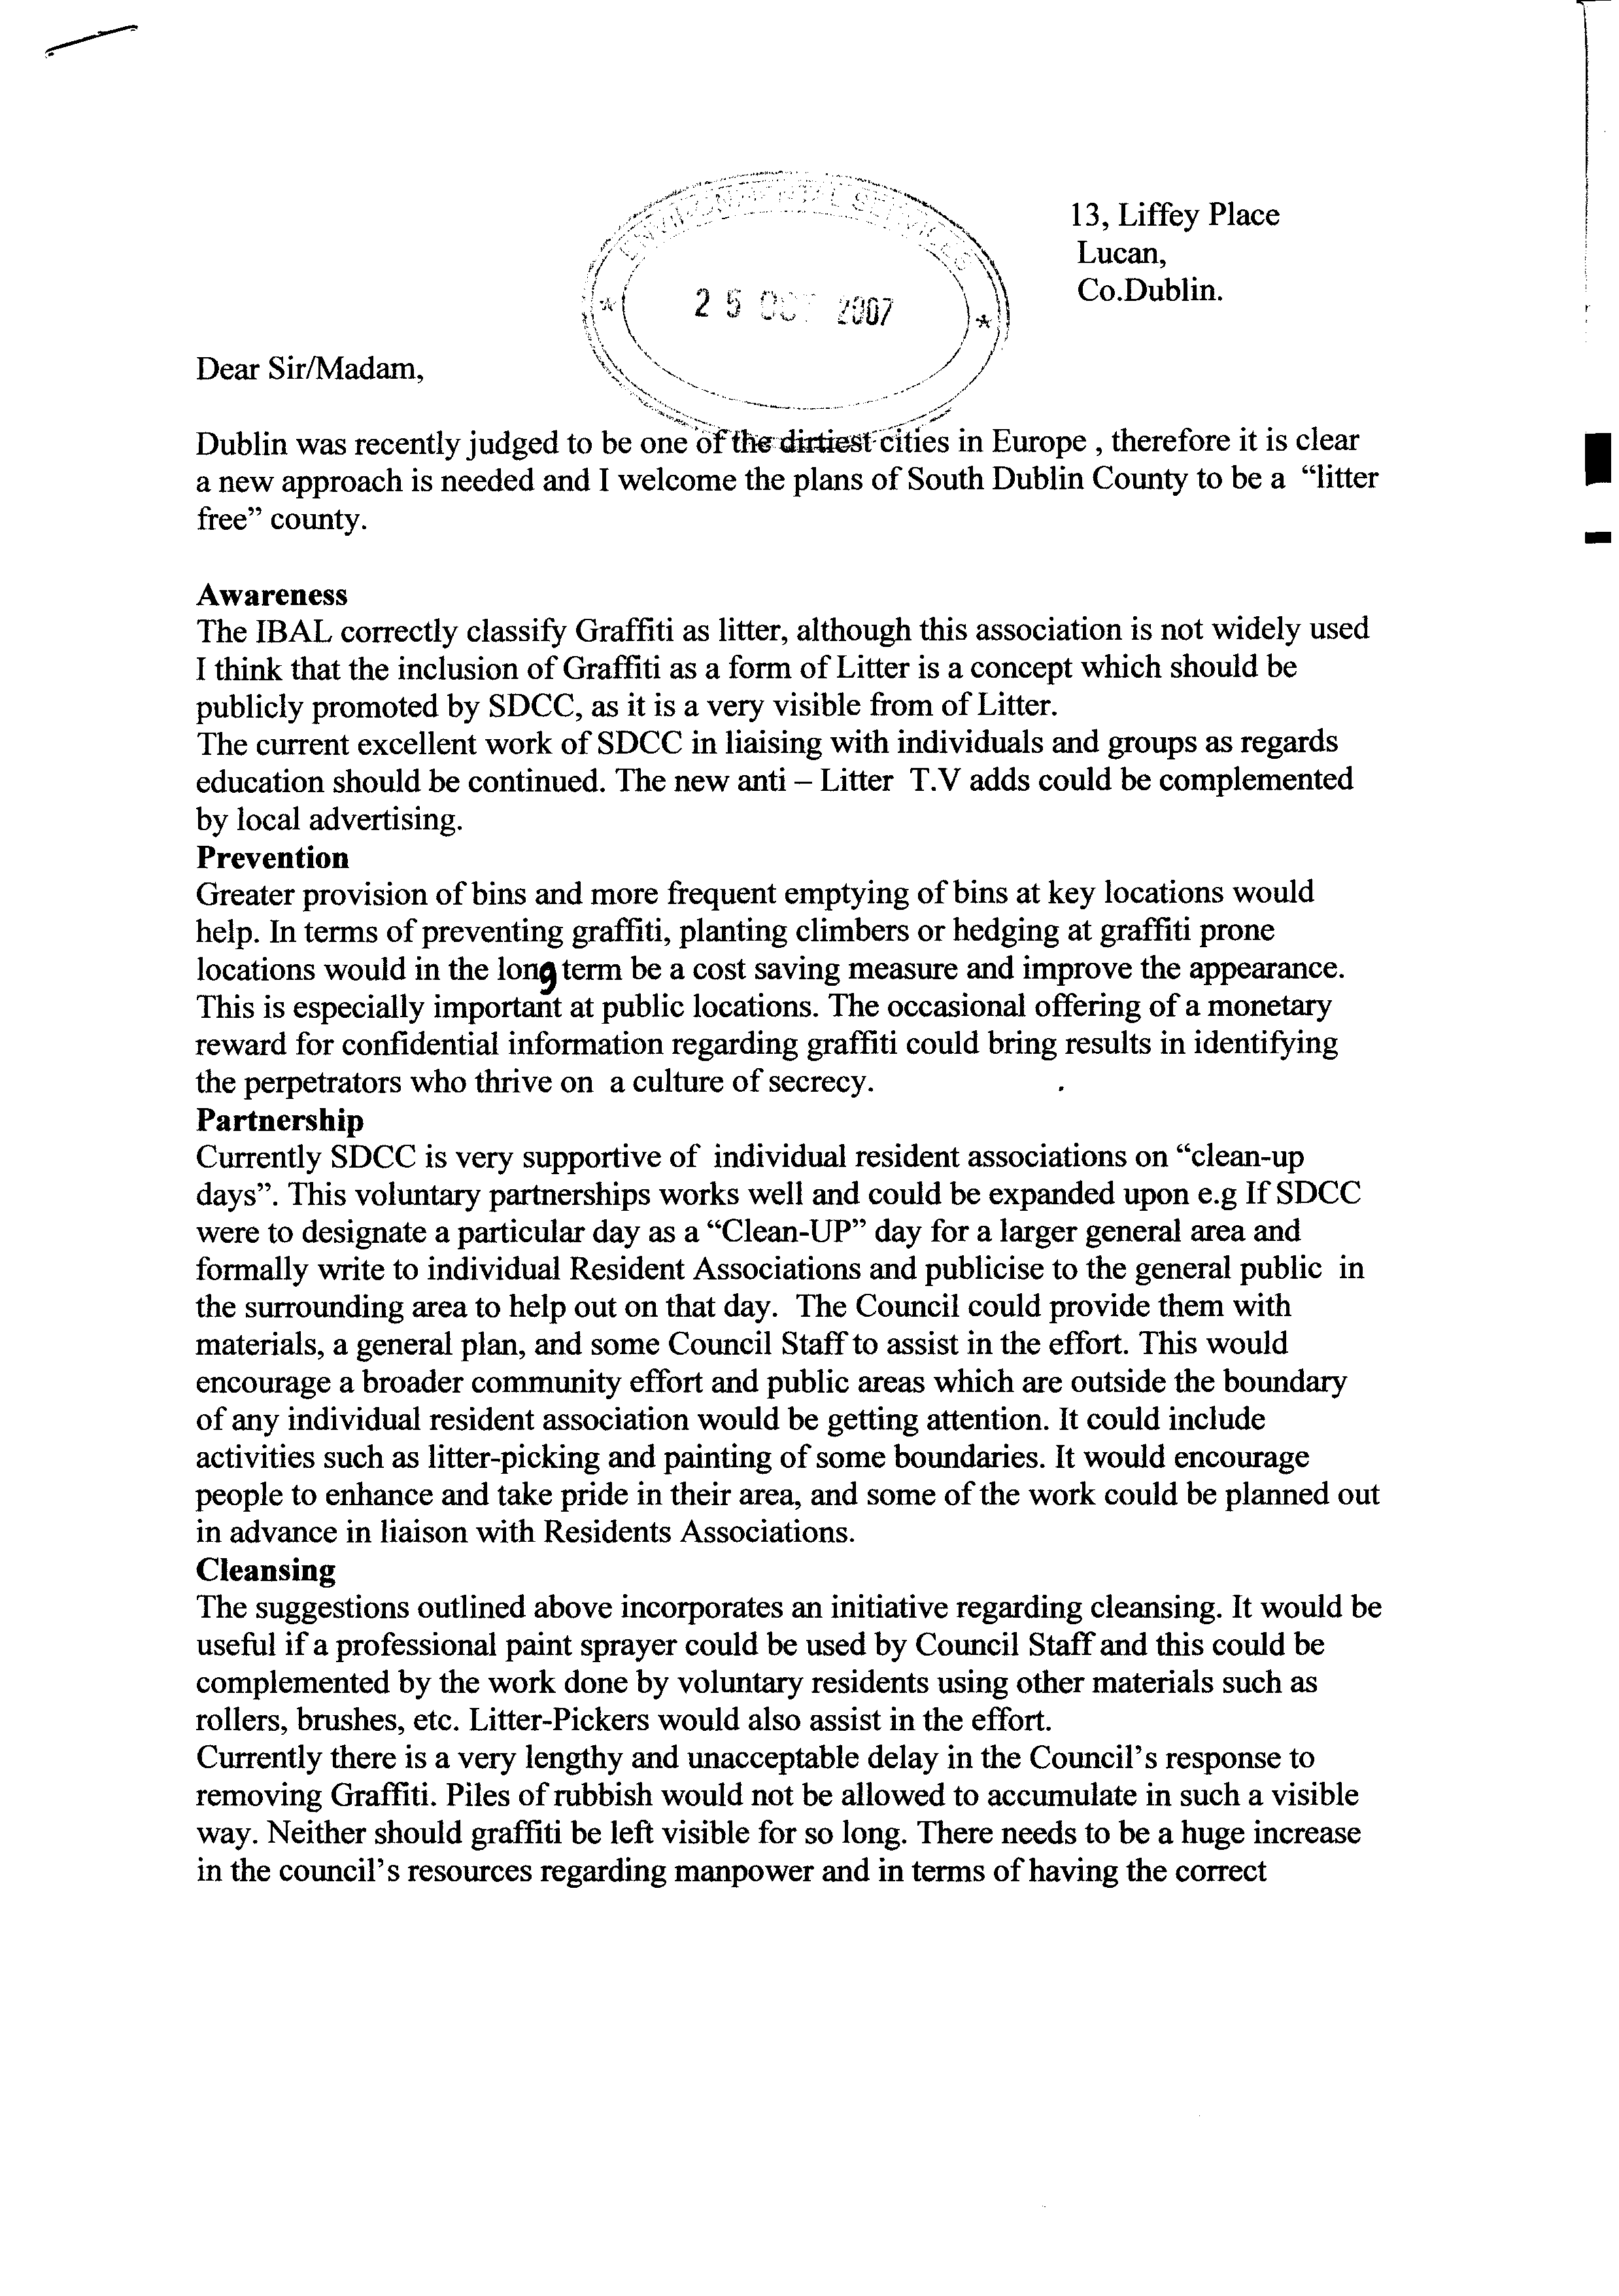

7.2 . Litter Monitoring in South Dublin County

National Litter Monitoring System

Litter Pollution Index % | 2006 | 2005 | 2004 | 2003 | 2002
1 – Unpolluted (litter free) | 1 | 2 | 3 | 0 | 4
2 – slightly polluted | 33 | 44 | 41 | 17 | 37
3 – moderately polluted | 43 | 36 | 32 | 48 | 45
4 – significantly polluted | 19 | 14 | 17 | 25 | 11
5 – Grossly polluted | 4 | 4 | 6 | 10 | 3

IBAL – Irish Business against Litter
Tallaght

Year | Status | Ranking
2004 | ‘Moderately littered’ | 19/30
2005 | ‘Moderately littered’ | 44/57
2006 | ‘Moderately littered’ | 27/53

Lucan
Year | Status | Ranking
2005 | ‘Serious Litter Problem’ | 46/57

7.3 Recycling and waste disposal facilities

Civic Amenity
http://environment.southdublin.ie/index.php?option=com_content&task=view&id=51&Itemid=129

57 Bring Banks South Dublin County October 2007
Clondalkin Area | Glass | Cans | Plastic | Textiles | Key Sites
Bawnogue Shopping Centre Carpark | X
Bawnogue Enterprise Centre |  |  |  | X
Camac Valley Caravan Park | X
Corkagh Park Carpark, off Naas Road | X |  | X
Clondalkin Sport and Leisure, Old Nangor Road | X
Corkagh Park Carpark, Off St. John’s Road | X | X | X
Ronanstown Garda Station |  | X
The Mill Shopping Centre | X | X | X | X | X
The Swallows Pub | X
Quarryvale Community Centre | X | X | X | X | X
Total | 8 | 4 | 4 | 3

Tallaght Central Area | Glass |  | Cans |  | Plastic |  | Textiles |  | Key Sites
Rear Entrance of SDCC Offices, County Hall | X
The Square, Level 3, The Carpark | X |  | X
Abberley Court Hotel | X |  | X
Ahernes Pub, Old Bawn | X
Sean Walsh Park | X |  | X |  | X |  | X |  | X
St. Marys National School, Greenhills Road |  |  | X
Cuckoos Nest, Greenhills Road | X |  | X
Molloys Pub (Foxes Covert) |  |  | X
Ard Mhuire National School, Belgard |  |  | X |  |  |  | X
Kingswood Shopping Centre | X
Avonbeg Road | X
Tymon Park Carpark, Castletymon Road | X
Red Cow Complex | X
Greenhills Community College |  |  | X
Greenhills Community Centre | X |  | X
Total | 11 |  | 9 |  | 1 |  | 2
Tallaght South |  | Glass |  | Cans |  | Plastic |  | Textiles |  | Key Sites
Bohernabreena Bus Terminal |  | X
Brittas Village, Community Centre |  | X
Firhouse Community Centre |  | X
Jobstown House, Blessington Road |  | X |  | X
Earth Tech, Citywest |  |  |  | X
Tallaght Sports and Leisure Centre, Jobstown |  | X |  | X |  | X
Avoca Handweavers, Rathcoole |  | X |  | X
Spar, Rathcoole |  |  |  |  |  |  |  | X
Fettercairn Community Centre |  | X |  | X |  | X
Killinarden Heights |  | X
Greenogue Business Park |  | X
Roadstone Group Sports Club, Old Naas Road |  | X
Rathcoole Community Centre |  |  |  |  |  |  |  | X
Total |  | 10 |  | 5 |  | 2 |  | 2

Lucan Area | Glass | Cans | Plastic | Textiles | Key Sites
Eurospar, Ballyowen Shopping Centre | X | X
Lucan Spa Hotel | X
Griffeen Road at Moyglass | X
Griffeen Valley Park car park Haydens Lane | X
Lord Lucan Pub, Newcastle Road | X
Lucan Sports & Leisure Centre | X
Athletics Track car park, Newcastle Road | X | X | X
Superquinn, Newcastle Road | X | X |  | X
Supervalu, Kennelsfort Road, Palmerstown | X | X
Total | 9 | 4 | 1 | 1

Terenure – Rathfarnham Area | Glass | Cans | Plastic | Textiles | Key Sites
Perrystown Community Centre | X
Buglers Pub, Rathfarnham | X | X
Grange Road/Sarah Curran Avenue | X
Rathfarnham Shopping Centre | X | X |  | X
Whitechurch Shopping Centre | X |  | X
Kimmage Mission Institute | X
Superquinn Knocklyon | X | X |  | X
Tymon Park, Limekiln Road | X
Tymon Park, Wellington Lane | X |  | X
Templeogue Football Club |  | X
Total | 9 | 4 | 2 | 2

Material | No of Bring Sites
Glass | 47
Cans | 26
Textiles | 10
Plastic | 10

Top of Form
Bottom of Form
=

Bottom of Form

