An Garda Síochána

An tArd-Cheannfort,  Réigiún Chathair Átha Cliath (Theas),  Stáisiún An Garda,  Croimghlinn,  Baile Átha Cliath 12.  Tel/ Teileafón: 01-6666292/93  Fax/Facs: 01-6666299  Please quote the following reference number  DS M18/10/07 | 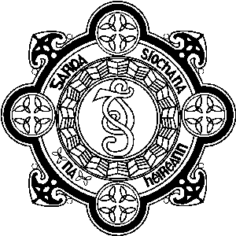 | Chief Superintendent,  D.M.R. South,  Crumlin Garda Station,  Dublin 12.  Web site: www.garda.ie  E-mail: Crumlin_DV@garda.ie  Date: 29 July, 2026

Re: Public Order: DMR South Division
____________________________________________________________________________________

Public Order offences include drunkenness offences, trespassing offences, affray and public order offences.

I outline hereunder an outline of public order offences dealt with by Gardai in stations in the DMR South Division during the first 3 months of 2008.

In most of these cases Gardai affected an arrest of one or more persons.

Rathfarnham Garda Station

Tallaght Garda Station

Crumlin Garda Station

Terenure Garda Station

______________________________
John Manley
Chief Superintendent

