An Garda Síochána

An t-Ard-Cheannfort,
Réigiún Chathair Átha Cliath
An Roinn Thiar,
Stáisiún Garda Bhaile Bhlainséir,
Baile Bhlainséir,
Fine Gall,
Baile Átha Cliath, 15.

Tel/Teileafón: (01) 6667092
Fax/Facs: (01) 6667099

Chief Superintendent,
Dublin Metropolitan Region,
West Division,
Blanchardstown Garda Station,
Blanchardstown,
Fingal,
Dublin 15.

Web.Site: www.garda.ie
E-Mail:

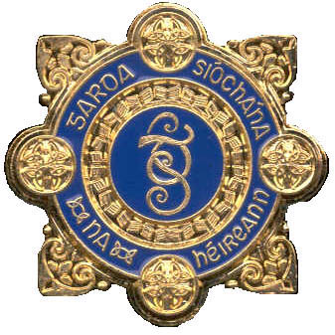

Please Quote the following Date: 31 July 2026
Ref. Number:
LT
________________________________________________________________________

Tackling Violent Crime in the Clondalkin Area

In measuring the incidence of what is described as ‘Violent Crime’, I will make reference to those Headline Offences which offer physical or mental injury to the person.

Commentary on Crime Categories

A significant proportion of gun related crime is linked to either ongoing feuds or power struggles within organized criminal groups.

Bearing in mind the strong relationship between organized criminal groups and serious crime, there has been a marked increase in successful drug seizures with over 278 searches carried out this year, an increase of 15% on last year, and over €9.6m in illegal drugs seized to date.

Likewise, Serious Investigations required complex and involved investigations and can take months to conclude. Therefore, I expect the Detection Rate will improve going forward.

The following is a summary of Headline Crime to date in 2008:

Comm. No. Chg. % Chg. Detec.

Theft from MPV 42 -4 -9% 12%
Theft from Person 6 0 0 17%
Robbery of Establishment 8 +2 +33% 25%
Aggravated Burglary 0 -1 -100% 0%
Discharge of Firearm 6 +4 +200% 33%

The following Operations targeting Organised Crime are ongoing in the Clondalkin area of South Dublin:

Operation Anvil - National Initiative targeting Organised Crime.
Operation Schilling - Targets Drug related crime.

In terms of Public Order, a total of 421 incidents were recorded in 2008 to date. This represents an increase of 22% in comparison with the same period in 2007 in which 344 incidents were recorded. It should be noted however that of these incidents the detection is comparable and currently stands at 92%.

The statistics in terms of stations are as follows:

PUBLIC ORDER INCIDENTS

2008 2007 % Difference

Clondalkin 101: 95 84 : 81 +20%
Ballyfermot 172 : 164 141 : 139 +22%
Rathcoole 11 : 11 17 : 16 -35%
Lucan 64 : 47 42 : 40 +50%
Ronanstown 74 : 70 60 : 56 +23%

Total 421 : 387 344 : 332 + 22%

In addition, the following Public Order specific Operations are in place in the Clondalkin area:

Operation Encounter - Targets Public Order Hotspots.
Operation Safe Passage - Tackling Bus related crime.
Operation Greencastle - Public Order initiative in Clondalkin.

___________________
John Twomey
Chief Superintendent.

