COMHAIRLE CONTAE ÁTHA CLIATH THEAS
SOUTH DUBLIN COUNTY COUNCIL

MEETING OF SOUTH DUBLIN COUNTY COUNCIL
MONDAY, 10TH MARCH, 2008
HEADED ITEM NO. 2 (d)
REPORT OF TALLAGHT AREA COMMITTEE MEETING 2
Monday, February 25, 2008

Proposed extinguishment of public right of way on land adjoining 58 & 60 Dunmore Park, Kingswood, Dublin 24. Map Ref: RE 0708
The following report was considered at the Tallaght Area Committee Meeting (2) on 25th February, 2008.
It was proposed by Councillor J. Neville, seconded by Councillor E. Maloney and AGREED:
“That this Committee recommends to the Council that the public right of way, on land adjoining 58 & 60 Dunmore Park, Kingswood, Dublin 24 as shown coloured red on Drawing No RE 0708 be extinguished.”

The extinguishment is to be effected by means of incorporation into their gardens.

The decision regarding the extinguishment of a public right-of-way is a reserved function of the Council.

If the Council agrees to the recommendation, the following resolution is required:

“South Dublin County Council in pursuance of its power under Section 73 of the Roads Act, 1993 hereby orders that the public right-of-way on land adjoining 58 & 60 Dunmore Park, Kingswood, Dublin 24, as shown coloured red on Drawing No. RE 0708 be extinguished.”

COMHAIRLE CONTAE ÁTHA CLIATH THEAS
SOUTH DUBLIN COUNTY COUNCIL
MEETING OF TALLAGHT AREA COMMITTEE 2
Monday, February 25, 2008
HEADED ITEM NO. 10

Proposed extinguishment of public right of way on land adjoining 58 & 60 Dunmore Park, Kingswood, Dublin 24.

The following report was considered at the Tallaght Area Committee Meeting on 25th June, 2007.

“An application has been received from Development Department and Residents of Dunmore Park, Kingswood, Dublin 24, to formally extinguish the public right of way on land adjoining 58 & 60 Dunmore Park, Kingswood, Dublin 24, due to antisocial behaviour, and to effect the closure by means of incorporation into their gardens.”
Following consideration of the report, it was agreed to initiate the procedure.
The proposal to extinguish the public right-of-way was advertised in the Echo on 15th August, 2007 and signs were erected on site in accordance with Section 73 of the Roads Act, 1993. The latest date for receipt of objections, representations and requests for an oral hearing was 1st October, 2007.
No submissions were received in response to the public advertisement/notice.
Bord Gais has no objection with the stipulation that they must be notified prior to commencement of any works.
Eircom and NTL have stated that they have no objections to the proposed extinguishment.
ESB has no objection but want to be contacted prior to commencement of any works so that an up-to-date map can be issued.
Water Section has no objection to the proposed extinguishment.
Drainage Section objects to the proposed extinguishment on the grounds that
“there are two main drains and two manholes on this land. One manhole is the foul sewer mains. The Drainage Maintenance Section would need access to these services at all times. This land would have wayleaves over it for the Council to access these services and change of ownership would be subject to wayleave agreements being transferred to the new owners.”
Public Lighting has no objection to the proposed extinguishment but stated that there is IPL Column which would have to be re-located.
The decision regarding the extinguishment of a public right-of-way and the granting of an oral hearing is a reserved function of the Council.
The recommendation of the Committee will be brought to the attention of the Council.
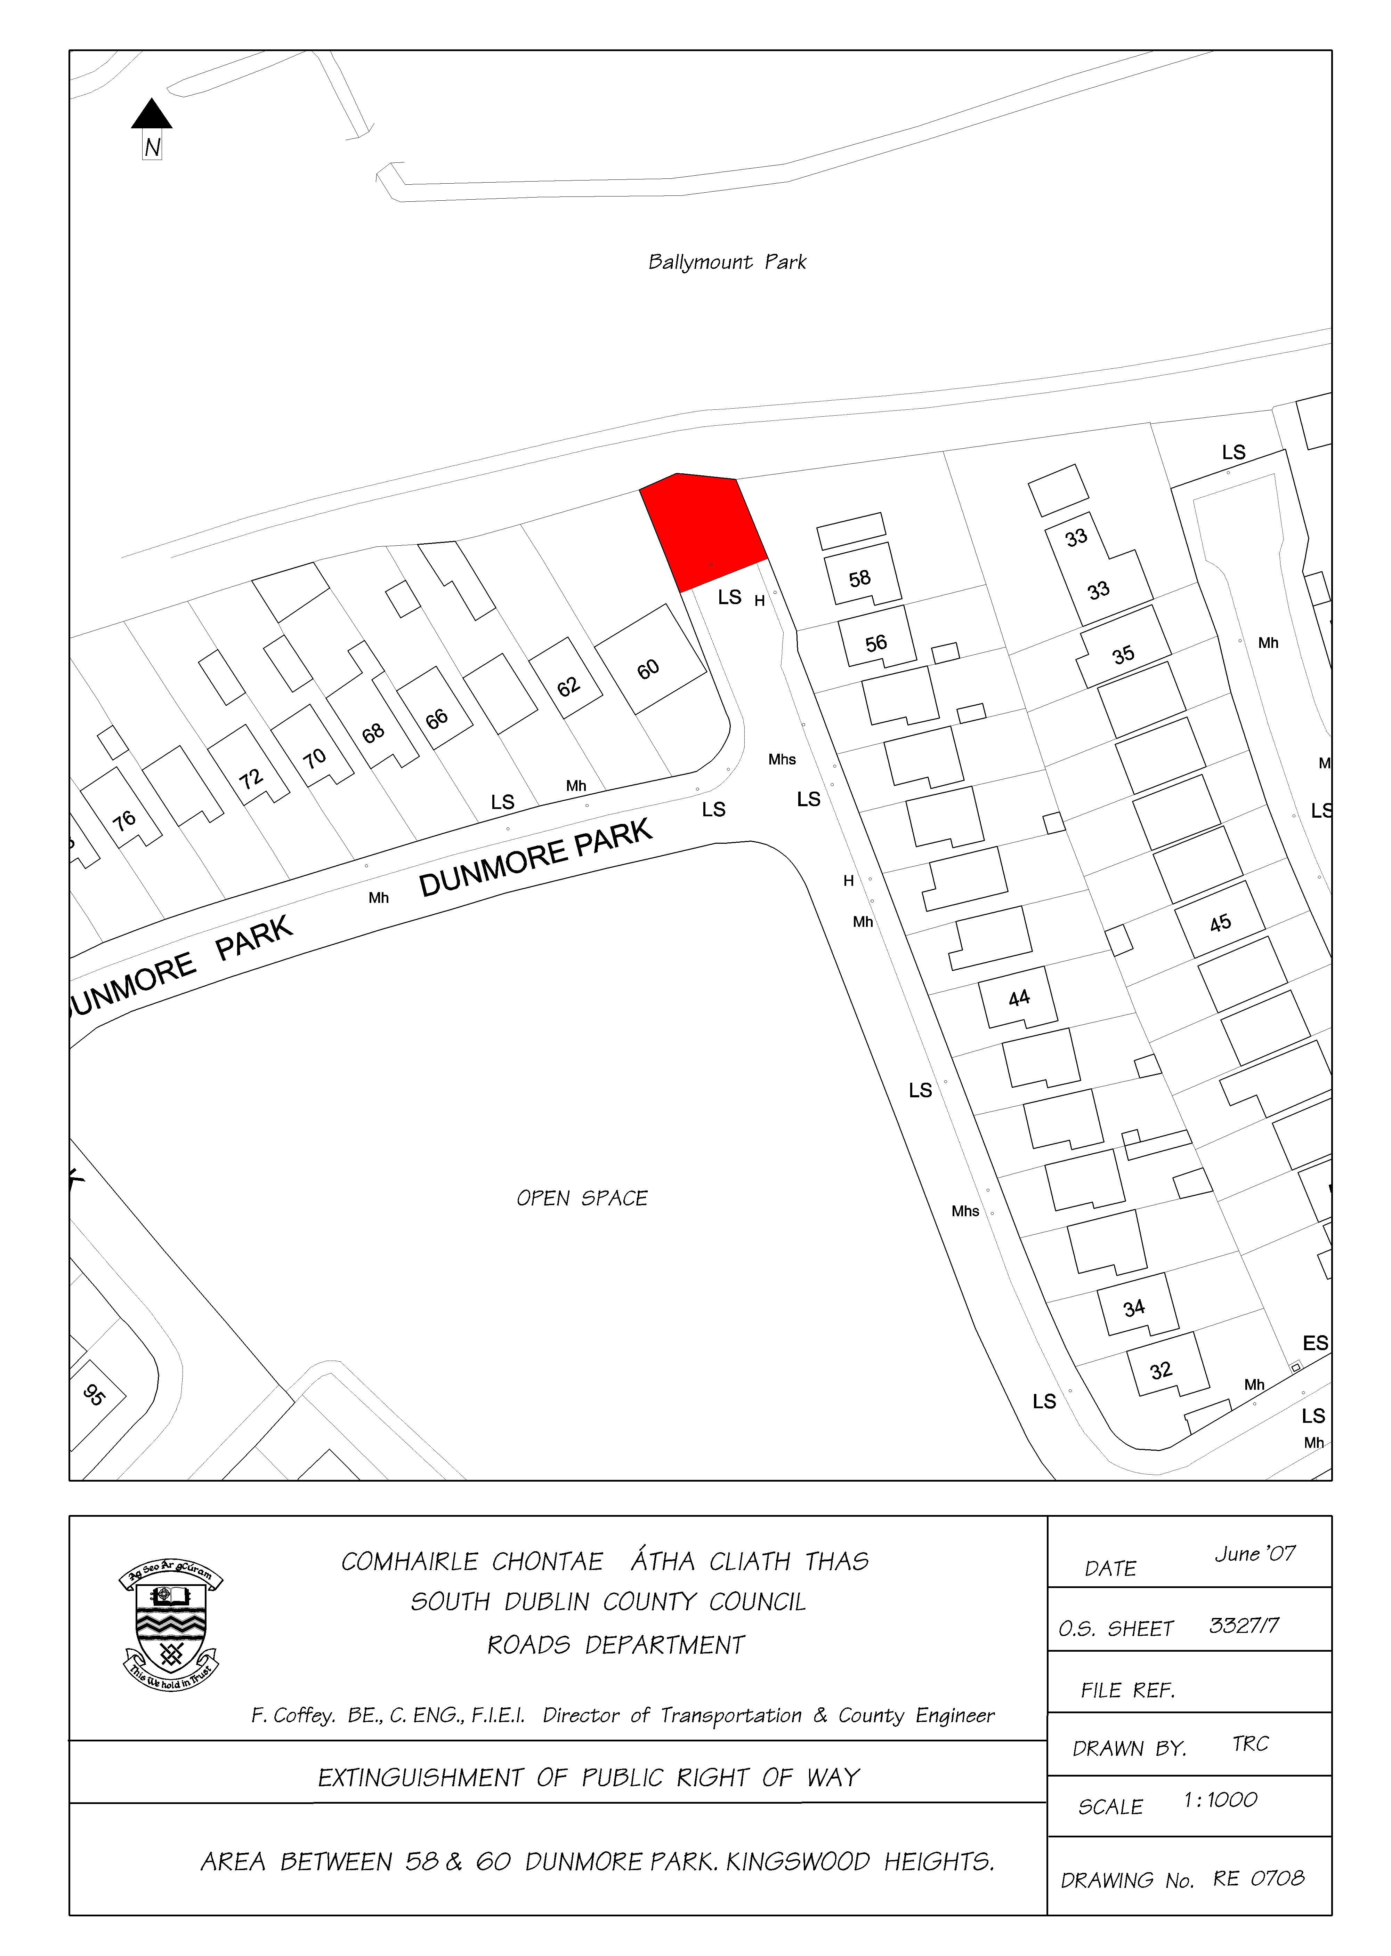Bottom of Form

