Comhairle Baile na Sionna
Shannon Town Council
Town Hall, Shannon, Co. Clare.

(Cléireach an Bhaile – Tomás Mac Cormaic Guthán 061 478081)

(email shannontclerk@eircom.net)

February 18th 2008

To Each Local Authority

A Chara,

The following is the text of a resolution adopted at the February monthly meeting of the Shannon Town Council;

“that Shannon Town Council calls on the HSE to provide accommodation for Cystic Fibrosis (CF) patients in single rooms in private hospitals as an interim solution to cater for CF patients until the planned opening of a new 120 bed unit at St. Vincent’s Hospital in 2010, and that this resolution be circulated to all local authorities for their support”.

The members of the Town Council would appreciate the support of all Local Authorities for this resolurion.

Is mise, le meas,,

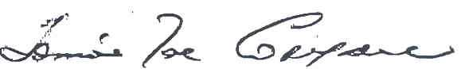
Cleireach an Bhaile

