COMHAIRLE CONTAE ATHA CLIATH THEAS

SOUTH DUBLIN COUNTY COUNCIL

MINUTES OF MEETING OF THE TALLAGHT AREA COMMITTEE
(Dealing with Environment, Housing, Community and Parks )
HELD ON 3rd DECEMBER, 2007

PRESENT

Councillors | Councillors
Corr M. | Maloney E
Daly J. | Murphy M.
Hannon J. | Neville J.
Jones C. | Warren K.
King C.

An Cathaoirleach, Councillor M. Corr presided.

OFFICIALS PRESENT

Director of Community Services | P. Smith
Senior Executive Officers | B. Coman, H. Hogan,
A/County Librarian | I. Stobbart
Senior Executive Parks Superintendent | M. Keenan
Administrative Officers | J. Kilgarriff, T. O’Neill
A/Administrative Officers | B. Martin, M. McCartan
Staff Officer | E. Conlon
Assistant Staff Officer | L. Hannon

T/859/07 CONFIRMATION AND RE-AFFIRMATION OF MINUTES

Minutes of Tallaght Area Committee Meeting held on 19th November, 2007 which had been circulated, were submitted and APPROVED as a true record and signed.

It was proposed by Councillor M. Corr, seconded by Councillor K. Warren and RESOLVED:

“That the recommendations contained in the Minutes of the Tallaght Area Committee held on 19th Novemebr, 2007 be ADOPTED and APPROVED".

COMMUNITY BUSINESS

T/860/07 QUESTIONS
It was NOTED there was no business under this heading

T/861/07 Application for Grants

The following report by the Manager which had been circulated was CONSIDERED:

“Application for a grant under the Council’s Community Grants Scheme have been received from the ogranisations listed below. Payment of these grants to these organisations, in accordance with the conditions of the Scheme, in the amounts set out hereunder, is recommended for approval:-
Ref: | Group: | Type of Application | Date of Application | Amount
GF 1661 | Tallaght Swim Team, Balrothery Sports Complex | Equipment Grant | 12/11/07 | €3,000
Application for Grants (Arts Act 2003)
Application for a grant under the Council’s Arts Scheme has been received from the organisation listed below. Payment of this grant, in accordance with the conditions of the scheme, in the amount set out hereunder, is recommended for approval.
Ref: | Group: | Type of Application | Date of Application | Amount
AGF 611 | South Dublin County Tourism | Arts Grant towards event subsidy and professional support | 14/11/07 | €4,500

Mr P. Smith, Director of Services, summarised the report.

It was proposed by Councillor M. Corr , seconded by Councillor E. Maloney and RESOLVED:

“That this Committee recommends that South Dublin County Council approve payment of the above grants recommended in the foregoing report”.

T/862/07 LIBRARY/ NEW EVENTS

The following report by the Manager which had been circulated was CONSIDERED:

Branch | Event | Date
Castletymon
Adult Activities | English for Foreign Nationals | Mondays at 10am  All Welcome
 | Beginners Irish Conversation Class | Tuesdays 10am
 | Book Club | Last Tuesday of the Month at 11am  All Welcome
 | Computer Class  Booking Necessary. | Wednesdays  10am – 12pm  Booking Necessary
Adults  Activities | Spanish Conversation Group | Fridays at 10am.  All Welcome.
 | ******
Children’s Activities | Story time for 3-6 year olkds | Wednesdays at 3pm  All Welcome
 | Arts & Crafts with Elaine  Booking Necessary | Thursdays at 3.30pm
 | ******
School & Creche Visits | Tour of Library | Thursday Morning  Booking necessary
 | ******

Castletymon Library
Castletymon Shopping Centre
Tallaght
Dublin 24

Mr Ian Stobbart, A/County Librarian summarised the report.

Following a discussion to which Councillors E. Maloney and M. Corr contributed, Mr Ian Stobbart, A/ County Librarian responded to queries raised. The report was NOTED.

T/863/07 NEW WORKS
It was NOTED there was no business under this heading

T/864/07 CORRESPONDENCE
It was NOTED there was no business under this heading

T/865/07 CATHAOIRLEACH’S BUSINESS
It was NOTED there was no business under this heading

T/866/07 THE PROPOSED CCTV SYSTEM FOR THE TALLAGHT AREA

It was proposed by Councillor E. Maloney, seconded by Councillor M. Corr:
“That this committee requests immediate action by the Department of Justice for the provision of the proposed CCTV system for the Tallaght area.”

The following report by the Manager which had been circulated was READ:

“The Council has to date fully supported and assisted the provision of the Community CCTV system for the Tallaght and Clondalkin areas.
In June 2005 a grant aid scheme was launched by the Minister for Justice, Equality & Law Reform in response to a demonstrated demand from community groups across the country. The scheme is intended to contribute to the capital costs associated with the initial establishment of local community CCTV schemes, up to a maximum of €100,000.
The Department of Community, Rural & Gaeltacht Affairs will match funding allocated by the DJELR to successful applications from RAPID areas provided that the total grant aid from both departments does not exceed €200,000 or 100% of the capital costs of the project (or whichever is the lesser).
Capital costs include items such as the purchase of cameras, monitors & related equipment, cabling, ducting, outfitting of a monitoring station etc. It does not include running costs which are the sole responsibility of the applicant.
The overall purpose of the scheme is to support local communities who wish to install & maintain CCTV security systems in their area with the aim of increasing public safety & reducing the risk of anti-social & criminal activity in places that the general public have routine access to in their areas.
As a result of the Garda Siochána Act 2005, the Garda Siochána (CCTV) Order 2006 came into operation in May 2006. This provides a Policy for Community CCTV Systems and a Code of Practice for CCTV Systems.
The Act requires that all persons other than members of An Garda Siochána wishing to install & operate a CCTV system designed to monitor public places for the purposes of securing public order & safety by facilitating the deterrence, prevention, detection & prosecution of offences, must be authorised in writing by the Garda Commissioner to do so.
There are 4 schemes in the South Dublin County area:
North Clondalkin
Jobstown
Brookfield – Fettercairn
Killinarden
The respective promoters for these schemes are Clondalkin Partnership, Jobstown CDP and Partas.
Pobal informed the project promoters in April 2007 of the success of their applications. The promoters then engaged in tender processes, in line with public procurement guidelines issued by Pobal, to select suppliers of CCTV cameras and ancillary civil and electrical works. Each of the promoters chose TEC Security, based in Tallaght, as the preferred supplier.
In order for the systems to proceed to installation, a number of steps remain to be completed. These are:
a) Approval of the scheme by the Joint Policing Committee
b) Authorisation by the Garda Commissioner to operate a CCTV system, by forwarding necessary documentation to the Garda Divisional Officer (Chief Superintendent) in the first instance.
c) On receipt of the Garda Commissioner’s approval, Pobal will enter into contracts with the project promoters and the draw-down of grants can begin.
The approval of the South Dublin County Joint Policing Committee was received at its meeting held on 26th October 2007 and the promoters have requested the approval of the Garda Commissioner.”

Following a discussion to which Councillors E. Maloney and M. Corr contributed, Mr P. Smith, Director of Community Services responded to queries raised.
The report was NOTED and it was AGREED that a letter would issue to the Department of Justice, Equality and Law Reform.

PARKS BUSINESS

T/867/07 QUESTIONS

It was proposed by Councillor M. Corr, seconded by Councillor J Hannon and RESOLVED:

“That pursuant to Standing Order No. 13, questions 1 - 4, be ADOPTED and APPROVED."

T/868/07 THE SITE ADJACENT TO 1 KNOCKMORE DRIVE

QUESTION: Councillor M. Corr
"To ask the manager to adequately secure the site adjacent to 1 Knockmore Drive as a matter of urgency due a significant number of dumping and horse grazing incidents over the past number of weeks?"
REPLY:
The ownership of this location is currently being investigated. When this is established arrangements will be made to have the area secured and hopefully alleviate the anti-social activity.

T/869/07 THE RIGHT OF WAY BETWEEN PARKLANDS COURT AND BALLYCRAGH

QUESTION: Councillor C. Jones
“To ask the manager to extinguish the right of way between Parklands Court and Ballycragh.”
REPLY:
A pedestrian access exists into Ballycragh Park from Parklands Court. In order to optimise access to and usage of the park to ensure its viability within the community, the Parks & Landscape Services Department would not be in favour of closing this access.

T/870/07 PROVISION OF A FOOTPATH

QUESTION: Councillor J. Neville
"To ask the Manager to have included or confirmed in the forthcoming estimates the provision of a footpath between *Details supplied and will the Manager note that this issued was raised via a written question in May, 2006 where there appeared to be a misunderstanding over the precise location of this proposed footpath?"
REPLY:
The provision of a footpath at this location will be examined having regard to cost and suitability and if it is agreed to construct the path arrangements will be made to have this work carried out in 2008.

T/871/07 PATHWAY BETWEEN WOODLAWN AND MONALEA WOOD IN FIRHOUSE
QUESTION: Councillor K. Warren
“To ask the Manager if the Parks Department would remove all overgrown grass etc. from the existing pedestrian pathway between Woodlawn and Monalea Wood in Firhouse which is in poor condition and, if this pathway could be resurfaced in the context of next year’s Parks Works Programme, and if he will make a statement on the matter?”
REPLY:
The resurfacing of this pathway between Woodlawn and Monalea Wood will be considered for funding as part of the 2008 Parks Works Programme.
Bottom of Form

T/872/07 NEW WORKS

REPORT ON PROPOSED PART 8 FOR CONSTRUCTION OF CHANGING ROOM FACILITIES AND CAR PARK, RELOCATION OF TENNIS COURTS, RE-ORIENTATION OF PLAYING PITCHES, AND LANDSCAPE IMPROVEMENT WORKS AT OLD BAWN WEIR, DODDER VALLEY PARK, OLDBAWN, TALLAGHT.
“Following consultation with representatives of the Old Bawn Residents Association and the sports clubs - Thomas Davis GAA, Shamrock Rovers FC, Dominic Celtic FC and Dragon Rangers FC - who use the playing pitch facilities at Dodder Valley Park, Oldbawn, it is proposed to construct a pavilion which would incorporate changing facilities to replace the existing containers adjacent to the ESB substation in the Oldbawn area of Dodder Valley Park. A grant allocation of 250,000 under the Sports Capital Programme is available to fund this proposal. This project represents an opportunity to initiate a major programme of improvement work in this area of the Dodder Valley Park. The proposal also includes the development of car park facilities with access off the Oldbawn Road to provide parking for all users of the park. The existing tennis court facilities would be relocated to a securely fenced enclosure alongside the proposed changing facilities which could also be used by users of the tennis courts and would incorporate a storage area for nets etc. This would enable greater security and better management of the tennis court facility. These proposals will entail the re-orientation of the existing playing pitches and the construction of some new pedestrian paths to optimise use of the park area.
The Oldbawn Weir is a very attractive feature of the Dodder Valley Park and it is proposed to enhance its accessibility and amenity value for park users with the development of landscaped viewing areas on either side linked by a pedestrian bridge over the river. This proposal will also include new pedestrian path connections and soft landscaping detail.
All of the above works will be subject to Public Consultation under Part 8 of the Planning & Development Regulations 2001. It is proposed to commence the Public Consultation process in January 2008. A drawing will be available at the meeting to illustrate the nature and extent of the proposed works.”
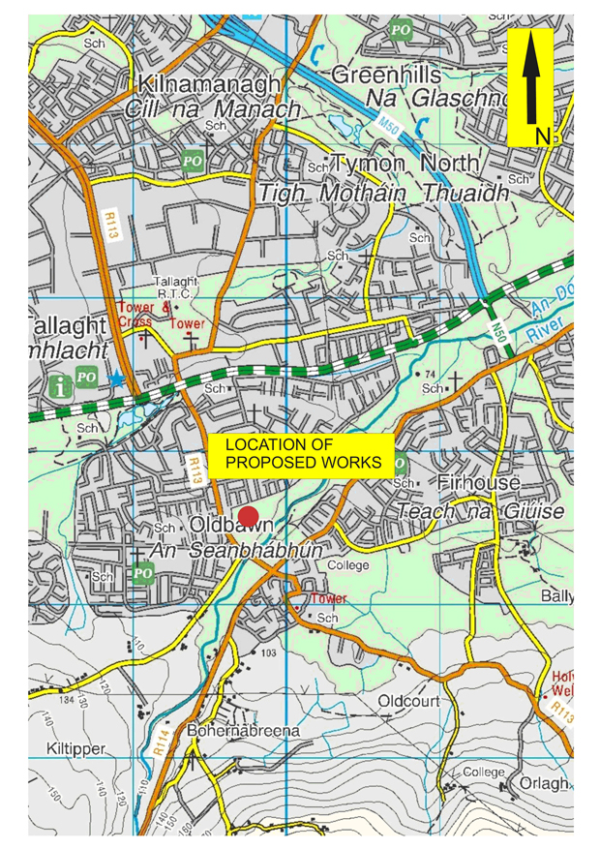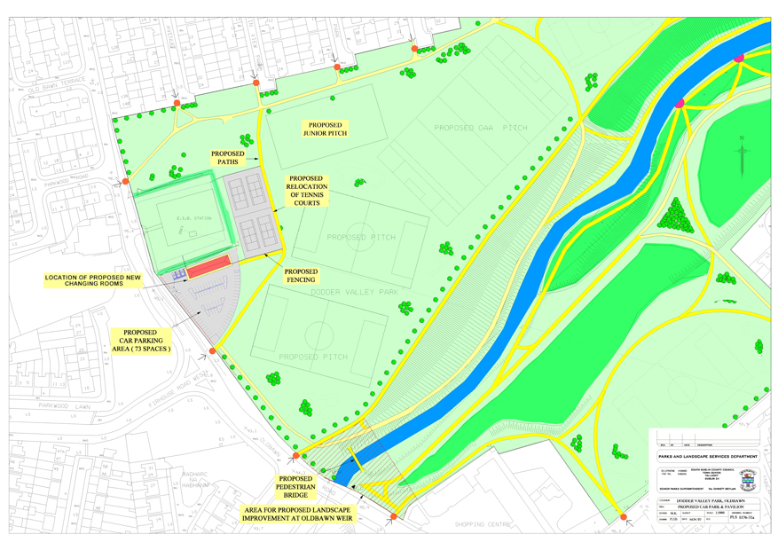

Ms M. Keenan, Senior Executive Parks Superintendent, summarised the report.

Following a discussion to which Councillors E. Maloney, J. Neville, K. Warren, C. King, M. Murphy and J. Daly contributed Ms. M. Keenan, Senior Executive Parks Superintendent, responded to queries raised.

The report was NOTED.

T/873/07 CORRESPONDENCE
It was NOTED there was no business under this heading.

T/874/07 CATHAOIRLEACH’S BUSINESS
It was NOTED there was no business under this heading.

T/875/07 THE CHILDREN'S PLAYGROUND IN THE TALLAGHT END OF TYMON PARK

It was proposed by Councillor E. Maloney, seconded by Councillor M. Corr:
“That this committee supports the upgrading of the children's playground in the Tallaght end of Tymon Park.”

The following report by the Manager which had been circulated was READ:

“As part of its programme of major capital works for 2008, the Parks Department proposes to renew the children's playground in Tymon Park near to the Tymon North entrance which serves the Tallaght catchment area. The proposal will involve the relocation of the playground from its current site to a new location near to the Visitor Centre to enhance its supervision. Plans are currently being prepared and will be brought to a meeting of the Tallaght Area Committee in early 2008 in order to initiate a Part 8 Public Consultation Process for the project.”

Following a discussion to which Councillors E. Maloney and M. Corr contributed, Ms M. Keenan, Senior Executive Parks Superintendent, responded to queries raised.
The report was NOTED.

ENVIRONMENT BUSINESS

T/876/07 QUESTIONS

It was proposed by Councillor M. Corr, seconded by Councillor J. Hannon and RESOLVED:

“That pursuant to Standing Order No. 13, question 5, be ADOPTED and APPROVED."

T/877/07 ASSESSMENT OF GRAFFITI IN THE RAPID AREAS OF TALLAGHT

QUESTION: Councillor M. Corr
"To ask the Manager as a matter of urgency to carry out an assessment of graffiti in the RAPID areas of Tallaght with a view to arranging both the removal and assistance for removal to owners of private property by the end of the year - to focus on a number of private rented houses in Montpelier, Swiftbrook, Suncroft, Sundale and De Selby?"
REPLY:
The Council’s Graffiti Removal Squad have treated 9 RAPID areas in Tallaght since May 2006 and graffiti requires to be removed in a further 7 RAPID area. With regard to the five housing estates referred to in the question the position is as follows
Mount Pellier:
The graffiti in this estate requires sandblasting as it has been posted on dry dashed walls and accordingly consideration will have to be given to engaging the services of a private contractor.
Swiftbrook
Graffiti has been treated inside this estate but the brickwork at the external boundary will require sandblasting.
Suncroft/ Sundale
A lot of graffiti was removed from this estate by Council staff this morning.
DeSelby
2 long brick work walls in this estate require sandblasting by a private contractor.
With regard to private rented houses, in all of the foregoing estates, the Litter Warden for the area has been requested to conduct a survey of the dwellings which require to have graffiti removed by the householders.

T/878/07 NEW WORKS
It was NOTED there was no business under this heading

T/879/07 CORRESPONDENCE
It was NOTED there was no business under this heading

T/880/07 CATHAOIRLEACH’S BUSINESS
It was NOTED there was no business under this heading

HOUSING BUSINESS

T/881/07 QUESTIONS

It was proposed by Councillor M. Corr, seconded by Councillor J. Hannon and RESOLVED:

“That pursuant to Standing Order No. 13, question 6, be ADOPTED and APPROVED."

T/882/07 DOOR TO DOOR SURVEY BY THE ALLOCATIONS SUPPORT PERSONNEL

QUESTION: Councillor M. Corr
“To ask the Manager to conduct a survey door to door by the Allocations Support personnel at *Details supplied with a view to ascertaining issues tenants are experiencing at this location and addressing promptly any problems that have arisen as a result of anti-social behaviour?”
REPLY:
It is intended that the Housing Department will carry out a door to door survey in the areas in question and it is expected that this survey will be completed before the end of the year and the matters raised by the residents will be addressed.

T/883/07 REPORT ON HOUSING CONSTRUCTION PROGRAMME

The report by the Manager which had been circulated was CONSIDERED:

“Completions 2004
Cushlawn (Phase 1) - 28
Tymon Park - 2
Bolbrook - 11
Kilcarrig (Phase 2) - 8
Russell Square - 5
Marlfield (Part V) - 26
Total 80
Completions 2005
Marlfield (Part V) - 1
Russell Square - 110
Bawnlea - 7
Jobstown Village Core - 11
Cushlawn (Phase 2) - 31
Daletree(Part V) - 8
Fettercairn Village -22
Total - 190
Completions 2006
Fettercairn Village - 19
Deerpark Joint Venture - 11
Fortunestown B (Phase 2) - 38
Fortunestown B (Phase 4) - 120
Daletree (Part V) - 24
Total - 320
Completions 2007
Fortunestown B (Phase 2) - 28
Daletree (Part V) - 3
Brookfield - 16
Castlepark - 9
Total - 56
Schemes in progress - anticipated completion date
Fortunestown B (Phase 1 - 110 units) - In phasesearly 2008
Avonbeg (Phase 3 - 47 units) - 14 units to be handed over 5th December 2007, rest early 2008
Deerpark (Part V - 36 units) - early 2008
Cushlawn (Phase 3 - 22 units) - 1st Qtr 2008
Greenhills Road (Part V - 9 units) - 1st Qtr 2008
Kilcarrig (Phase 3 - 80 units) - 4th Qtr 2008
Kiltalown Green (27 units) - 3rd Qtr 2008
Ardmore (Part V - 2 units) - 2nd Qtr 2008
Total - 333 units
Tender Assessment
Avonbeg (Phase 4 - 7 units) - Anticipated start date 1st Qtr 2008
Fettercairn (Phase 2 - 33 units) - Anticipated start date 1st Qtr 2008
Comments
Fortunestown B (Phase 3 & 5 - 160 units) - tender being assessed
Castletymon (32 units) - tenders being assessed
Rossfield Old Shop Site (9 units) - Target tender 1s Qtr 2008
Knockmore (96 units) - Target tender 1st Qtr 2008
Stocking Lane (100 units) - Target tender date 2nd Qtr 2008
Deerpark (8 units) - cost plan to DOE
Total - 445
Concept/Design Stage
Suncroft (10 units) - possible affordable option - concept to ACM on 19th Nov 07
Swiftbrook (11 units) - concept to ACM 8th Dec 2004
Total - 21
Other potential sites are also being examined.”

Mr H. Hogan Senior Executive Officer summarised the report.

Following a discussion to which Councillors M. Corr and C. King contributed, Mr H Hogan Senior Executive Officer, responded to queries raised.
The report was NOTED.

T/884/07 REPORT ON IMPLEMENTATION OF TRAVELLER ACCOMMODATION PROGRAMME

The report by the Manager which had been circulated was CONSIDERED.

“The following is the current position on developments at various stages of delivery throughout the Tallaght Area of the County.
Scheme | Type and No. of Units | Status | Comments
Daletree Place | 10 Group Houses | Completed & Occupied | Residents moved into houses in August 2005.
Belgard Park | 10 bay RCP | Completed & Occupied | Residents moved into houses in August 2005.
St. Aidan’s Close Brookfield | 5 Group Houses | Completed & Occupied | Families moved in to houses on 3rd May 2006.
Hazel Hill, Killinardin | Group Houses – 5 R.C.P. – 5 Bays | Completed & Occupied | Residents moved into scheme in December 2006.
Fortunestown | 10 Group Houses – | Completed & Occupied | Residents moved into scheme in Dec. 2006.
Stocking Lane | 10-bay RCP | Pre-construction | ESB currently on site (ie laying of cables underground), prior to construction commencing
Rathcoole | 10 GH | Pre-part 8 | Design for revised Part 8 process for group housing to be prepared. Discussions with future residents being held

Mr H Hogan Senior Executive Officer summarised the report.

Following a discussion to which Councillors J. Neville, J. Daly and C. King contributed Mr H Hogan Senior Executive Officer responded to queries raised.

The report was NOTED.

T/885/07 Report on Social and Affordable Housing
The report by the Manager which had been circulated was CONSIDERED.
“The Councils Housing Strategy, which was prepared in accordance with Part V of the Planning and Development Act 2000, was adopted by the Council at its meeting held on 11th June 2001. This Strategy was reviewed and now forms an integral part of the County development Plan 2004-2010, which was adopted by the Council on 10th November 2004.
The Strategy requires 15% of all residential developments to be reserved for Social/Affordable purposes. The Council has been successful in the delivery of affordable housing under the following initiatives:
(a) Part V of the Planning & Development Acts 2000 - 2006 (as amended)
(b) Joint Venture Schemes
(c) Integrated Area Plans
To date 640 affordable homes have been procured throughout the County. Of these 411 have been procured and sold on in the Tallaght Area.
The following schedule sets out (a) the location and number of affordable homes procured to date in the Tallaght Area, (b) a schedule of social/affordable homes to be procured where a Letter of Exchange has issued and/or an Agreement has been reached, (c) location and number of social homes procured to date in the Tallaght Area, (d) a schedule of traveller accommodation homes procured to date in the Tallaght area under Part V of the Planning and Development Acts 2000 – 2006 (as amended) (e) a schedule of voluntary homes procured to date in the Tallaght Area, (f) schedule of developments where a Commencement Notice has been served and negotiations are ongoing with the developer.
- Schedule of Affordable Homes procured in the period 2003 - to date.

Location | Number of Homes | Date of Procurement
The Farm, Balrothery | 3 homes | 21/09/2004
Corner Site bounded by Blessington Road/Belgard Square East | 8 homes | 26/11/2004
Russell Square, Fortunestown | 100 homes | 2004/2005
Deerpark, North Kiltipper Road | 102 homes | 2004/2005
Kiltalown, Jobstown | 28 homes | 2004/2005
Brownsbarn, Kingswood | 4 homes | 21/08/2004
Springfield, Tallaght | 40 homes | 13/10/2005
Westend Gate, Tallaght | 17 homes | 04/10/2005
Loftus Hall, Belgard Square West | 20 homes | 20/10/2006
Hunterswood, Ballycullen | 9 homes | May 2007
Verschoyle Park | 2 homes | July 2007
Deerpark, Kiltipper Road | 18 homes | July 2007
Block E, The Belfry | 9 homes | July/August 2007
Blackthorn Hill, Rathcoole | 16 homes | July/August 2007
Carrigmore/Carrig Court, Fortunestown | 40 homes | July/August 2007
The Bungalow, Main Street, Rathcoole | 17 homes | 22/11/2007
Total | 433

(b) Schedule of Social/Affordable Homes to be procured where a Letter of Exchange has issued and/or an Agreement has been reached.

Location | No. of Homes | Target Completion Date for homes
Tallaght Cross, Belgard Square North | 66 | End 2007
Dalriada, Woodstown, Ballycullen | 22 | 22 social housing homes still to be delivered – Autumn 2007
Killinarden Shopping Centre | 3 | Autumn 2007
Whitestown Way, Tallaght By-Pass | 35 | End 2007 - Voluntary
Junction of Greenhills Road and Main Street, Tallaght | 8 | End 2007 - Social
Citywest Shopping Centre | 40 | September 2007
Suncroft | 2 | End 2007
Swiftbrook, Saggart | 47 | From September 2007
Kingswood, Naas Road | 25 | 2008
Total | 243
(c) Schedule of Social Homes procured in the period 2004 - to date.

Location | Number of Homes | Date of Procurement
Marlfield | 27 homes | 2004
Daletree | 8 homes | 2005
Daletree | 24 homes | 2006
Daletree | 3 homes | 2007
Heathersett, Old Court Road | 20 homes | 2007
Total | 82 homes

(d) Schedule of Traveller Accommodation Homes procured under Part V of the Planning and Development Acts 2000 – 2006 (as amended)
Location | Number of Homes | Date of Procurement
Marlfield, Kiltipper | 5 | December 2004
(e) Schedule of Voluntary Housing Homes procured under Part V of the Planning and Development Acts, 2000 - 2006 (as amended)
Location | Number of Homes | Date of Procurement
Loftus Hall, Belgard Square West, Tallaght | 38 | January 2007
(f) Schedule of developments where a Commencement Notice has been served and negotiations are ongoing with the developer
Location | Estimated Number of homes for Social/Affordable/voluntary | Target Completion Date for Homes*
Tallaght Leisure Centre, Old Bawn Road | 3 homes | March 2007
Former Iceland Site, Tallaght Road | 32 homes | Late 2007
Tallaght Retail Unit | 16 homes | 2007
Marlfield | 25 homes | 2007
Tallaght Cross, Belgard Square North | 76 homes | 2007/2008
Boherboy Road/Watercross, Saggart | 34 homes | 2007/2008
The Bungalow, Main Street, Rathcoole | 4 homes | 2008
Former Cats and Dogs Home, Stocking Lane | 103 homes | 2008
Tallaght Road, Tallaght Village (besides Greenhills Rd Extension) | 19 homes | 2008
Former Woodies Site, Belgard Square East | 29 homes | 2008
Saggart Lodge | 6 homes | 2008
Total | 347 homes

* Please note that the foregoing schedule provides an estimate only of homes to be procured pursuant to Part V as no formal agreements have yet been reached with the developers. Please also note that date of procurement may change due to external factors, outside the control of the Council, e.g. registration of title issue, climatic conditions etc.
In addition to the foregoing, there is potential to procure a further 278 (approx.) social/affordable homes in the Tallaght Area on foot of Planning Permissions granted.
Maps for the areas mentioned in the report can be viewed at:”
http://intranet/cmas/documentsedit.aspx?id=12926&itemTxt=H-I12
Mr H. Hogan, Senior Executive Officer, summarised the report.

The report was NOTED.

T/886/07 NEW WORKS
It was NOTED there was no business under this heading.

T/887/07 CORRESPONDENCE
It was NOTED there was no business under this heading

T/888/07 CATHAOIRLEACH’S BUSINESS
It was NOTED there was no business under this heading.

The Meeting concluded at 4.30 p.m.

Siniú: ______________________ Dáta: ________________

An Cathaoirleach

