COMHAIRLE CONTAE ÁTHA CLIATH THEAS

SOUTH DUBLIN COUNTY COUNCIL

TERENURE/RATHFARNHAM AREA COMMITTEE MEETING (1)

Minutes of Terenure/Rathfarnham Area Committee Meeting (1), (dealing with Development, Corporate Services, Roads and Planning business) held on 4th
December 2007.

PRESENT
Councillors
M. Árdagh
P. Cosgrave
C. Keane
S. Laing
T. McDermott
E. Walsh

An Cathaoirleach, Councillor S. Laing presided.

OFFICIALS PRESENT
Senior Executive Officer | M. Judge
Senior Engineer | T. O’Grady
Administrative Officers | T. Curtin, M. Kelly, M. Hunt
Senior Executive Engineer | S. Daly, M. Glynn, A O’Mullane
Senior Staff Officer | N. Fitzgibbon
Clerical Officer | A. Shaw

TR/830/07 CONFIRMATION AND RE-AFFIRMATION OF MINUTES

HEADED ITEM (1) Item ID: 12417
Minutes of meeting of Terenure/Rathfarnham Area Committee (1) dealing with Planning, Development, Corporate Services and Roads business) held on 6th November 2007 which had been circulated were submitted, APPROVED as a true record and signed.

It was proposed by Councillor S. Laing, seconded by Councillor M. Ardagh and RESOLVED:

“That the recommendations contained in the Minutes of the Terenure/Rathfarnham Area Committee Meeting (1) held on 6th November 2007 be ADOPTED and APPROVED.”

Development

TR/831/QUESTIONS

It was proposed by Councillor S. Laing, seconded by Councillor M. Ardagh and RESOLVED:

“That pursuant to Standing Order No. 13, Question number 1 be

ADOPTED and APPROVED.”

TR/832/07 ALLOTMENTS IN TERENURE/RATHFARNHAM AREA

QUESTION (1): Councillor T. McDermott Item ID: 12659
"To ask the Manager for a status report on the supply and management of allotments in the Terenure / Rathfarnham area?"
REPLY:
In 2006 the Council opened 3 new allotment sites at Tymon Park, Corkagh Park and Mill Lane, Palmerstown. In 2007 a further site was opened at Friarstown. The total number of plots in all 4 sites is 161 and are divided as follows:
Location | No of Plots | Size | Cost | Waiting List
Tymon Park, Tallaght | 13 | 100 Sq Mtrs | €40.00 €25.00 OAP | 39
Friarstown | 36 | 120 Sq Mtrs | €48.00 €30.00 OAP | 87
Friarstown | 12 | 250 Sq Mtrs | €100.00 €62.50 OAP
Mill Lane, Palmerstown | 73 | 120 Sq Mtrs | €48.00 €30.00 OAP | 42
Corkagh Park, Clondalkin | 27 | 100 Sq Mtrs | €40.00 €25.00 OAP | 49
The plots are generally the size of an average back garden with a small number of larger plots at Friarstown. The plots are allocated in accordance with the Allotment Scheme which was adopted by the Elected Members in September 2005. The former tenants from the Kishogue site wishing to relocate to any of the new sites were given priority and have been allocated plots. Allocation of plots in all sites is in accordance with place on waiting list with priority given to residents of South Dublin County.
At present there is a waiting list for all 4 sites which highlights the demand for this type of recreational facility. The Council is considering the extension of the Allotment Scheme to facilitate those on the waiting list. The provision of the new allotments is by way of an extension to Friarstown in 2008 which will accommodate approximately 90 plots of various sizes. We are also providing a new site in the Grange Park, Lucan which will accommodate approximately 30 plots which should be operational by the 2009 season.
Any future allocation of plots will be made on the basis of priority to residents of South Dublin County.
The new allotments have been improved by the provision of water, storage and composting facilities on site. Parking areas have been created and toilet facilities provided for the convenience of the plot holders.
The sites are developing very well and feedback from the tenants is very positive.
The allotment facilities in Tymon Park and Friarstown are the most favourable with residents of the Terenure/Rathfarnham area. However, there is no capacity for extension at Tymon at present.
Bottom of Form

TR/833/07 NEW WORKS

HEADED ITEM (2) Item ID: 12418
It was NOTED that there was no business under this heading.

TR/834/07 CORRESPONDENCE

CORRESPONDENCE (1) Item ID: 12419
It was NOTED that there was no business under this heading.

TR/835/07 Cathaoirleach's Business

MOTION (1) Item ID: 12900
It was NOTED that there was no business under this heading.

TR/836/07 GREENHILLS COLLEGE

MOTION (2) Item ID: 12655
It was proposed by Councillor T. McDermott and seconded by Councillor C. Keane

"That this committee calls on the Manager to consider proposals from the principal and Board of Management of Greenhills College to dispose of a portion of the adjoining park to the college in order to secure it from on-going and persistent anti-social behaviour."
The following report by the Manager was READ:
“The boundary of the School where it adjoins the park land is being examined in conjunction with the Parks Department. In the event of agreement being reached to transfer any portion of the park land to the School to improve the security of the School, it will be necessary for the owners of the school i.e. Department of Education and Science or County Dublin V.E.C. to accept responsibility for ownership and maintenance of the lands.”
Following contributions from Councillors T. McDermott, C. Keane, M. Ardagh and S. Laing, Ms. M. Kelly, Administrative Officer responded to queries raised and the report was NOTED.
Bottom of Form

Corporate Services

TR/837 QUESTIONS

It was NOTED that there was no business under this heading.

TR/838/07 CORRESPONDENCE

CORRESPONDENCE (2) Item ID: 12421
It was NOTED that there was no business under this heading.

TR/839/07 NEW WORKS

HEADED ITEM (3) Item ID: 12420
It was NOTED that there was no business under this heading.

TR/840/07 Cathaoirleach's Business

MOTION (3) Item ID: 12902
It was NOTED that there was no business under this heading.

Roads

TR/841/QUESTIONS

It was proposed by Councillor S. Laing, seconded by Councillor M. Ardagh and RESOLVED:

“That pursuant to Standing Order No. 13, Question number 2-10 inclusive be

ADOPTED and APPROVED.”

TR/842/07 ROAD SURFACING ORWELL PARK HEIGHTS

QUESTION (2): Councillor P. Cosgrave Item ID: 12903
"To ask the Manager when road resurfacing will be completed at Orwell Park Heights and will he make a statement on the matter?"
REPLY:
This area will be considered for inclusion in the 2008 programme of works.
Bottom of Form

TR/843/07 TRAFFIC CALMING WHITECHURCH GROVE

QUESTION (3): Councillor P. Cosgrave Item ID: 12904
"To ask the Manager to put traffic calming measures in place along Whitechurch Grove with agreement with the local residents?"
REPLY:
Whitechurch Grove is included in scheme 1 of traffic calming Programme 2.A design for this scheme will be carried out early in 2008 and will be discussed with the residents association.
Bottom of Form

TR/844/07 ROUNDABOUT ON ANNE DEVLIN ROAD

QUESTION (4): Councillor P. Cosgrave Item ID: 12905
"To ask the Manager to review the traffic calming roundabout on Anne Devlin Road, taking into account its safety aspect with cars driving straight over the roundabout and cars not giving way as to the highway code?"
REPLY:
The dimensions of this roundabout conform with the Traffic Management Guidelines. Whereas the roundabout is designed to be mountable, it is important that motor vehicles while negotiating the roundabout give way to traffic travelling from the right.
Traffic movements at this roundabout have been examined on a number of occasions and no difficulties with regard to turning movements were noticed during these inspections.

TR/845/07 TRAFFIC LIGHT SEQUENCE BUTTERFIELD AVENUE JUNCTION

QUESTION (5): Councillor P. Cosgrave Item ID: 12906
"To ask the Manager to review the traffic light sequence at the junction on Butterfield Avenue, Ballyroan Road, Firhouse Road and Old Bridge Road. When a motorist is turning right from Old Bridge Road onto Firhouse Road the traffic signals are briefly at variance with one another when lights are changing which is confusing for motorists?"
REPLY:
We have checked the traffic signal sequences at Templeogue Bridge/Firhouse Road Junction and confirm that they are operating as designed. For the record, these sequences are as follows:-
Stage 1:
Green to straight-through and right-turning traffic from Firhouse Rd.
Red to all other traffic.
Red to pedestrians.
Stage 2:
Green to straight-through traffic from Firhouse Rd.
Red to right-turning traffic from Firhouse Rd onto Ballyroan Rd.
Green to Traffic on Butterfield Ave.
Red to traffic on Ballyroan Rd.
Red to traffic on Oldbridge Rd.
Red to Pedestrians.
Stage 3:
Red to traffic on Firhouse Rd.
Green to traffic on Butterfield Ave. including right-turn into
Oldbridge Rd.
Red to traffic on Ballyroan Rd.
Red to traffic on Oldbridge Rd.
Red to pedestrians.
Stage 4:
Red to traffic on Firhouse Rd.
Red to traffic on Butterfield Ave.
Green to traffic on Oldbridge Rd.
Green to traffic on Ballyroan Rd.
Red to pedestrians.
Stage 5:
Red to traffic on Firhouse Rd.
Red to traffic on Butterfield Ave.
Red to traffic on Ballyroan Rd.
Green to traffic on Oldbridge Rd including right-turn into Firhouse Rd.
Red to pedestrians.
Stage 6:
Red to traffic on Oldbridge Rd except right-turn into Firhouse Rd.
Red to traffic on Ballyroan Rd.
Red to traffic on Firhouse Rd.
Red to traffic on Butterfield Ave.
Green to pedestrians on Butterfield Ave.
Green to pedestrians on Ballyroan Road
The left-turns from Oldbridge Rd. onto Butterfield Ave., from Ballyroan Rd. onto Firhouse Rd. and from Firhouse Rd onto Oldbridge Rd are all YIELD controlled.
Right-turning traffic from both Oldbridge Rd and Ballyroan Rd may turn right on “gaps” at their own discretion during Stage 4.
Right turn traffic from Butterfield Ave. may turn right on “gaps” at their own discretion during Stage 2.
The junction is fully VA (Vehicle Actuated) and stages are called only by demand.
As can be seen from above the right-turn from Templeogue Bridge onto Firhouse Rd is catered for during stages 5 and 6. Stage 6 is called only by pedestrian demand.
This is a common arrangement and is in use through-out the county.
Bottom of Form

TR/846/07 RE-ALIGNMENT OF KNOCKLYON ROAD

QUESTION (6): Councillor J. Lahart Item ID: 12571
"To ask the Manager to update the members on the re-alignment of the Knocklyon Road, to include anticipated contract times etc?"
REPLY:
South Dublin County Council will commence prequalification of Contractors for the realignment of the Knocklyon Road in early December. The prequalification period is 36 days. Following qualification the applicants will be invited to tender for the scheme and the tender period is 40 days. Following assessment of the tender the successful Contractor will be appointed. The contract will be of 1 year duration.

TR/847/07 PARKING AT SHOPS ON KIMMAGE ROAD

QUESTION (7): Councillor S. Laing Item ID: 10468
"To ask the Manager to examine the parking area outside the shops on the corner of Kimmage Road east-west which needs upgrading?"
REPLY:
The paved area behind the public footpath is not in charge of South Dublin County Council.
Bottom of Form

TR/848/07 CUL-DE-SAC SIGN AT ORLAGH PINES

QUESTION (8): Councillor S. Laing Item ID: 11283
"To ask the Manager to provide a Cul-De-Sac sign at the entrance to Orlagh Pines in order to prevent accidents taking place especially with regard to children?"
REPLY:
The requested sign will be provided as soon as practicable.
Bottom of Form

TR/849/07 FOOTPATH REPAIRS 41 WILLOWBANK PARK

QUESTION (9): Councillor S. Laing Item ID: 12565
"To ask the Manager to carry out footpath repairs at the side of No. 41 Willowbank Park, Rathfarnham?"
REPLY:
This area has been inspected. A minor lip is present between footpath slabs. This will be included on the programme for scabbeling.
Bottom of Form

TR/850/07 FOOTPATH REPAIRS 55a BUTTERFIELD AVENUE

QUESTION (10): Councillor S. Laing Item ID: 12567
"To ask the Manager to carry out footpath repairs outside No.55a Butterfield Avenue, Rathfarnham?"
REPLY:
The area will be included in our programme for repairs as soon as is practicable.
Bottom of Form

TR/851/07 PROPOSED DECLARATION OF ROADS TO BE PUBLIC ROADS - BARTON DRIVE SHOPPING CENTRE CAR PARK

HEADED ITEM (4) Item ID: 12422

Barton Drive Shopping Centre Car Park
PROPOSED DECLARATION OF ROADS TO BE PUBLIC ROADS.
“Statutory Notice has been given in the public press of the Councils intention to consider the making of a declaration that the roads in the following estate,
Barton Drive Shopping Centre Car Park
as set out in the Schedule attached, be public roads.
No objections were received.
It is recommended that the roads be declared to be public roads.
The recommendation of the Committee will be brought before the Council at its next meeting.”
SCHEDULE FOR: Barton Drive Shopping Centre Car Park
LOCAL ELECTORAL AREA: Rathfarnham
TOWNLAND: | Rathfarnham | B.C. NO: | 1383
ELECTORAL DIVISION | Rathfarnham

ROADNAME | AREA | DESCRIPTION
Barton Drive Shopping Centre Car Park | 840 sq.m. | Road and footpaths fronting shops between Nos 20 and 32 Barton Drive comprising of 840 sq. m.

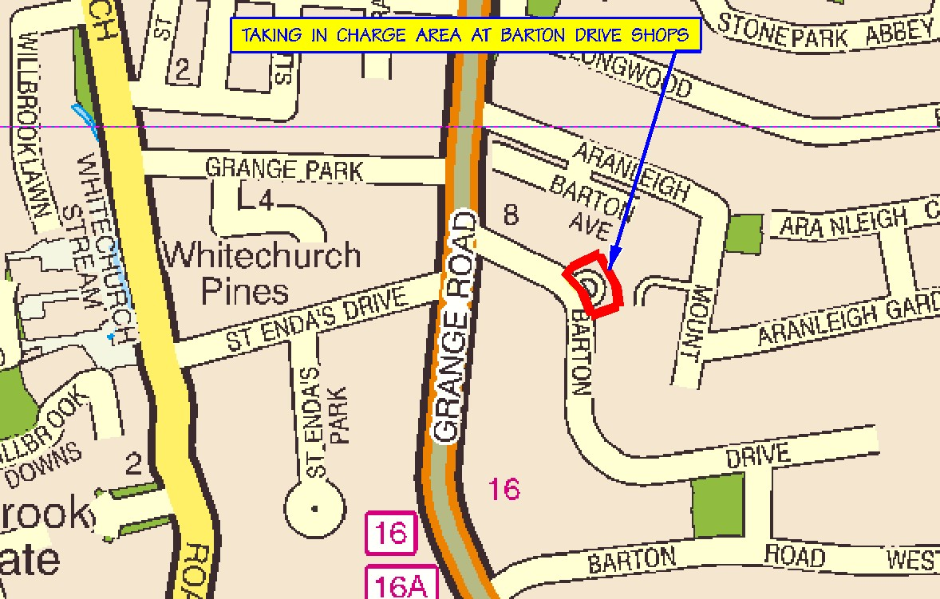

It was proposed by Councillor C. Keane, seconded by Councillor M. Ardagh and AGREED:

“That this Committee recommends that South Dublin County Council declare the roads at Barton Drive Shopping Centre Car Park, as set out in the above report to be public roads.”
TR/852/07 TRAFFIC CALMING PROGRAMME (2)

HEADED ITEM (5) Item ID: 13001

Traffic Calming Programme 2
“The present position on Traffic Calming Programme (2) is as follows:-
Schemes selected to date.
1. Moyville/Pearse Brothers/Palmer Park/Whitechurch/Glenmore Park & Grangebrook.
Present position:- Traffic Calming Scheme to be designed.
2. Dangan/Shelton/Muckross/Hillsbrook and Fernhill.
Present position:- Traffic Calming Scheme to be designed.
There are two further Traffic Calming Schemes to be selected.
The selection of these further Traffic Calming Schemes is now before the Committee.”
It was AGREED to defer selection of the two remaining schemes to early in the new year.

Bottom of Form

TR/853/07 RIGHT TURN BAN SPRINGFIELD AVENUE

HEADED ITEM (6) Item ID: 12911

RIGHT TURN BAN SPRINGFIELD AVENUE
“The traffic section has completed its findings of the analysis of the Templeogue Road and Springfield Avenue junction. Two scenarios as follows were tested.
(1) Existing layout, right turn ban to Springfield Avenue in place, with a bus lane / left turn lane and a straight ahead lane provided.
(2) Right turn permitted and lanes altered thus: a combined ‘bus lane, left turn lane and straight ahead lane’ and right turn lane.
Comparison of the results for the existing and modified junction showed the following:
- The provision of a right turn lane would confine all the other traffic (left turning, straight ahead and bus traffic) into one lane.
- There would be less straight ahead and left turning traffic accommodated at the junction. This would result in traffic queueing back into Templeogue village.
- Journey times for buses would be increased due to additional congestion in the village.
- A new phase is required to permit the traffic to make the turning movement removing ‘green time’ from the remaining movements.
- The provision of the right turn would increase the amount of traffic using Templeogue Village in order to access the turn.
- The associated congestion would have a negative impact on the environment of the village.
In summary in light of the above, it is recommended that the right ban is retained.
Analysis
The data fort this report was analysed on two models, firstly a network model was used to calculate the effect the removal of the right turn ban would have on traffic flows and the potential demand for the turn. This model provided a data set for the junction analysis which looked more closely at signal operation for the two models.
Network Model
The network model used to calculate the traffic flows is the same model the DTO use for modelling changes in the Dublin road network.
“5 Conclusions
5.1.1 The Local Area Traffic Model developed for South Dublin County Council was used to assess the removal of the right-turn ban from Templeogue Village onto Springfield Avenue. SATURN is a predictive modelling tool and uses an ‘equilibrium’ technique based on an optimum combination of all-or-nothing assignments, so that for a given Origin-Destination pair a range of routes is normally used but each has the same minimum Origin-Destination cost.
5.1.2 The output from the model has used the Pessimistic matrix in the assessment works as it best met the counties employment scenario. This is based on a slower rate of growth in the South Dublin Region in terms of employment and population.
5.1.3 The analysis of this option was undertaken based on a comparison of traffic flows around Springfield Avenue, via network wide summary statistics from the traffic model and select link analysis techniques. The option has been compared against the 2016 DM network.
5.1.4 Option DS1 reduces the actual flow on Templeogue Road to the north east of the Templeogue Road/Templeville Road/Springfield Avenue junction and increases traffic levels on Springfield Avenue itself.
5.1.5 The overall results demonstrate that the implementation of the removal of the right turn ban would have a negative impact on the overall network performance. There is a deterioration in the overall network performance equating to an additional 171 pcu hrs of overall network travel time and 516 km of overall travel distance in the network in the one hour period modelled.
5.1.6 A select link analysis has been carried out on the right turn from Templeogue Road to Springfield Avenue which shows that 169 vehicles could potentially use this right turn if the existing ban was removed. This equates to approximately 19% (169 of 896 vehicles) of the total eastbound flow on Springfield Avenue.
5.1.7 It is recommended that the removal of the right turn ban at the Templeogue Road/Templeville Road/Springfield Avenue junction is assessed more fully using the appropriate traffic signal program. This will have the effect of optimising the signal timings which should avoid the increases in traffic flows on Wainsfort Road and Fortfield Road that the SATURN model is predicting.
5.1.8 From a SATURN traffic forecasting viewpoint the removal of the right turn ban from Templeogue Road onto Springfield Avenue shows an increase of 66 vehicles between the DM and DS1 options however the total level of traffic that could potentially use the right turn if the ban was lifted is 169 vehicles. The difference is due to the fact that a redistribution of traffic occurs across the network when the ban is removed.
5.1.9 SDCC will have to come to a view on whether to proceed with the removal of the right turn ban after taking into account other factors that may come into play regarding the increase in flows on Springfield Avenue e.g. increase in noise and pollution levels and also whether a right turn lane can be provided without prejudicing bus priority and straight ahead traffic movements.”
Junction Model
From the network model the signals were analysed for an increase of 19% in traffic volume representing the right turning traffic. This was compared to a current scenarios model of the junction.
For the existing arrangement the PRC (practical reserved capacity) for the junction is 23%, this indicates the junction works within its capacity. If the PRC drops below 10% the junction is considered to be congested as it will tend to block approaching traffic.
For removal of the ban and the introduction of the right turn lane and signal the PRC dropped to -14% (minus 14%) i.e. the traffic demand exceeded the theoretical maximum capacity for this junction. The model reports the traffic needs to be reduced by 16% for the junction to operate
“Unable to find a cycle time for which the junction is within capacity because the junction is heavily overloaded.
Flows must be reduced by 16 percent.””
Scenario 1
Bottom of Form
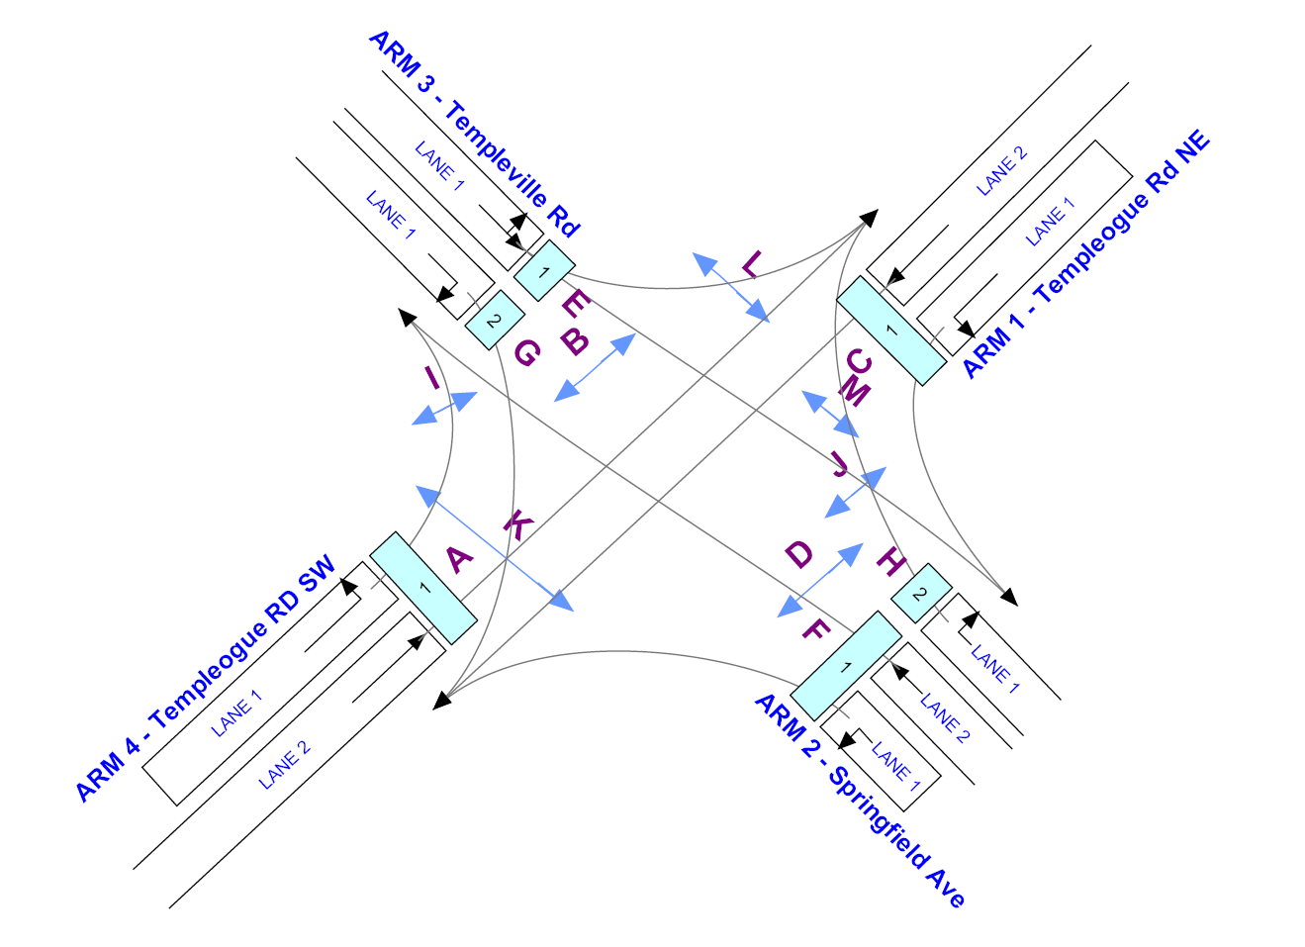

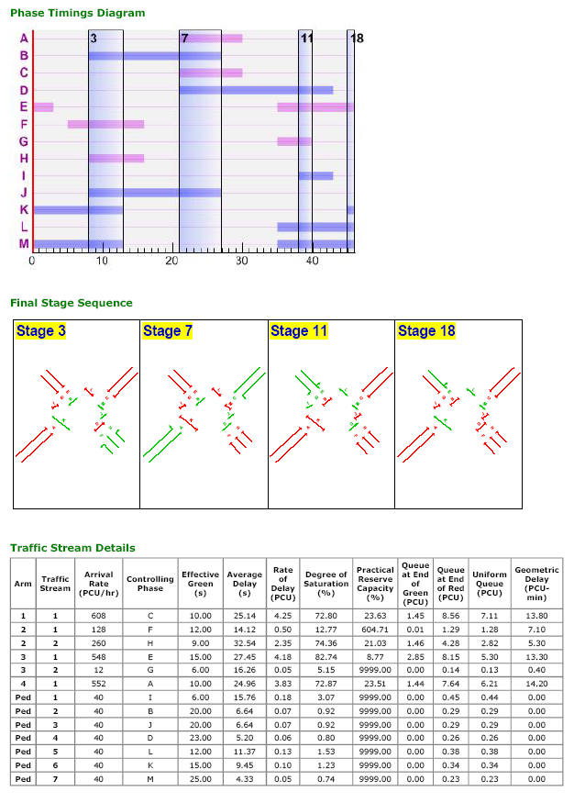
Scenario 2

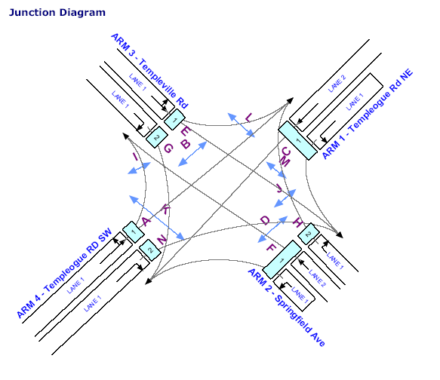

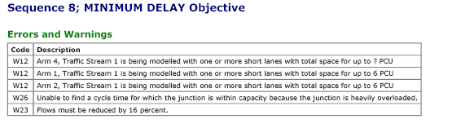
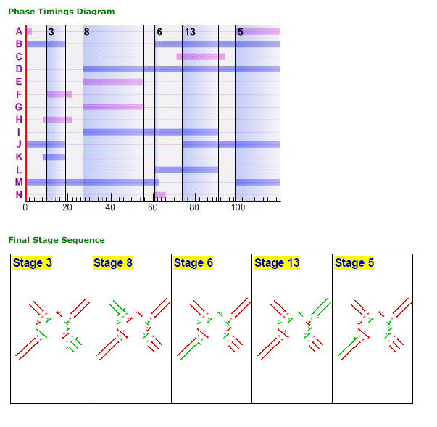
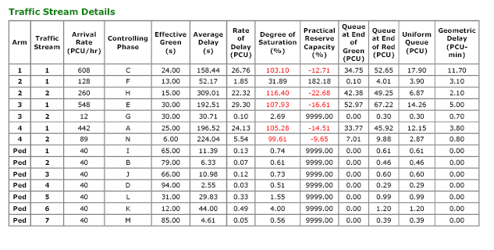
Mr. A. O’Mullane, Senior Executive Engineer presented the report. Following contributions from Councillors T. McDermott, C. Keane, M. Ardagh and S. Laing, Mr. A. O’Mullane responded to queries raised and the report was NOTED.

TR/854/07 PROPOSED EXTINGUISHMENT OF PUBLIC RIGHT OF WAY

HEADED ITEM (7)

Proposed Extinguishment of Public Right of Way Item ID: 13044

Proposed Extinguishment of Public Right of Way at rear of
34, St Peter's Drive, Greenhills, Dublin 12. Map Ref: RE 0615
The following report was considered at the Terenure/Rathfarnham Area Committee Meeting on Tuesday 6th March, 2007.
“An application has been received from Development Department and the resident of 34 St Peter’s Drive, Greenhills to formally extinguish the public right-of-way at rear of 34 St Peter’s Drive, Greenhills, due to antisocial behaviour and to affect the closure by means of incorporation into their gardens.”
Following consideration of the report, it was agreed to initiate the procedure.
The proposal to extinguish the public right-of-way was advertised in the Echo on Thursday, December 7th, 2006 and signs were erected on site in accordance with Section 73 of the Roads Act, 1993. The latest date for receipt of objections, representations and requests for an oral hearing was Friday 9th February, 2007.
The following is a breakdown of the submissions received in response to the public advertisement/notice:-
Objections 6
Request for Oral Hearing 6
The committee granted the request for an Oral Hearing at its meeting held on 6th March, 2007.
Mr Joe O’Gorman (former Planning Inspector) was appointed to conduct the Oral Hearing in respect of the proposed extinguishment and the said Oral Hearing took place on Monday 2nd July, 2007. See attached Mr O’Gorman’s report for consideration.
Bord Gais, Eircom and NTL have stated that they have no objections to the proposed extinguishment.
ESB has no objections to the proposed extinguishment.
Public Lighting Section has no objection to the proposed extinguishment.
Water & Drainage Sections have no objections to the proposed extinguishment.
The decision regarding the extinguishment of a public right-of-way and the granting of an oral hearing is a reserved function of the Council.
Any recommendation of the Committee will be brought to the attention of the Council.”

Bottom of Form

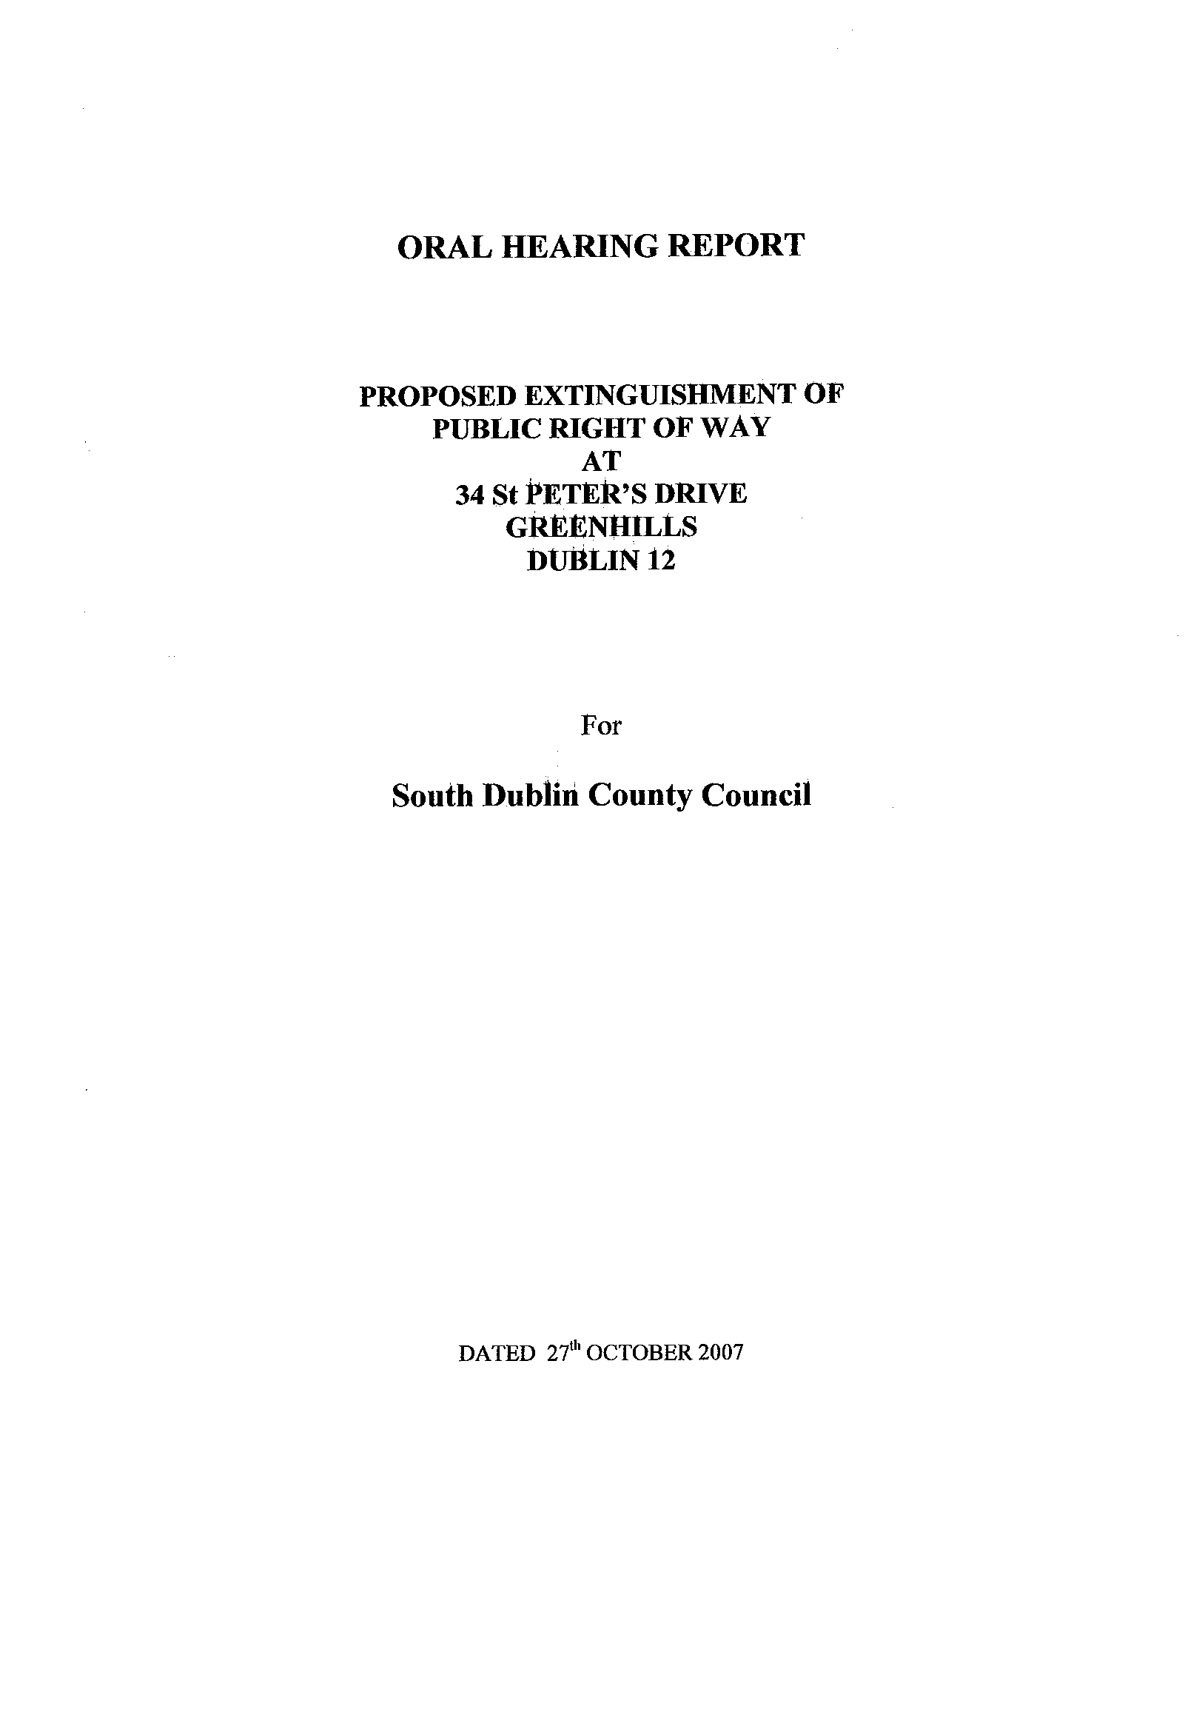
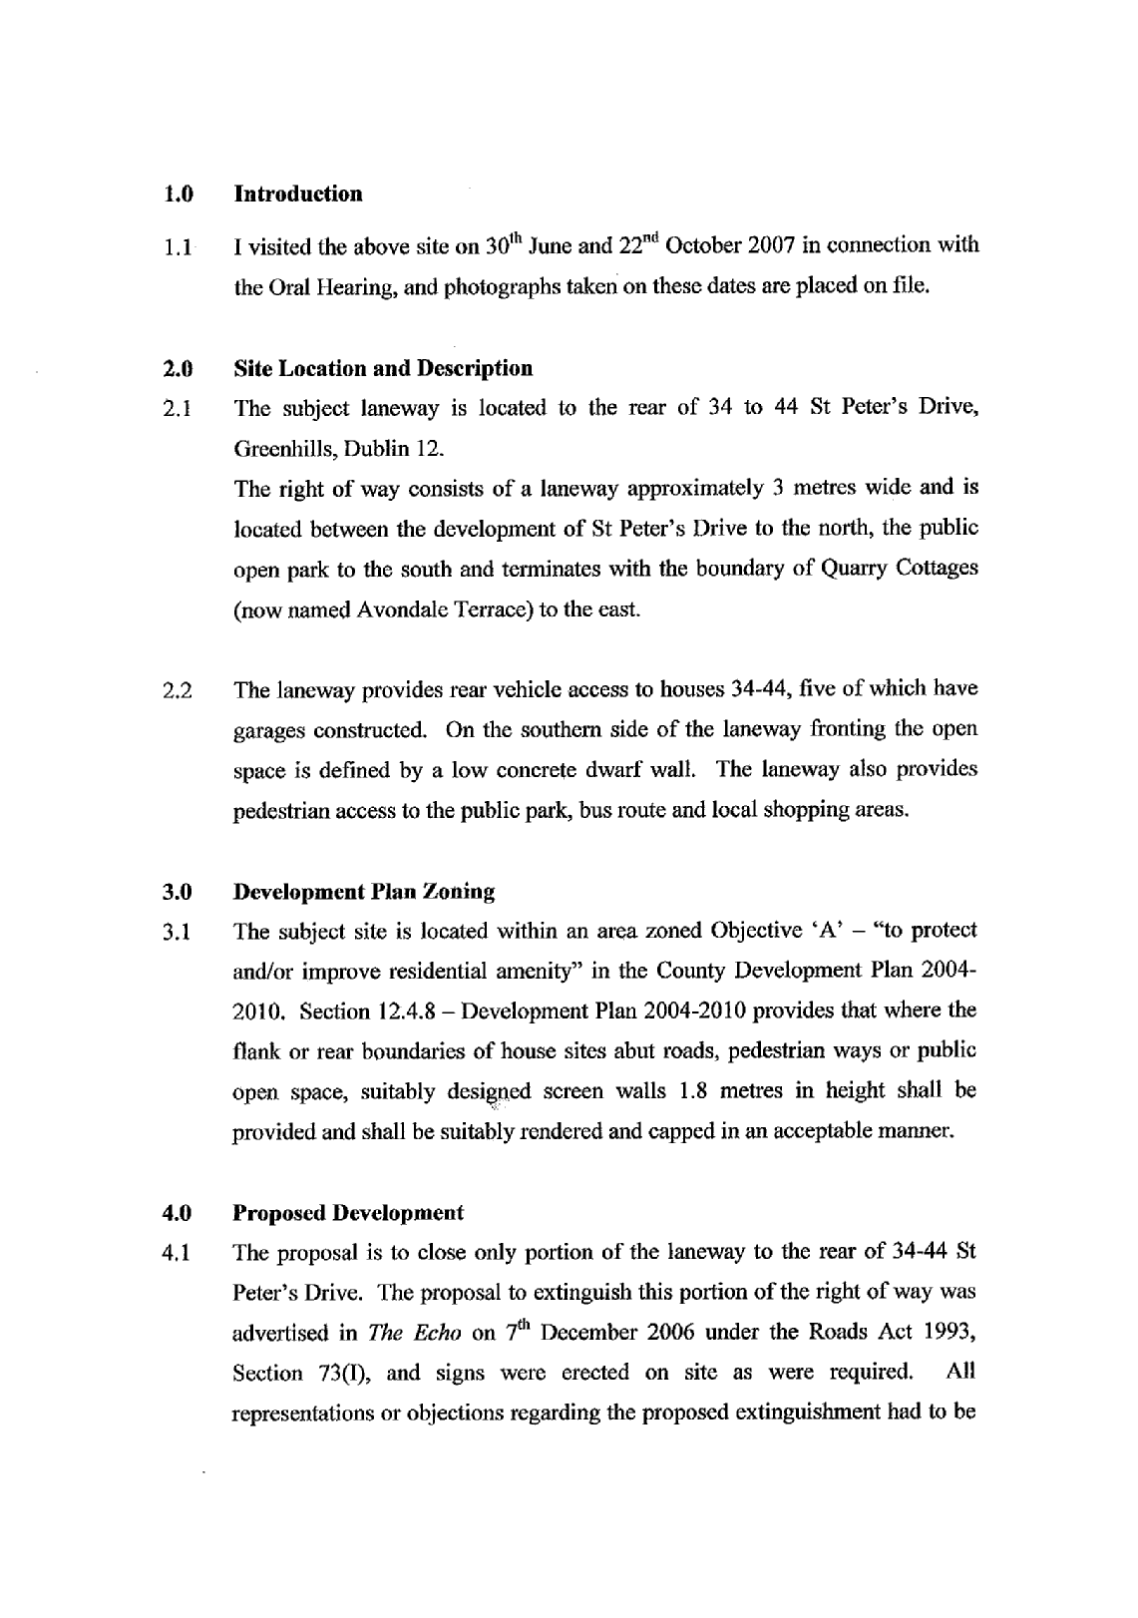
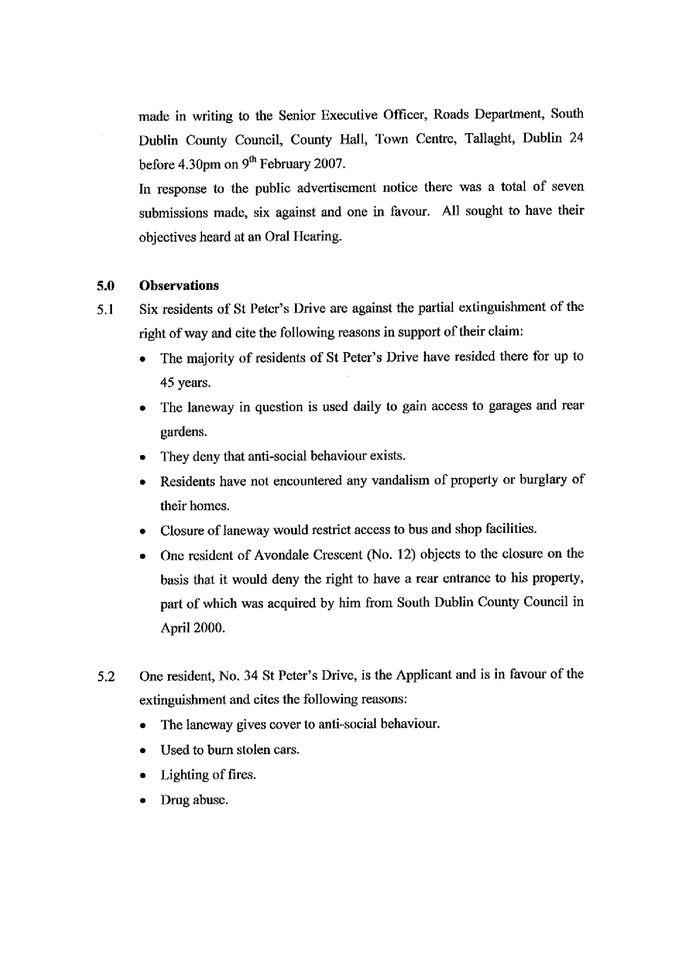

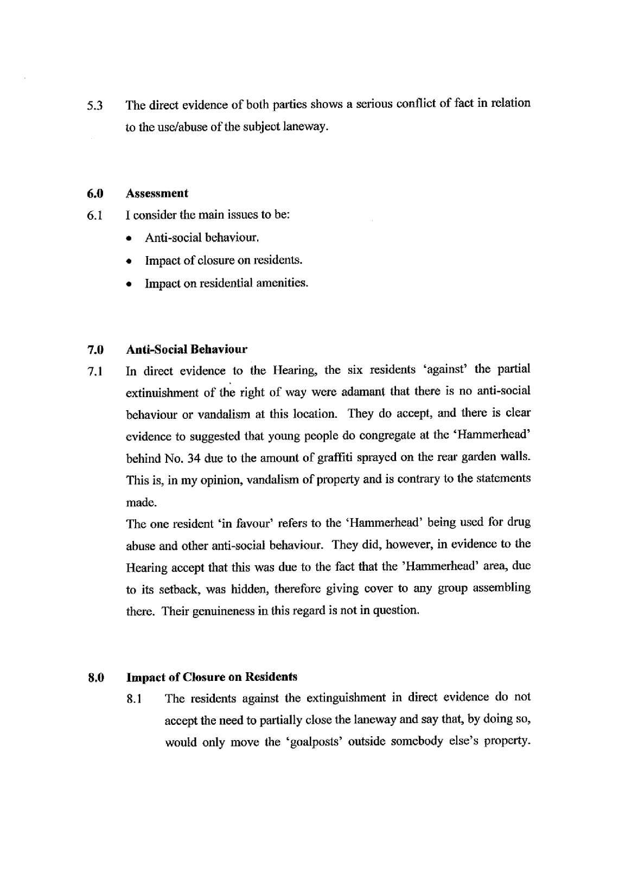
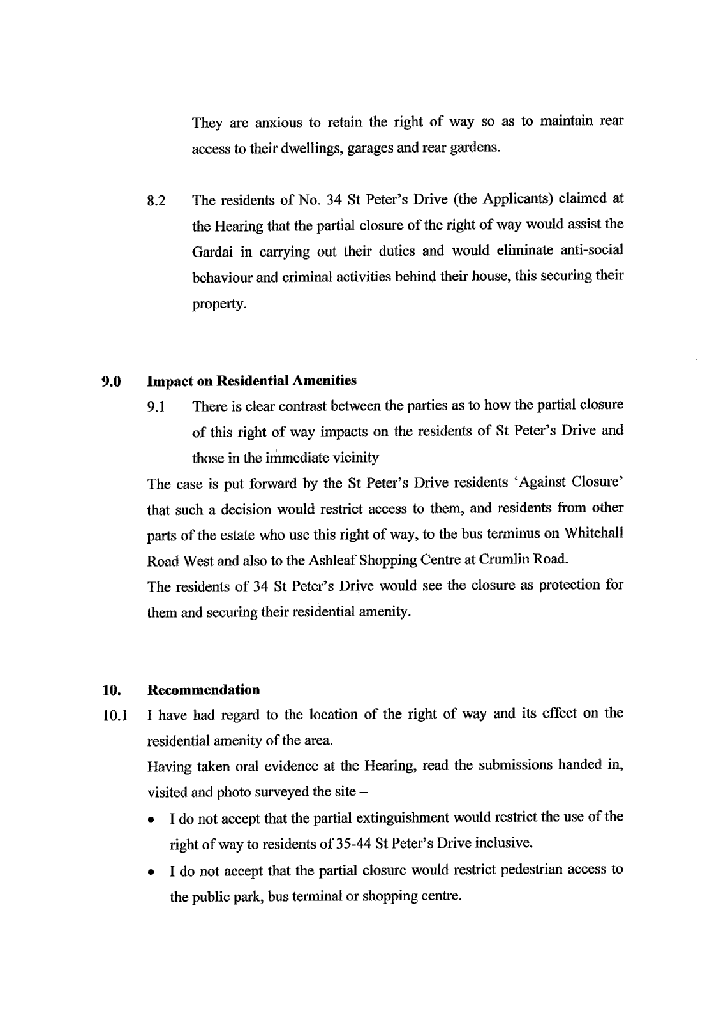
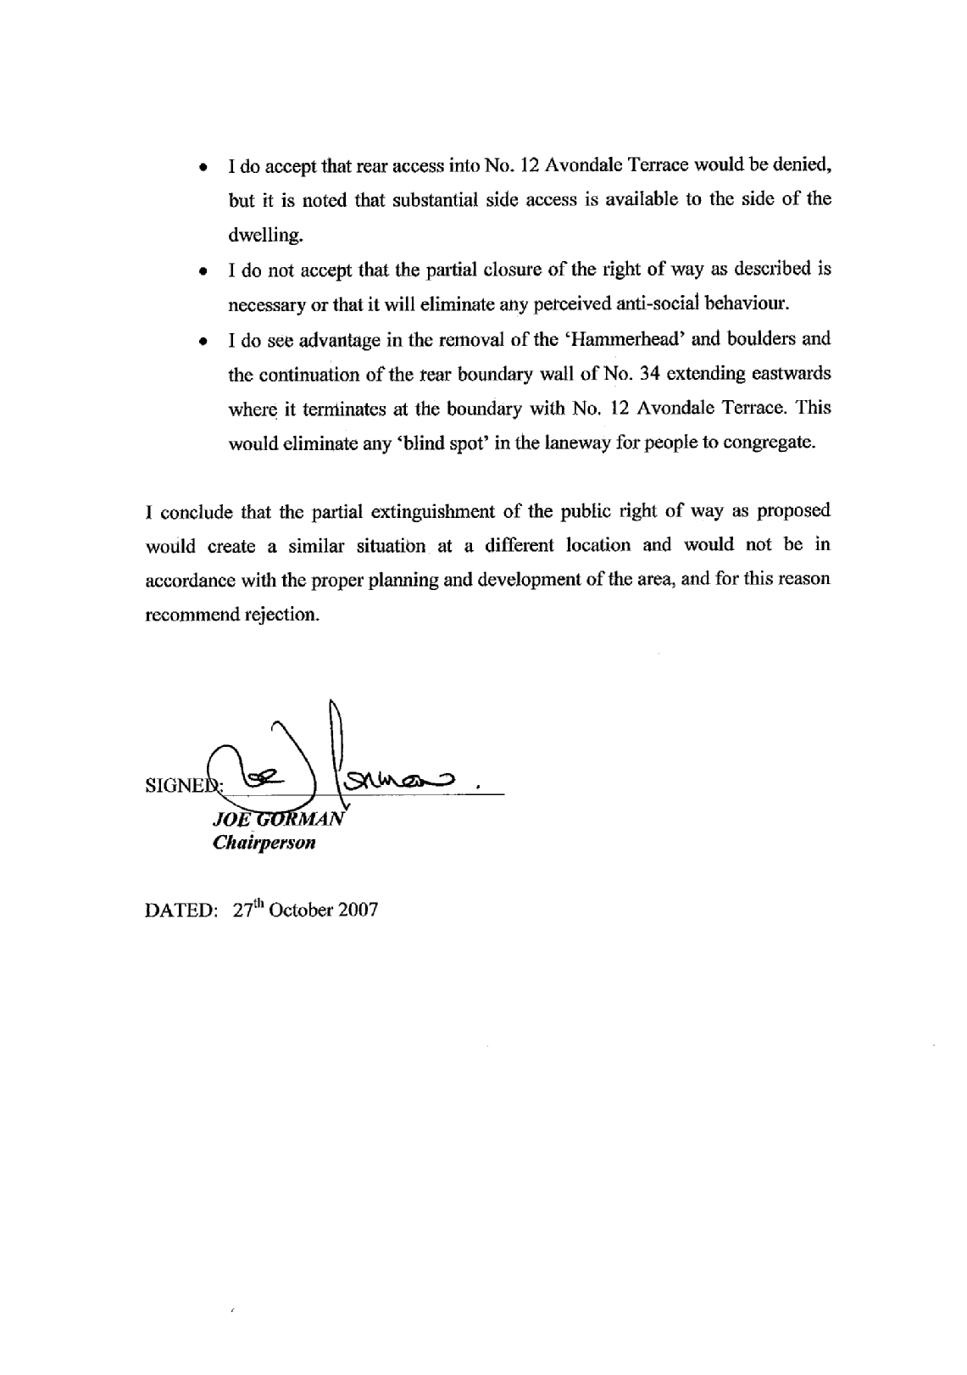

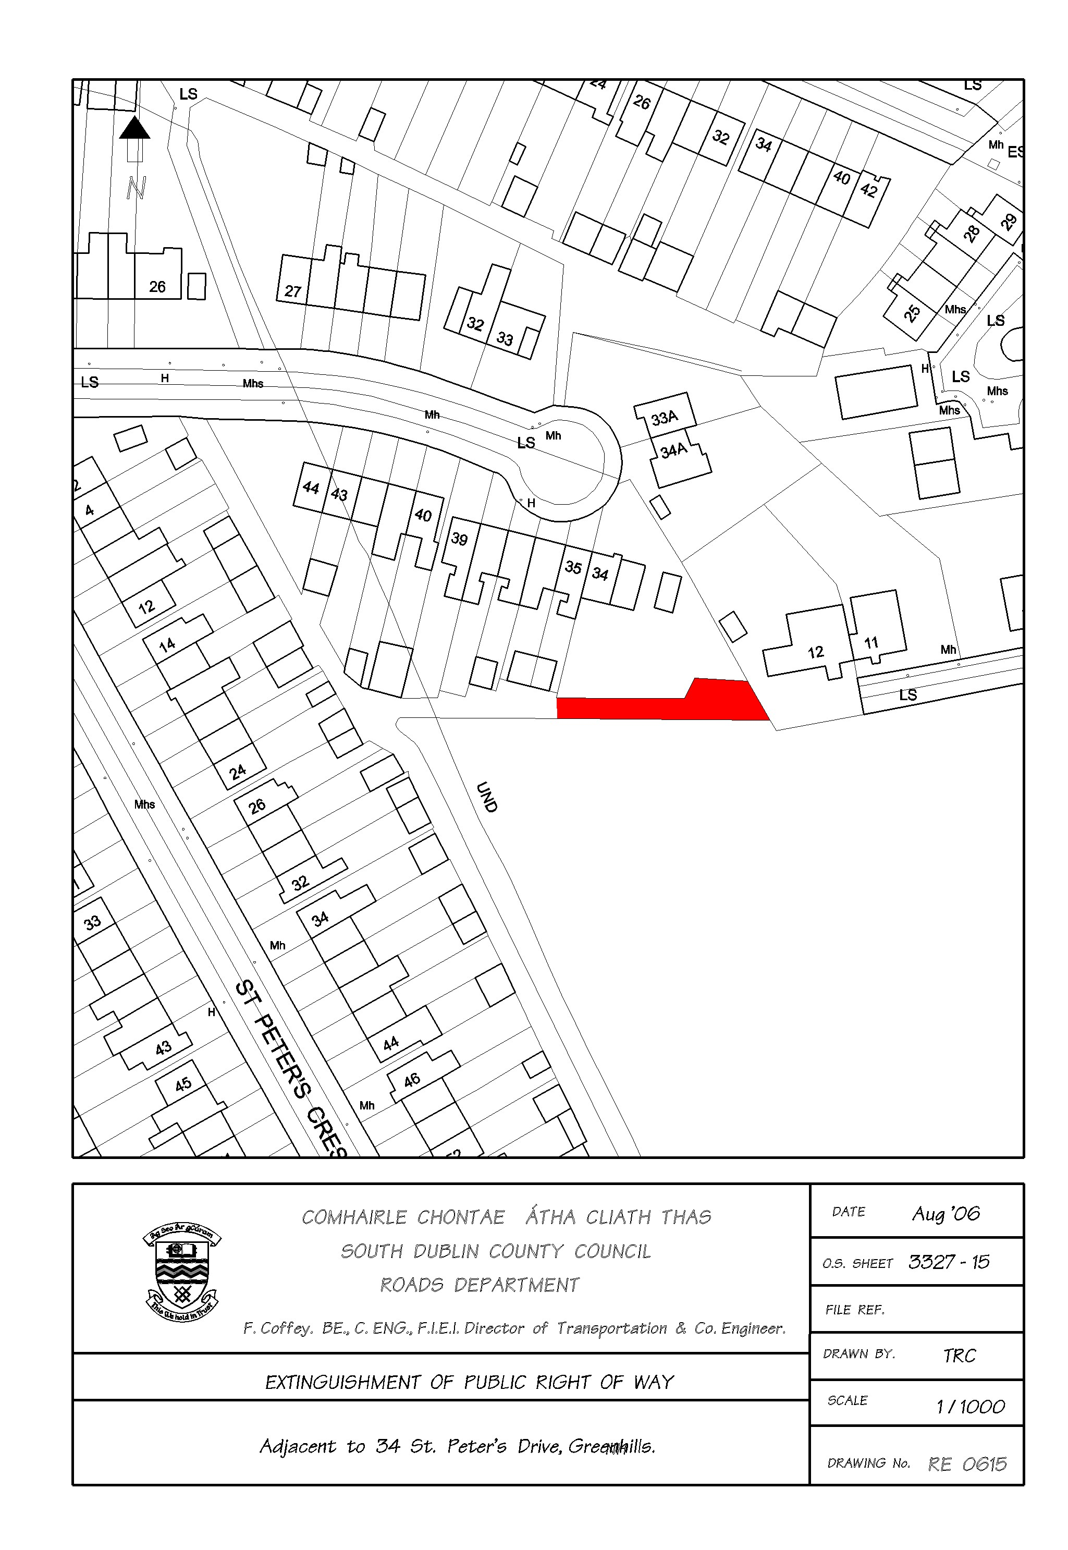

Mr. T. O’Grady, Senior Engineer presented the report. Following contributions from Concillors T. McDermott and C. Keane it was AGREED that the Development Department discuss the extinguishment of that portion of the hammerhead immediately to the rear of 34 St. Peter’s Drive with the applicant and present a further report to a future meeting of this Committee.

TR/855/07 NEW WORKS

HEADED ITEM (6) Item ID: 12423
It was NOTED that there was no business under this heading.
Bottom of Form

TR/856/07 CORRESPONDENCE
COR (3) Item ID: 12424
Letter 12th November 2007 to Dublin Bus

Mr. Paddy Doherty
Business Development Manager
Bus Atha Cliath/Dublin Bus
59 Upper O’Connell Street
Dublin 1

12th November 2007

At the Terenure/Rathfarnham Area Committee Meeting of 6th November 2007 the following Motion was passed by the elected members.
"That this Committee calls on Dublin Bus to re-instate a bus link between Whitechurch Estate and Rathfarnham Village and that Dublin Bus should examine linking the Ballyboden area of SDCC with Tallaght Town Centre."
I would be obliged if you could examine this matter and let me have a reply as soon as possible.
Yours sincerely,

N. Fitzgibbon
Staff Officer
Roads Department
nfitzgibbon@sdublincoco.ie

The above correspondence was NOTED.
TR/857/07 Cathaoirleach's Business – 2 TO 16 HILLSBROOK AVENUE

MOTION (4) Item ID: 12910
It was proposed by Councillor S. Laing and seconded by Councillor C. Keane

"That the Manager give a full detailed Report as to when the proposed improvement works will be carried out on the frontage of No.2 to 16 Hillsbrook Avenue as requested by me some years ago and which approval was granted and to state if the Residents have been contracted."

The following report by the Manager was READ:
“A proposal has been drawn up which involves the construction of an access road in front of the houses in question. A copy of the plans has been circulated to the residents for their comments. Some comments have been received from individual residents which have requested changes to the scheme, some of which are not practical. However, the scheme is currently being reviewed. A meeting will be arranged with the residents to progress the scheme.”
Following contributions from Councillors, S. Laing, C. Keane and M. Ardagh, Mr. M. Glynn, Senior Executive Engineer responded to queries raised and the report was NOTED. It was AGREED to discuss proposals with the local residents and to present a further report on this issue to a future meeting of this Committee.

Bottom of Form

TR/858/07 TRAFFIC AT CRUMLIN CROSS

MOTION (5) Item ID: 12907
It was proposed by Councillor M. Ardagh and seconded by Councillor T. McDermott

"That the Manager re-examine the sequencing of traffic at Crumlin Cross. Motorists do not have sufficient time to make a right hand turn from St. Agnes Road to Cromwellsford Road and are fearful that accidents will occur as neither the motorists or pedestrians are best served by the current sequencing. (Ref: Motion 7, TRAC, March 6th, 2007)."

The following report by the Manager was READ:
“Work is in hand to change the sequence of the signals at the above junction such that each of the side roads will operate separately. In effect, traffic exiting St. Agnes Road will be shown a full green light and a right turn arrow at the same time and will not be held up waiting for a gap in opposing traffic.
It is expected that the above work will be completed in the next three weeks, following which, monitoring of the new arrangements will be ongoing.”
Following contributions from Councillors M. Ardagh and C. Keane, Mr. A. O’Mullane, Senior Executive Engineer responded to queries raised and the report was NOTED.
Bottom of Form

TR/859/07 PARKING PEARSE BR. PARK & PALMER PARK

MOTION (6) Item ID: 12908
It was proposed by Councillor C. Keane and seconded by Councillor M. Ardagh

"That this Committee recommends that we discuss with the aid of plans the proposed parking provision at Pearse Br. Park and Palmer Park, this has been ongoing for some years and some of the elderly residents - are having great difficulty exiting/access to residences, this is not acceptable. Ensuring that plans are agreed with residents association prior to execution as previous plans as drawn up were totally unacceptable."

The following repot by the Manager was READ:
“Extensive consultation has taken place in relation to the provision of parking in Pearse Brothers Park and Palmer Park. Numerous meetings were held between Roads staff and the resident's association including February 1, May 29 and October 9th, 2007. Earlier plans as proposed by the Council and rejected by the residents have been altered and acceptance / agreement was reached on the remaining areas. Works commenced on site in September 2007 and were completed in November.
It should be noted that the parking facilities provided exceed what was shown in the approved Ballyboden Area Plan. A total of 43 additional parking spaces were provided overall in addition to other works- footpaths, paving, landscaping etc.”
Bottom of Form

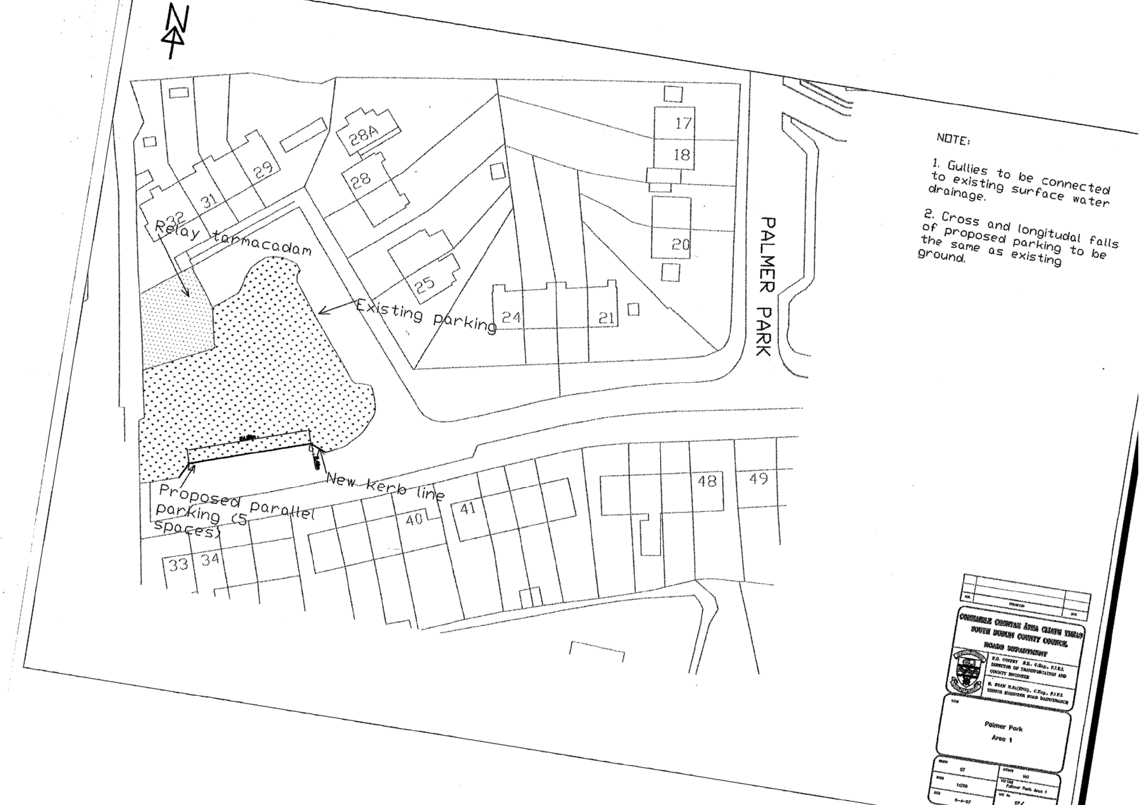

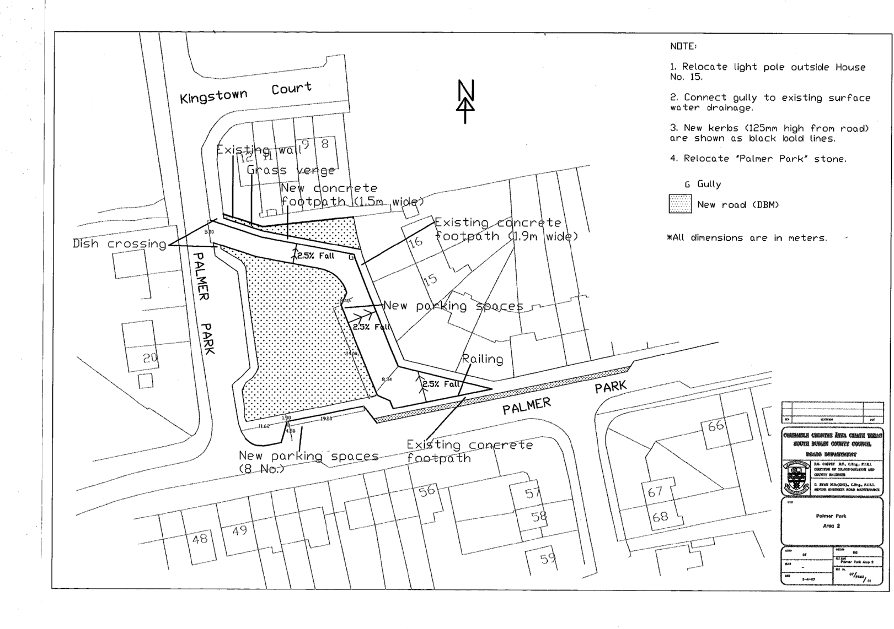

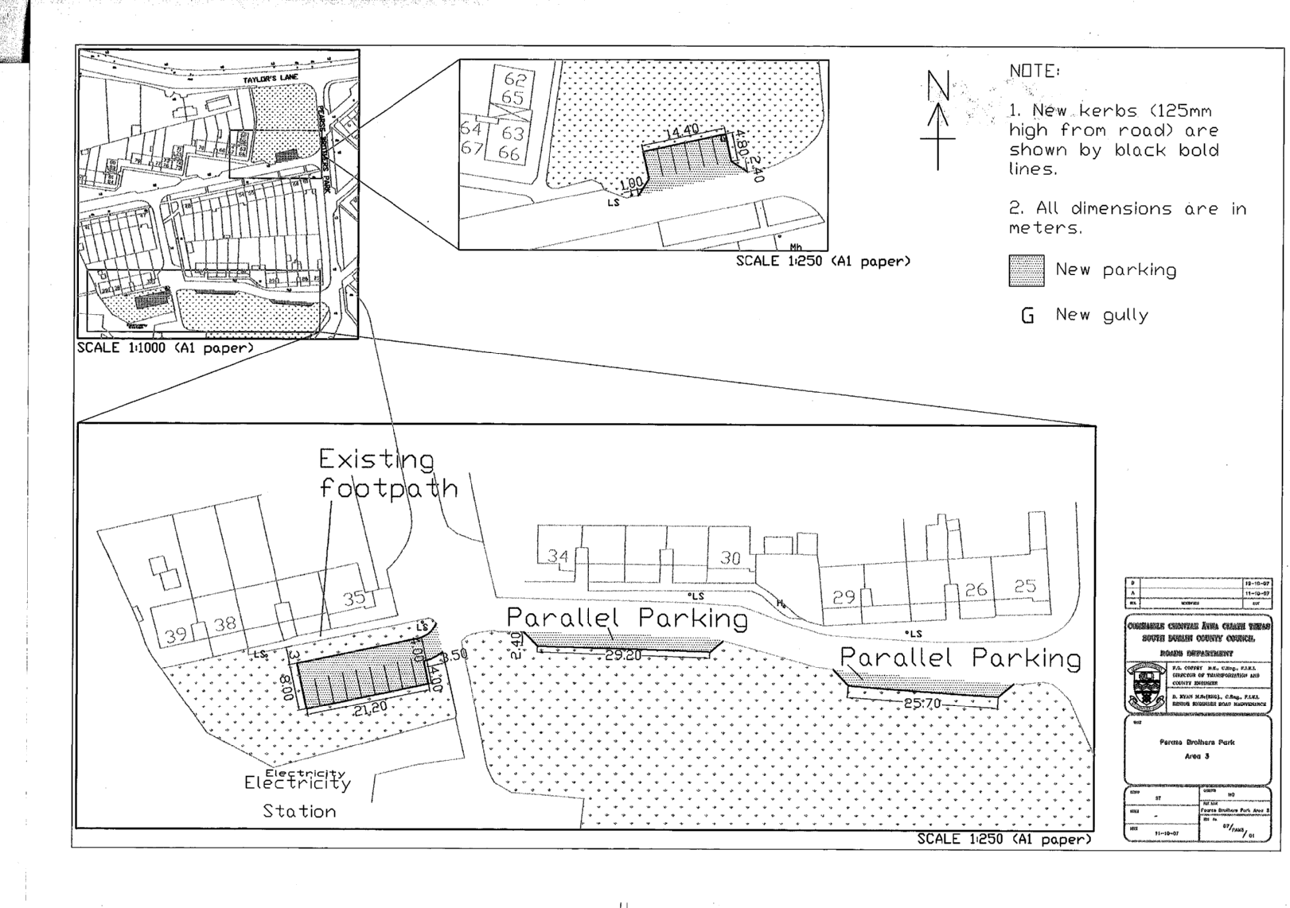
Following contributions from Councillors C. Keane and S. Laing the report was NOTED.

TR/860/07 PARKING ON WAINSFORT CRESCENT

MOTION (7) Item ID: 12909
It was proposed by Councillor M. Ardagh and seconded by Councillor S. Laing

"That the Manager examine the situation pertaining on Wainsfort Crescent in relation to students from the adjacent college parking their cars all day on this narrow residential road. Every week the bin men leave notices on the students' cars asking them not to park on the road on bin day. Approaches have been made to the school to provide parking for their students on the school grounds and a suggestion made that alternative parking should be sourced at St. Mary's Rugby Club opposite the school. Residents are being inconvenienced by cars blocking the road and services not gaining access?"

The following report by the Manger was READ and NOTED:
“The problem on this public road, and on many other similar roads in estates throughout the County, arises because the existing width of the carriageway between kerblines is insufficient to simultaneously allow free passage of all vehicles and permit parking on both sides. This problem has intensified in recent years with the growth in the number of vehicles using the roads. Putting Single yellow or Double yellow lines on one side of such roads would improve the passage of through traffic, which is an ongoing serious problem in itself, but would subsequently ban or only allow restricted parking on the road for everybody which would also seriously inconvenience residents. Unfortunately, as a public road, there is no ready-made solution to this problem.
The above parking problem was discussed at length at the Traffic Management Meeting of 22nd November 2007 at which it was agreed that:-
a) the Road Safety Officer be asked to visit the school concerned in order to highlight the parking issues,
b) the matter be placed on the Agenda of the next Strategic Policy Committee Meeting.”
Bottom of Form

TR/861/07 GRASS VERGES ORLAGH GROVE

MOTION (8) Item ID: 10040

The following in the name of Councillor J. Lahart was NOT MOVED

"That the Manager take action in relation to the grass verges on Orlagh Grove Road which have been churned up by cars and that the Manager examine the possibility of parking bays on Orlagh Avenue."

TR/862/07 PUBLIC LIGHTING ON WAINSFORT ROAD

MOTION (9) Item ID: 12526
It was proposed by Councillor M. Ardagh and seconded by Councillor C. Keane

"That the Manager include funding in this year's estimates for the upgrading of public lighting on Wainsfort Road, Avenue, Park and College Park."

The following report by the Manger was READ:
“A new public lighting installation will be implemented on Wainsfort Road complete with new underground cabling in 2008,if adequate funding is made available outside the normal public lighting budget ie. capital grant for structural column replacement.
It is not the intention of the Section to change the lighting installation on Wainsfort Avenue or College Park. However, lighting in Wainfort Park will be ugraded with pole numbers 5 to 8 inclusive on the ESB overhead network being replaced with 8 No. columns on the opposite green area.”
Following contributions from Councillors M. Ardagh, C. Keane and S. Laing, Mr. T. O’Grady, Senior Engineer responded to queries raised and it was AGREED to present a further report on the location of the new lighting columns to a future meeting of the Committee.
Bottom of Form

TR/863/07 CONNECTION OF KNOCKLYON/BALLYCULLEN WITH TALLAGHT LUAS LINE

MOTION (10) Item ID: 10387

The following in the name of Councillor J. Lahart was NOT MOVED

"That this Committee recommends that the Manager facilitate discussion between local developers and RPA to sponsor the connection of Knocklyon/Ballycullen with the Tallaght LUAS line."

Planning

TR/864/ QUESTIONS

It was NOTED that there was no business under this heading.

TR/865/07 PLANNING FILES

HEADED ITEM (9) Item ID: 12425

Planning Files A. Large applications under consideration
B. Files requested by members

It was NOTED that there was no business under this heading.

TR/866/07 BUILDERS YARD MUCKROSS AVENUE

HEADED ITEM (10) Item ID: 12929

BUILDERS YARD MUCKROSS AVENUE
“As the members are aware the Council’s Planning Department has for some time now been investigating the builder’s yard at Muckross Avenue with a view to ascertaining whether or not it is in breach of the planning laws, and if enforcement action is warranted.
The file on this matter was referred to a barrister, Mr. Damian Keaney, B.L., for advice on the matter.
Mr. Keaney has summarised the situation as follows:
1. A builder’s yard/ depot has been in operation at this location since the 70s, and therefore there is an established use at this location.
2. During the 1980’s, the builders yard was acquired by Chatham Pipelines. Enforcement action for unauthorized change of use was taken by the then Dublin County Council, but was ultimately unsuccessful as An Bord Pleanala ruled that no material change of use had taken place.
3. In April 2005, the premises were leased by SLM Builders Providers. It is suggested that since then, the premises has been used as builder’s providers, either wholesale or retail. SLM deny that any material change of use has occurred.
Mr. Keaney went on to advise that in order to take an action in a case of this kind, the Council must establish two things;
- Firstly that a change of use has taken place and
- Secondly, that such change of use is material.
In this instance, evidence that any change of use has taken place is scant, amounting to nothing more than a copy of an advertisement from a local newspaper and one receipt.
Nontheless, if the Council is to proceed, substantial evidence that the change of use is material would have to be provided. Mr Keaney has advised that to do this, it would be necessary to demonstrate that the amenity of local residents has been significantly adversely affected by the operation of the yard in recent years. This could best be provided by way of sworn evidence from local residents, testifying to the extent to which matters have worsened since SLM began leasing the premises.
A letter to this effect has issued to the complainants, which also advises that if they feel that they are in a position to provide evidence to assist in substantiating that a material change of use has taken place,the Council would be happy to hear from them with a view to discussing how to proceed.
Unfortunately however, without such evidence the Council cannot proceed any further with this matter, at this time.
Also it should be noted as previously indicated to the members it is not possible to acquire these lands by Compulsory Purchase Order under the Derelict Sites Act as they site is not deemed to be a derelict site within the meaning of the Act.
However, the Council’s Valuer was instructed to commence negotiations with the owners of the site to purchase the land in question. The Council’s Valuer has written on a number of occasions to the owner, but to date no response has been received indicating the owners willingness to dispose of the site to the Council.
The Housing Department has indicated that given the estimated site value as given by the Valuer, and the likely number of homes that could be permitted on the site, that the acquisition of the site for the provision of social/affordable housing is not considered a viable option either by Compulsory Purchase Order or agreed purchase.”
Following contributions from Councillors T. McDermott, C. Keane, M. Ardagh and S. Laing, Mr. M. Judge, Senior Executive Officer responded to queries raised and the report was NOTED.
Bottom of Form

TR/867/07 NEW WORKS

HEADED ITEM (11) Item ID: 12426
It was NOTED that there was no business under this heading.

TR/868/07 CORRESPONDENCE

CORRESPONDENCE (4) Item ID: 12427
It was NOTED that there was no business under this heading.

TR/869/07 Cathaoirleach's Business

MOTION (11) Item ID: 12901
It was NOTED that there was no business under this heading.

TR/870/07 PLANNING NOTICES

MOTION (12) Item ID: 12716

The following in the name of Councillor J. Lahart was NOT MOVED

"That, not withstanding a previous motion and answer on the subject, this committee reviews the procedure for planning notices with the Terenure Rathfarnham area with particular regard to planning notices hidden from adjoining or adjacent residential areas on which these applications have a material impact."

The meeting concluded at 4.30 p.m.

Siniú ________________ Dáta ________________
An Cathaoirleach

