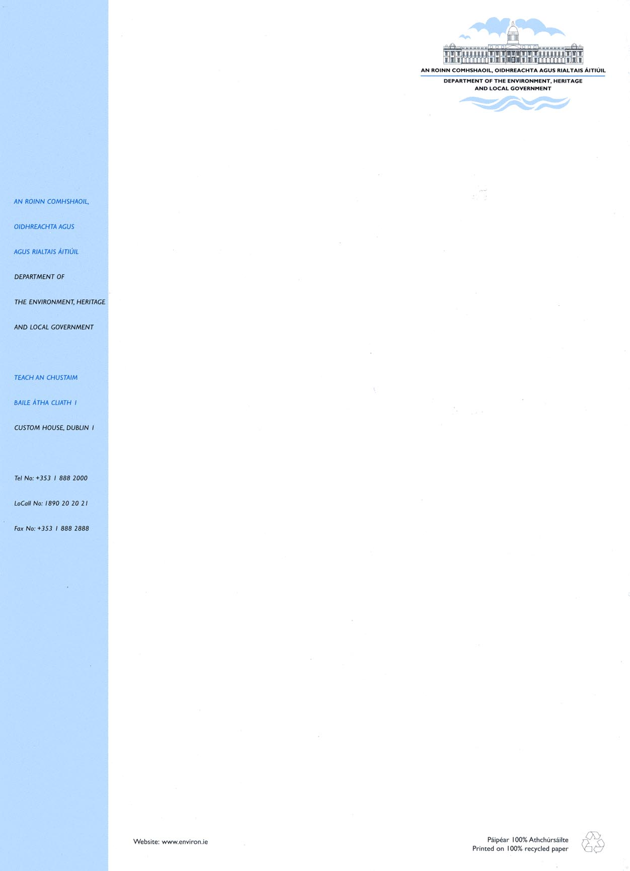
4 October 2007

SIU 4/07

To each Director of Housing

Re: Housing Adaptation Grant Schemes for Older People and People with a Disability

I am directed by Mr. Batt O’Keeffe, T.D., Minister for Housing, Urban Renewal and Developing Areas, to refer to the Disabled Persons and Essential Repairs Grant Schemes administered by local authorities in accordance with the legal framework laid down in Section 6 of the Housing (Miscellaneous Provisions) Act, 1979 and the statutory Regulations made under that Act.

The enclosed Housing (Adaptation Grants for People with a Disability and Older People), Regulations 2007 [S.I. No: 670 of 2007] consolidate and revoke the previous Regulations dealing with these schemes – Housing (Disabled Persons and Essential Repairs Grant) Regulations, 2001 (S.I. No. 607 of 2001).

The new Regulations make legal provision for the introduction of a revised framework of grant aid as follows:

- a Housing Adaptation Grant Scheme for People with a Disability which will assist with the provision/adaptation of accommodation to meet the needs of people with a disability;

- a Mobility Aids Housing Grant Scheme, which will assist with adaptations to address mobility problems primarily associated with ageing;

- a scheme of Housing Aid for Older People, which will provide targeted support to improve conditions in the existing housing of older people;

- standardisation of means testing;

- indexation of grant levels and income bands;

- increase in the recoupment rate to local authorities to 80% in respect of individual grants; and

- streamlining of arrangements in respect of Occupational Therapy assessment.

Implementation Date
The new framework of grant aid will become operational on 1 November 2007. Applications for grant aid received prior to 1 November 2007 will be processed under the terms and conditions of the authority’s Disabled Persons and Essential Repairs Grant Schemes.

Transfer of Special Housing Aid for the Elderly Scheme to the Local Authority Sector
The new scheme of Housing Aid for Older People, which will become operational from 1 November 2007, implements the Government Decision to transfer the Special Housing Aid for the Elderly Scheme from the Health Service Executive to the Local Authority sector, by amalgamating the provisions of the existing Essential Repairs Grant and the Special Housing Aid for the Elderly Schemes.

In order to facilitate transitional arrangements, it has been agreed with the Health Service Executive that the Special Housing Aid for the Elderly Scheme will continue to operate, and be administered by the Health Service Executive until 31 March 2008. From 1 April 2008, the Special Housing Aid for the Elderly Scheme will cease operation (except for the processing of applications on hand as of 31 March 2008) and all future applications for grant aid will be processed by the local authorities under the Housing Aid for Older People Scheme.

Further guidance regarding the operation and administration of the Housing Aid for Older People Scheme, following the cessation of the Special Housing Aid for the Elderly scheme, will issue to local authorities in due course.

Administrative Guidance
Administrative guidance underpinning the operation of the new schemes and a copy of the Housing (Adaptation Grants for People with a Disability and Older People), Regulations 2007, are attached to this Circular, and should be brought to the attention of all staff involved in the processing of housing adaptation grants for older people and people with a disability.

As outlined in Circular SIU 3/07, the formal launch of the revised schemes will take place on Monday 22 October 2007 and the Department will also undertake a series of regional workshops, targeted at administrative staff, who will have responsibly for implementing the new schemes.

Enquiries regarding this Circular can be addressed to:

Colin Hehir
Social Inclusion Unit
Tel: (01) 8882138
E-mail colin.hehir@environ.ie.

Yours sincerely

____________________
John Laffan
Principal
Social Inclusion & Social Housing Management

- standardisation of means testing;

- indexation of grant levels and income bands;

- increase in the recoupment rate to local authorities to 80% in respect of individual grants; and

- streamlining of arrangements in respect of Occupational Therapy assessment.

Implementation Date
The new framework of grant aid will be implemented on 1 November 2007. Applications for grant aid received prior to 1 November 2007 will be processed under the terms and conditions of the authority’s Disabled Persons and Essential Repairs Grant Schemes.

Transfer of the Special Housing Aid for the Elderly Scheme to the Local Authority Sector
The new scheme of Housing Aid for Older People, which will become operational from 1 November 2007, implements the Government Decision to transfer the Special Housing Aid for the Elderly Scheme from the Health Service Executive to the Local Authority sector, by amalgamating the provisions of the existing Essential Repairs Grant and the Special Housing Aid for the Elderly Schemes.

In order to facilitate transitional arrangements, it has been agreed with the Health Service Executive that the Special Housing Aid for the Elderly Scheme will continue to operate, and be administered by the Health Service Executive, until 31 March 2008. From 1 April 2008, the Special Housing Aid for the Elderly Scheme will cease operation (except for the processing of applications on hand as of 31 March 2008) and all future applications for grant aid will be processed by the local authorities under the Housing Aid for Older People Scheme.

Further guidance regarding the operation and administration of the Housing Aid for Older People Scheme, following the cessation of the Special Housing Aid for the Elderly scheme, will issue to local authorities in due course.

Administrative Guidance
Administrative guidance underpinning the operation of the new schemes, standardised application forms and a copy of the Housing (Adaptation Grants for People with a Disability and Older People), Regulations 2007 [S.I. No: 670 of 2007], are attached to this Circular, and should be brought to the attention of all staff involved in the processing of housing adaptation grants for older people and people with a disability.

As outlined in Circular SIU 3/07 of 2 October 2007, the formal launch of the revised framework of grants will take place on Monday 22 October 2007 in the Custom House. The Department will also undertake a series of regional workshops, targeted at administrative staff, with responsibility for processing the new schemes.

Official Languages Act 2003
In line with commitments arising under the Official Languages Act 2003 and the Department’s Irish Language Scheme, local authorities should note that the Department will shortly issue Irish versions of the attached application forms.

Enquiries regarding this Circular can be addressed to:

Colin Hehir
Social Inclusion Unit
Tel: (01) 8882138
E-mail colin.hehir@environ.ie.

Yours sincerely

____________________
Theresa Donohue
Social Inclusion

The Government Decision arose as a result of a recommendation in the Core Functions of the Health Service Report that the Special Housing Aid for the Elderly scheme should, in future, be administered by the local authority sector.

