COMHAIRLE CONTAE ÁTHA CLIATH THEAS

SOUTH DUBLIN COUNTY COUNCIL

MINUTES OF MEETING OF THE TALLAGHT AREA COMMITTEE
(Dealing with Roads, Corporate Services, Planning and Development)
HELD ON 25th JUNE, 2007

PRESENT

COUNCILLORS

Corr M. | King C.
Daly J. | Maloney E.
Daly M. | Murphy M.
Hannon J. | Warren K.
Jones C.

An Cathaoirleach Councillor K. Warren presided.

OFFICIALS PRESENT

Director of Transportation & County Engineer | F. Coffey
Director of Planning | T. Doherty
Director of Economic Development | J. Walsh
Senior Executive Officers | P. Murphy, M. Judge, H. Hogan
Administrative Officers | C. Ward, T. Curtin, T. Shanahan,
Senior Engineer | T. O'Grady,
Senior Executive Engineers | S. Fagan, S. Daly, A. O'Mullane, F. Moran
Senior Planner | M. Kenny
Senior Staff Officers | J. Kelly, U. Donnellan
Staff Officer | E. Conlon
Assistant Staff Officer | L. Hannon

T/551/07 CONFIRMATION AND RE-AFFIRMATION OF MINUTES

Minutes of Tallaght Area Committee Meeting held on 28th May, 2007, which had been circulated, were submitted and APPROVED as a true record and signed.

It was proposed by Councillor K. Warren, seconded by Councillor C. King and RESOLVED:

"That the recommendations contained in the Minutes of the Tallaght Area Committee Meeting held on 28th May, 2007 be ADOPTED and APPROVED."

ROADS BUSINESS

T/552/07 QUESTIONS

It was proposed by Councillor K. Warren, seconded by Councillor J. Hannon and RESOLVED:

"That pursuant to Standing Order No. 13, questions 1 - 8 be ADOPTED and APPROVED."

T/553/07 REPAIR OF FOOTPATH

QUESTION: Councillor C. Jones

"To ask the manager to carry out footpath repairs in front of 27 and 29 Oldcourt Avenue?"

REPLY:

The necessary repairs to this footpath will be carried out as soon as possible.

T/554/07 REPAIR OF SHORE

QUESTION: Councillor C. Jones

"To ask the manager to fit a shore cover over the gap in the footpath in front of the extension to 14 Allenton Drive?"

REPLY:

An appropriate cover will be fitted at this location immediately.

T/555/07 RECONFIGURATION OF THE GREENHILLS ROAD

QUESTION: Councillor J. Neville

"To ask the Manager to clarify the situation already outlined to the Roads Department (in a number of e-mails), in relation to the re-configuration of the Greenhills Road. Will the Manager confirm that the re-configuration of the Road (approved under the Part 8 process) will result in the creation of "an unofficial laneway" at the rear of *details supplied and if so what action does the Road Department plan to take to alleviate the genuine concerns of adjacent residents?"

REPLY:

The Council have been in contact with the owners of the adjoining property. There is an apparent gap of approximately a metre existing on the Part 8 drawing. This gap is being eliminated in the detailed design which is currently underway.
T/556/07 PEDESTRIAN ACCESS AT PARKHILL ESTATE, KILNAMANAGH

QUESTION: Councillor J. Neville

"To ask the Manager to consider keeping the current unofficial pedestrian access/egress at Parkhill estate, Kilnamanagh and the Embankment Road as a permanant access/egress in view of its convenience for pedestrians in the general area?"

REPLY:

The approved Part 8 Drawing for the Embankment Road Extension Scheme shows the above access/egress being retained.

T/557/07 REPAIR OF KERB

QUESTION: Councillor K. Warren

“To ask the Manager if he could repair as soon as possible a badly damaged kerb at *details supplied and if he will make a statement on the matter?”

REPLY:

The necessary repairs to this kerb will be carried out as soon as possible.

T/558/07 ACQUISITION OF LAND AT FEATHERBED ROAD, BOHERNABREENA

QUESTION: Councillor K. Warren

“To ask the Manager if any consideration has been given by South Dublin County Council to the possibility of acquiring land on either side of the Featherbed Road in Bohernabreena, as a means of improving road safety on what has become a very dangerous stretch of road, particularly from around Callaghan’s Bridge, and if he will make a statement on the matter?”

REPLY:

We shall examine this location to determine if it is suitable for inclusion under a Low Cost Safety Improvement Scheme and report back to the next Area meeting.

T/559/07 INSTALLATION OF WOODEN PILLARS IN BEECHDALE, BALLYCULLEN

QUESTION: Councillor K. Warren

"To ask the Manager if he would install some wooden pillars at the junction of Beechdale Park and Beechdale Avenue in Beechdale, Ballycullen as a means of preventing motorists from using Beechdale Park as an unauthorised entrance and exit point onto Beechdale Avenue and as such a risk could be established as soon as possible and could you make a statement on the matter?"
REPLY:

As this junction adjoins open space, the area will be monitored and discussions will be held with the Parks Department to identify a suitable means of addressing this issue.

T/560/07 REINSTATEMENT OF FRONT GARDEN BOUNDARY WALL

QUESTION: Councillor K. Warren

"To ask the Manager if he will immediately reinstate the front garden boundary wall of *details supplied given the fact that this wall has been made unsafe following works completed by South Dublin County Council's Roads Department or contractors concerning the reinstatement of a footpath outside this address?"

REPLY:

The contractor, who carried out the work at this location, is reasonably sure that the wall was damaged before they undertook any footpath renewal work at this location. However, as there is no certainty as to the extent of the damage, prior to the works taking place, he has agreed to repair the damaged wall on this occasion.

T/561/07 PROPOSED DECLARATION OF ROADS TO BE PUBLIC ROADS
It was NOTED there was no business under this heading

T/562/07 PROPOSED EXTINGUISHMENT OF PUBLIC RIGHT TO THE REAR OF 1-6 BALROTHERY ESTATE AND TO THE SIDE OF 6-7 BALROTHERY ESTATE AND TO THE REAR OF 7-12 BALROTHERY ESTATE, TALLAGHT, DUBLIN 24 MAP REF: RE 2016

The following report by the Manager which had been circulated was CONSIDERED:

"The following report was submitted to the Tallaght Area Committee Meeting on the Monday 26th March, 2007

“Proposed extinguishment of public right of way at Balrothery Estate, Tallaght, Dublin 24.

An application has been received from Residents of Balrothery Estate to formally extinguish the public right-of-way between 1-6 Balrothery Estate 6/7 Balrothery Estate and to the rear of 7-12 Balrothery Estate due to anti-social behaviour. It is proposed to effect the closure by means of a gate.”

Following consideration of the report, it was agreed to initiate the procedure.

The proposal to extinguish the public right-of-way was advertised in the Echo on Tuesday 10th April, 2007 and signs were erected on site in accordance with Section 73 of the Roads Act, 1993. The latest date for receipt of objections, representations and requests for an oral hearing was 25th May, 2007.
No submissions were received in response to the public advertisement/notice.
Bord Gais, Eircom, NTL and ESB have stated that they have no objections to the proposed extinguishment.

Public Lighting and Water and Drainage Sections have no objections to the proposed extinguishment.

The decision regarding the extinguishment of a public right-of-way and the granting of an oral hearing is a reserved function of the Council.

Any recommendation of the Committee will be brought to the attention of the Council."
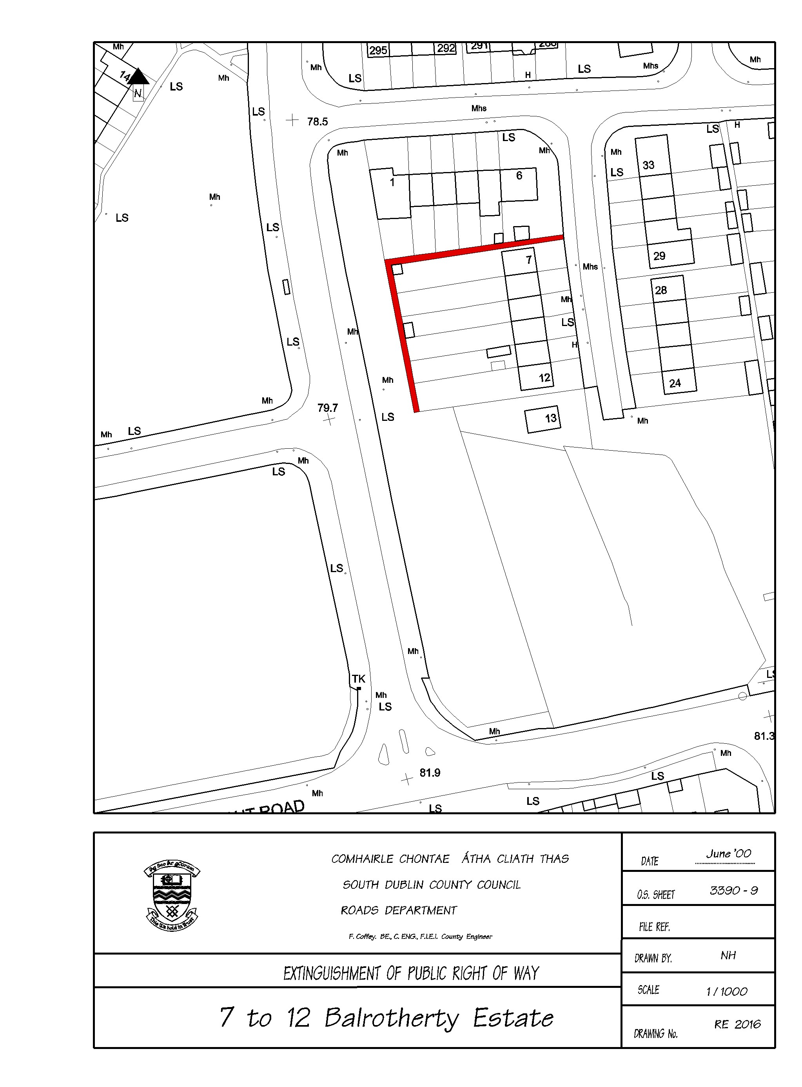

Mr. T. Curtin, Administrative Officer summarised the report.

It was proposed by Councillor K. Warren, seconded by Councillor E. Maloney and AGREED:

"That this Committee recommends to the Council that the Public Right of Way to the rear of 1-6 Balrothery Estate and to the side of 6-7 Balrothery Estate and to the rear of 7-12 Balrothery Estate, Tallaght, Dublin 24 as shown coloured red on Drawing No. RE 2016, be extinguished."

T/563/07 PROPOSED INITIATION OF EXTINGUISHMENT OF PUBLIC RIGHT ON LAND ADJOINING 58 & 60 DUNMORE PARK, KINGSWOOD, DUBLIN 24 MAP REF: RE 0708

The following report by the Manager which had been circulated was CONSIDERED:

"Proposed initiation of extinguishment of Public Right of Way on land adjoining 58 & 60 Dunmore Park, Kingswood, Dublin 24. Map Ref: RE 0708.

An application has been received from Development Department and Residents of Dunmore Park, Kingswood, Dublin 24, to formally extinguish the public right of way on land adjoining 58 & 60 Dunmore Park, Kingswood, Dublin 24, due to antisocial behaviour, and to effect the closure by means of incorporation into their gardens.

If the Committee agree the procedure to extinguish the public right-of-way as listed above will be initiated."
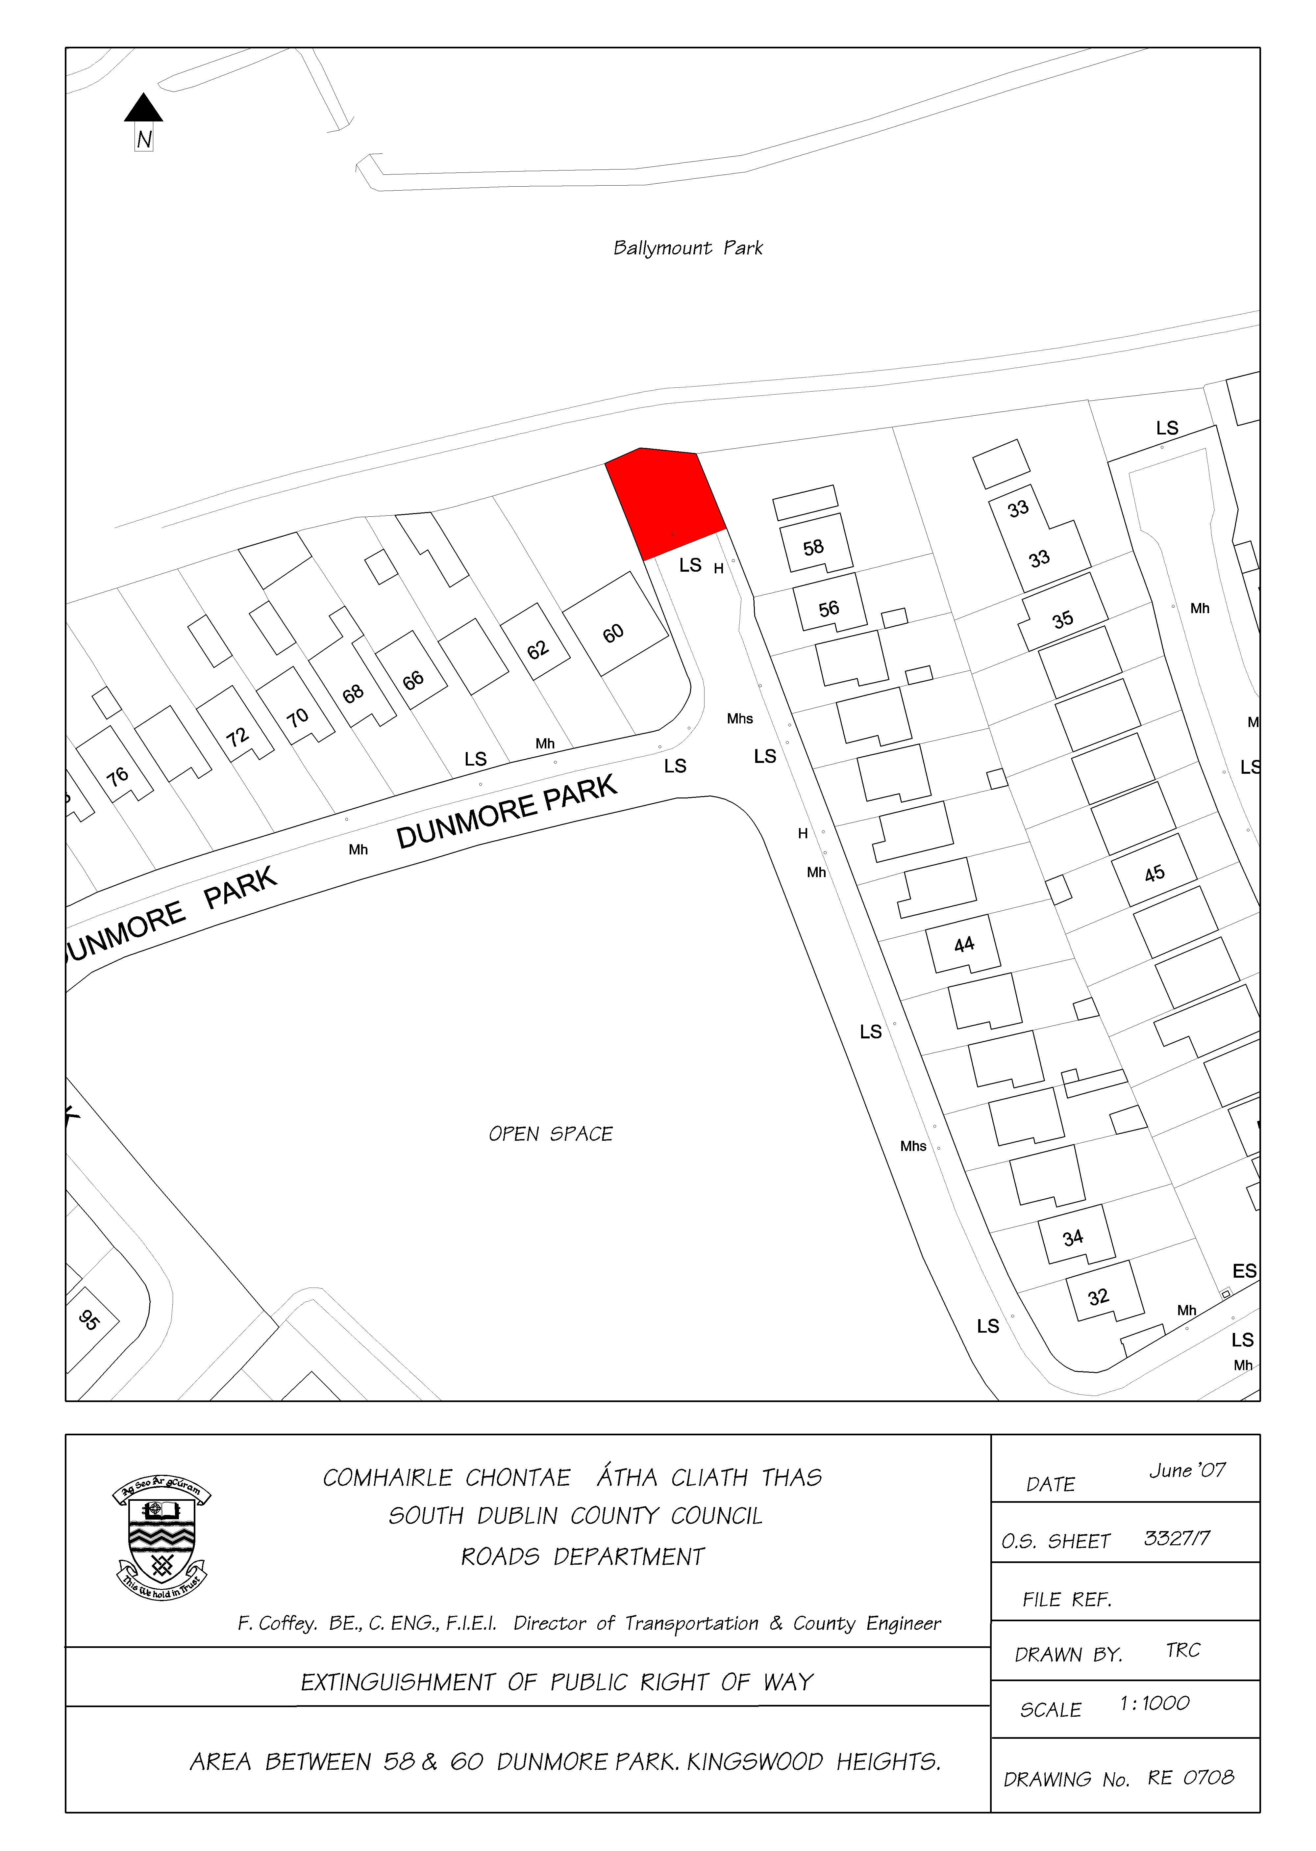

It was proposed by Councillor C. King, seconded by Councillor K. Warren and AGREED:

"That the procedure to extinguish the public right of way at the location in the foregoing report be initiated."
T/564/07 PROPOSED INITIATION OF PUBLIC RIGHT OF WAY AT MAPLEWOOD PARK, OLD BLESSINGTON ROAD MAP REF: RE 0709

The following report by the Manager which had been circulated was CONSIDERED:

"Proposed extinguishment of public right of way at Maplewood Park, Old Blessington Road, Tallaght – Map RE 0709.

The following motion was tabled at the Tallaght Area Committee Meeting held on Monday 28th May 2007

“That this Committee recommends the closure of the pedestrian access to Maplewood Park (new houses) which has led to the increase of anti-social behaviour and criminal damage to property from people using this as a cut through late at night.”

The report on this motion stated that no application had been received from residents in Maplewood Park requesting the closure of the pedestrian access in question.

A petition has now been received from residents of Maplewood Park and Maplewood Avenue requesting the closure of this pedestrian access. If the Committee agrees the procedure to extinguish the public right of way will be initiated."
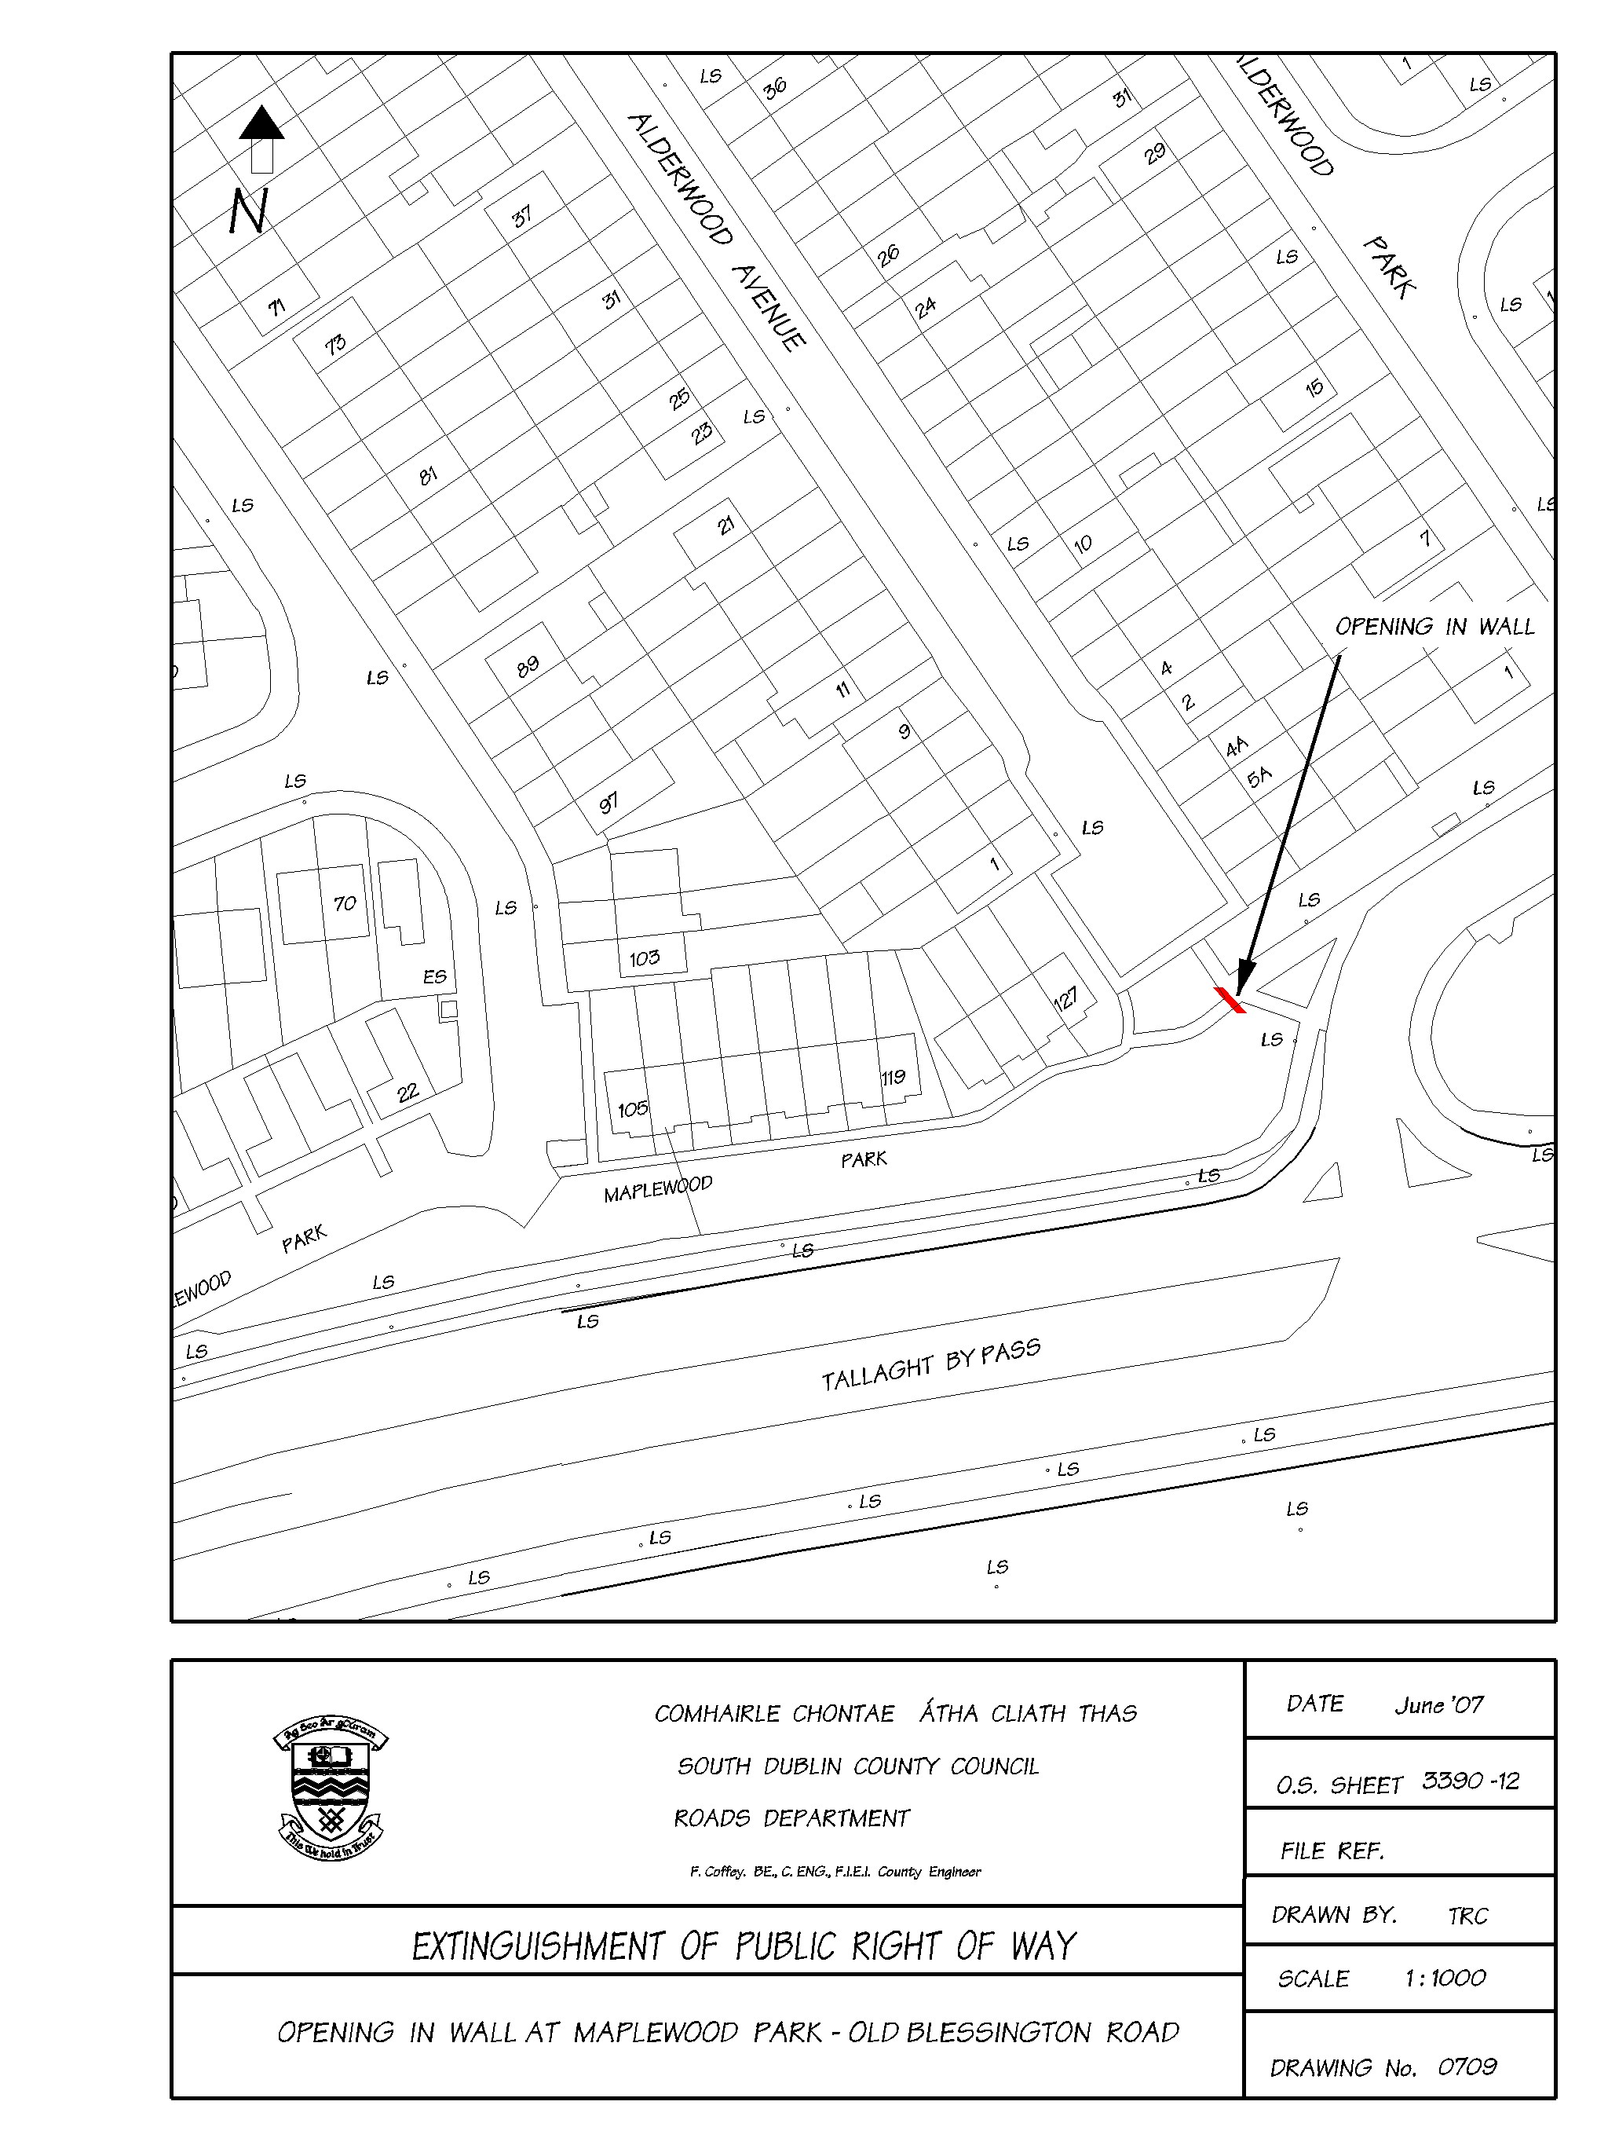

Mr. T. Curtin, Administrative Officer, summarised the report.

It was proposed by Councillor K. Warren, seconded by Councillor J. Hannon and AGREED:

"That the procedure to extinguish the public right of way at the location in the foregoing report be initiated."
T/565/07 REPORT ON TEMPORARY BRIDGE N81

The following report by the Manager which had been circulated was CONSIDERED:

"Work is being undertaken by the Contractor and is at an advanced stage and should be completed in the near future."

Mr. F. Coffey, Director of Transportation and County Engineer spoke on the report.

Following a discussion to which Councillors K. Warren and C. King contributed Mr. F. Coffey, Director of Transportation and County Engineer responded to queries raised. The report was NOTED.

T/566/07 TRAFFIC CALMING PROGRAMME

The following report by the Manger which had been circulated was CONSIDERED:

"Traffic Calming Programme (2)

The traffic calming programme (1) adopted by the Tallaght Area Committee in 2003 is as follows:-

Cells Roads
Tallaght Central
Kilnamanagh / Kingswood Alpine Rise / Belgard Heights
Old Bawn The Park, Millbrook Lawns
Tymon North Seskin View Avenue / Drive
Springfield

Present Position: Seskin View Avenue / Drive: alternative design being considered.

Remainder complete.

Tallaght South
Suncroft / Sundale Ballycullen Avenue / Drive
Brookview / Fettercairn Daletree /Parklands
Allenton / Oldcourt Kilclare Avenue
Aylesbury / Cushlawn Johnstown Road, Rathcoole

Present Position: Allenton / Oldcourt - Under Construction

Aylesbury / Cushlawn – Being designed. .

Remainder - Complete.

In response to a large number of requests for traffic calming measures throughout the Council’s administrative area the Council’s Transportation Strategic Policy Committee at its meeting on the 11th May 2006 adopted a new Traffic Calming programme comprising of four schemes in each of the Council’s five electoral areas. The selection of each individual scheme for the Tallaght Central and Tallaght South Electoral Areas is now a matter for this Committee.

The Traffic Calming Request List for the Tallaght Central and Tallaght South Electoral Areas is attached for the consideration of the Committee in selecting the new traffic calming schemes."

http://intranet/cmas/documentsview.aspx?id=13687

http://intranet/cmas/documentsview.aspx?id=13688

Following a discussion to which Councillors J. Hannon, C. King, E. Maloney, C. Jones and K. Warren contributed, Mr. T. O'Grady, Senior Engineer responded to queries raised. The report was NOTED and it was AGREED that this matter be discussed with the Committee and a report to issue to a future meeting of the Tallaght Area Committee dealing with Roads Business.

T/567/07 PROVISION OF SCHOOL WARDEN

The following report by the Manager which had been circulated was CONSIDERED:

"Under the terms of the Local Government Act, 1991 (Reserved Functions) Order, 1993, the making of arrangements under Section 96 (1) of the Road Traffic Act, 1961, for the patrolling of locations where school children cross the public road is a reserved function of the Council.

The Road Safety Officer has recommended the provision of a school warden service at the following location:

SCHOOL LOCATION

Holy Rosary National School, On Parklands Road
Oldcourt Avenue 8 metres north of
Ballycragh, lampstandard No. 27
Tallaght,
Dublin 24

The recommendation of the Committee will be brought before the Council at its next meeting."

Mr. F. Coffey, Director of Transportation and County Engineer spoke on the report.

It was proposed by Councillor J. Hannon, seconded by Councillor K. Warren and AGREED that the Committee recommends to the full Council the provision of a school warden service at the location as outlined in the above report.

T/568/07 NEW WORKS
It was NOTED there was no business under this heading.

T/569/07 CORRESPONDENCE
It was NOTED there was no business under this heading.

T/570/07 CATHAOIRLEACH'S BUSINESS
It was NOTED there was no business under this heading.

T/571/07 PARKING FOR THE DISABLED IN PUBLIC PLACES

The following motion in the name of Councillor M. Daly was NOT MOVED:

"That this Committee provides for adequate disabled parking in all public places within the Tallaght Town Centre area including those areas where parking restrictions are managed by private companies eg High Street."

T/572/07 WOODSTOWN CRESCENT - EXTINGUISHMENT OF PUBLIC RIGHT OF WAY

It was proposed by Councillor C. Jones, seconded by Councillor J. Hannon:

“That this Committee calls for the Manager to contact the owners of the Woodstown Village Shopping Centre to discuss extinguishing the right of way between the shops and Woodstown Crescent because of the negative effects that this opening is causing to adjacent residents"

The following report by the Manager which had been circulated was READ:

"The area in question is not in the charge or maintenance of the Council. Accordingly, there is no action open to the Council in this matter."

Following a contribution from Councillor C. Jones, Mr. F. Coffey, Director of Transportation and County Engineer responded to queries raised. It was AGREED that the owner of the shopping centre be contacted to progress this matter.

T/573/07 PUBLIC LIGHTS IN THE VICINTY OF 64 CUSHLAWN WALK

It was proposed by Councillor C. King, seconded by Councillor K. Warren:

"That this Committee calls on the Manager to arrange for the four public lights (with no numbers) in the vicinity of 64 Cushlawn Walk to be repaired with immediate effect as has been requested on numerous occasions and which was the subject of a motion at this Committee last year."

The following report by the Manager which had been circulated was READ:

"All 4 No. columns are now lighting between house numbers 60 to 67 in Cushlawn Park."
Following a contribution from Councillor C. King, Mr. F. Moran, Senior Executive Engineer responded to queries raised. The report was NOTED and it was AGREED that the report in the minutes be amended to "Cushlawn Walk" as follows.

"All 4 No. columns are now lighting between house numbers 60 to 67 in Cushlawn Walk."

T/574/07 THE WALL BORDERING KILAKEE AND THE FIRHOUSE ROAD

It was proposed by Councillor C. Jones, seconded by Councillor J. Hannon:

"That this Committee calls on the Manager to ensure

1) that the wall bordering Kilakee and the Firhouse road upgrade is finished to the same standard as the newly built wall adjacent to Woodlawn.

2) that the wall is high enough to ensure privacy for adjacent residents.

3) that the noise and vibration disruption that residents have experienced due to the upgrading works will cease."

The following report by the Manager which had been circulated was READ:

"There are no works planned under the current contract to raise or upgrade the existing rear garden walls to the houses on Kilakee Walk. The walls in question were built by the developer of the estate and the walls are the property of the individual householders. The finished level of the new road in the vicinity of Kilakee Walk will be essentially similar to the existing road level. The residual area between the new road and the rear garden walls to Kilakee Walk will be landscaped and planted. Previous surveys of the existing garden walls have indicated that the standard requirement for rear wall height of 1.8m over footpath would be maintained.

Notwithstanding this, the Council undertakes to re-examine the issue of the walls upon completion of road works in that vicinity.

With regard to noise and vibration, the contractor has been reminded to adhere to the strict limits as set out in the specification. However, it is unavoidable the some noise, vibration and other disruption will occur during the course of road upgrading works such as are in progress on Firhouse Road at present. South Dublin County Council apologises for any inconvenience caused during these necessary works."

Following a discussion to which Councillors C. Jones, J. Hannon and J. Daly contributed Mr. S. Fagan, Senior Executive Engineer responded to queries raised. The report was NOTED.

CORPORATE SERVICES BUSINESS

T/575/07 QUESTIONS
It was NOTED there was no business under this heading.

T/576/07 NEW WORKS
It was NOTED there was no business under this heading.

T/577/07 CORRESPONDENCE

(A) Letter dated 25th May, 2007 from the Department of Arts, Sport and Tourism regarding a question adapted at the Tallaght Area Committee Meeting of 23rd April, 2007, in relation to a reconfiguration the completion of the Shamrock Rovers stadium, Tallaght.

http://intranet/cmas/documentsview.aspx?id=13568

Letter dated 25th May, 2007 from the Department of Arts, Sport and Tourism regarding a question adapted at the Tallaght Area Committee Meeting of 23rd April, 2007, was NOTED.

(B) Letter dated 24th May, 2007 from the Department of Justice, Equality and Law Reform regarding a motion passed at the Tallaght Area Committee Meeting of 27th November, 2007, in relation to an assessment of the best location for a second Garda Station within the RAPID areas of Tallaght.

http://intranet/cmas/documentsview.aspx?id=13570

Letter dated 24th May, 2007 from the Department of Justice, Equality and Law Reform regarding a motion passed at the Tallaght Area Committee Meeting of 27th November, 2007, was NOTED.

T/578/07 CATHAOIRLEACH'S BUSINESS
It was NOTED there was no business under this heading.

T/579/07 NEW GARDA STATION IN CITYWEST/FORTUNESTOWN

It was proposed by Councillor M. Corr, seconded by Councillor K. Warren:

"That this Committee calls on the Minister for Justice to immediately take up the offer of a site for a new Garda station in Citywest/Fortunestown, to explore the possibility for funding this by the sale of part of the land in the Department's ownership in the Town centre and to award divisional status to the future City of Tallaght without delay."

The following report by the Manager which had been circulated was READ and NOTED:

"If the Motion is passed the matter will be referred The Minister of Justice for attention and when a reply is received the Members will be notified accordingly."

Councillor M. Corr requested that the Motion be RE-ENTERED on the Agenda for the next meeting of the Tallaght Area Committee dealing with Corporate Services.

T/580/07 REQUEST FOR SEATED BUS SHELTER ON OLD BAWN ROAD, ADJACENT TO ST. MAELRUANS ESTATE

The following motion in the name of Councillor J. Neville was NOT MOVED:

"That this Committee calls on the Manager to have arranged contact made with Dublin Bus requesting the provision of a seated bus shelter on the Old Bawn Road adjacent to St. Maelruans estate."

PLANNING BUSINESS

T/581/07 QUESTIONS

It was proposed by Councillor K. Warren, seconded by Councillor J. Hannon and RESOLVED:

"That pursuant to Standing Order No. 13, question 9 be ADOPTED and APPROVED."

T/582/07 PLANNING APPLICATION SD07A/0248

QUESTION: Councillor J. Neville

"To ask the Manager with respect to Planning Application SD07A/0248, if the correct procedure was carried out in relation to the location of site notice/s and will the Manager outline the up to date situation in respect of this planning application?"

REPLY:

Planning Application Register Reference SD07A/0248 was received on 05-Apr-2007 from Irish Radiophones for the erection of a 48 metre high telecommunications mast/ tower erected on a concrete base (6.5m x 6.5m) with dishes, antennas, etc.., a single storey retractable equipment building (11.5sq.m.), a 1.7m high security fence with a gate all around a 15m x 15m compound, and ancillary site development works at Crockaunadreenagh, Rathcoole, Co. Dublin.

An inspection of the Site Notice was carried out on 20-Apr-2007 and the site notice was found to comply with the requirements of the Planning & Development Regulations 2001 – 2006.

The following Additional Information was requested by the Council on 28-May-2007:

- The applicant is requested to outline in writing the maximum number of bays, antennae, dishes, aerials and other such structures to be located on the proposed mast and the height of the location of same above ground level. The applicant is also requested to submit revised drawings of same outlining the location of aforementioned structures on the mast.

- The applicant states, 'that ‘the proposed tower will be available for use by various telecommunication operators but is being specifically proposed in order to facilitate the nationwide expansion of a radio station. So unlike Vodafone, O2 or Meteor whose needs may be satisfied by sharing an existing facility in preference to developing one, it is neither practical nor feasible for the applicant to approach operators of neighbouring existing towers to share those facilities'. The applicant is requested to submit information from an appropriately qualified professional outlining in writing why it is not ‘technically practical nor feasible’ to co-locate with other existing structures in the vicinity.

- A site visit has revealed the presence of an existing mast structure located within the landholding outlined in blue on the plans submitted. Said structure is located to the south of the existing farmyard. The Planning Authority has no record of planning permission having been granted for this structure. The applicant is requested to clarify in writing the planning status of this structure and the use of same.

- The applicant is requested to submit a revised site plan to show the following:
(a) Minimum vision splay of 2 metre x 70 metre on the right hand side (when exiting) of shared vehicular entrance off Crockaunadreenagh Lane. This will involve removal of that part of existing front boundary within the visibility splay triangle and erection of new front boundary at back of the 70 metre sightline.
(b) Letter of agreement to carry out the above works from owner of site outlined in blue.

The Additional Information as requested has not been received to date.

T/583/07 PLANNING FILES

- Large Applications

The following report by the Manager which had been circulated was CONSIDERED:
SD07A/0443 | Reg. Date:  13-Jun-2007  Applicant’s Name:  Mormur Ltd., B. Morton & S. Murphy,  Submission Type:  New Application | Location:  Speaker Connolly Tavern, Firhouse Road, Dublin 24.  Proposed Development:  Demolition and the removal of the pyramid roof, the service yard to the eastern side and single storey structures to the northern and southern sides of the existing building to facilitate the construction of the new development on a 0.324 hectare site as part of the new Village Centre. There will be a single level underground car park of 1924sqm with 66 car parking spaces, refuse stores, bicycle parking, plant areas, storage for the apartments and access staircases & lifts. The structure will be 3 storeys over ground floor comprising 3 no. two bed and 2 no. one bed apartments at the western side, the existing Licenced Premises extended to 600sqm, 3 no. retail units totaling 417sqm, access lift & staircases and a 255sqm service yard at ground floor level. There will be 3 no. two bed and 2 no. one bed apartments, 2 no. office units totaling 701sqm and a restaurant of 360sqm including kitchen and stores at first floor level. There will also be 11 no. two bed and 4 no. one bed apartments at both 2nd and 3rd floor levels around an internal landscaped courtyard. The total number of apartments will be 40. 6 no. surface level staff car spaces are provided in the service yard and 16 no. short stay car spaces are provided at ground floor level. The total gross floor area of the development, excluding the basement and service yard, is 5230sqm.  Decision Due on or before:  07-Aug-2007
SD07A/0351 | Reg. Date:  14-May-2007  Applicant’s Name:  G, J & R Stanley  Submission Type:  New Application | Location:  Stoney Road, Rathcoole, Co. Dublin  Proposed Development:  52 residential units comprising 2 no. apartment blocks, A & B, each containing 14 no. 2 bed duplexes, 8 no. 1 bed apartments, 2 no. 2 bed apartments and 2 no. 3 bed apartments, all with private terraces and or balconies: maximum height of apartment blocks is 9.77m above ground level. The site car parking, bin storage and additional private storage will be provided for in the basement car park with a total of 78 car spaces. The development will be accessed via and built concurrently with the previously granted planning permission. The open space requirements are also met as part of the overall development planning permission SD06A/0699. The application site area extends to 1.01 acres or 0.41 hectares. Connections to foul and surface water sewers will be via previously granted planning permission SD06A/0699. This application is for revised apartment blocks A & B as omitted under Condition no. 3 of granted planning application SD06A/0699.  Decision Due on or before:  08-Jul-2007
SD07A/0339 | Reg. Date:  09-May-2007  Applicant’s Name:  Mr. J. Regan  Submission Type:  New Application | Location:  Firhouse Shopping Centre, Firhouse, Dublin 24.  Proposed Development:  Demolition and redevelopment of Firhouse Shopping Centre and construction of a new mixed use village centre on a site of 1.118ha in 3 blocks around a new landscaped village square over a single level underground carpark of 7384sq.m. consisting of 244 car spaces, refuse stores, bicycle parking and plant areas. Block A: 3 storeys over ground floor comprising 11no. retail units totalling 3007sq.m., including an anchor supermarket of 1250sq.m. with associated stores and staff welfare accommodation (existing service yard is retained), 1no. ESB substation, a new day care centre for the Central remedial Clinic of 480sq.m. with associated ambulance parking (4no. ambulance spaces and 3 disabled car spaces), an ATM at ground floor level, a crèche of 565sq.m. and fitness centre of 950sq.m. on first floor level, three storeys of office space over ground floor entrance totalling 859sq.m. and 7no. 1 bed and 30no. 2 bed residential units (37 in total); Block B: 3 storeys over ground floor comprising 6no. retail units totalling 517sq.m. and 5no. 1 bed, 12no. 2 bed and 5no. 3 bed residential units (22 in total) and 1no. ESB substation; Block C: single storey restaurant/cafe unit 135sq.m. and public lift and stair to carparking at basement level; 19no. short stay surface car spaces are also provided at ground level adjacent to the Village Square. The development to be carried out in two phases to facilitate the continued operation of the anchor supermarket unit. Permission is also sought for the temporary relocation of the existing Day Care centre (375sq.m.), pharmacy (75sq.m.) and supermarket (1000sq.m.) within the existing structure. The total gross floor area of the development excluding basement areas is 12707sq.m.  Decision Due on or before:  03-Jul-2007
SD07A/0259 | Reg. Date:  14-Jun-2007  Applicant’s Name:  Keenbury Properties Ltd.,  Submission Type:  Additional Information | Location:  Belgard Square North And West, Tallaght Town Centre, Dublin 24  Proposed Development:  Further Information and revised drawings which include for retention of alterations to fenestration at ground floor to the North and West elevations. Revisions to existing approved development Reg. Ref. No. SD02A/0275, SD03A/0702, SD04A/0084, SD05A/0188, SD06A/0938, SD04A/0205, SD06A/0619, SD04A/0809, SD03A/0392. 1. Revisions to Block A, comprising of a proposed change of use of permitted retail unit at northeast corner to off-license/wine shop; 2. Revisions to Block D comprising of a proposed change of use of permitted cafe unit in southeast corner to retail use, provision of 127 sq.m. mezzanine floor and amalgamation with 482 sq.m. of permitted retail area at first floor level, provision of two entrances on the north elevation of Block D and amendment to fenestration at first floor level of the north elevation; 3. Revisions to Block E, comprising of a change of use of permitted cafe unit to Hotel Cafe Bar/ Restaurant integrated into the permitted Hotel with additional access via Hotel reception, alterations to fenestration at ground floor to the north and west elevations; 4. Revisions to Block F comprising of change of use of the permitted two storey public house of 1420 sq.m. to a cafe unit of 270 sq.m., a retail unit of 107 sq.m. at ground floor level, a 292 sq.m. restaurant at ground floor level and 908 sq.m. restaurant at first floor level including the removal of staircore on the north elevation and change of use of this staircore to restaurant use, change of use of the permitted retail unit at ground floor level to a coffee/ juice bar of 56.5 sq. m. and alteration of the recessed entry door on the eastern elevation of this unit to a flush entry door.  Decision Due on or before:  11-Jul-2007
SD06A/1081 | Reg. Date:  05-Jun-2007  Applicant’s Name:  Citywest Ltd.,  Submission Type:  Clarification of Additional Information | Location:  Site 2050, Orchard Avenue, Citywest Business Campus, Dublin 24.  Proposed Development:  7 no. units consisting of single storey warehouse/production areas together with two storey offices and 3 no. units consisting of 2 storey offices to be built in two separate blocks (overall floor area 4554sq.m.) with associated car parking, landscaping, signage and ESB substation and switchroom.  Decision Due on or before:  02-Jul-2007
SD07A/0013 | Reg. Date:  01-Jun-2007  Applicant’s Name:  Kelland Homes Ltd.,  Submission Type:  Additional Information | Location:  Killinarden, Tallaght, Dublin 24  Proposed Development:  A residential development having a total of 532 no. houses, duplex and apartment units and a creche. The dwelling units consist of 16 no. 4 bed two storey semi detached houses, 1 no. 4 bed detached and 64 no 3 Bed 2 storeysemi detached houses, 72 no. 3 bed dormer bungalows, 7 no. 3 bed 2 storey wide frontage houses, 104 no. 3 bed 2 storey terraced town houses, 26 no. 2 bed apartments in 13 no. 2 storey end of terrace blocks, 47 no. 3 bed duplex units with 31 no. 2 bed apartments overhead and 31 no. 3 bed duplex units with 31 no. 2 bed apartments overhead, all in 14 no. 3 storey blocks, 12 no. 1 & 2 bed apartments in 2 no. 2 storey blocks and 90 no. 1 & 2 bed apartments in 2 no. 3 storey blocks and 1 no.2 storey block containing creche of 684 sq.m and retail unit with office and ancillary over of 356 sq.m all on a site circ 14.61 hectares (36.1 acres) located south of Killinarden Heights, north of Kiltipper Road and west of a development being completed at Deerpark, with two no. vehicular access points off Killinarden Heights to the north opposite Donomore Crescent; 1 no. vehicular access point from Deerpark to the east and 1 no. realigned vehicular access point off Kiltipper Road to the southeast through Deerpark Place. The development includes for all associated site development and infrastructural works, car & bicyle parking, bin storag, open spaces and landscaping with outfall drainage connections and services to and along Killinarden Heights with a foul sewer outfall extending north throught Killinarden Park connecting into the existing foul sewer opposite Donomore Park Road. An Enviromental Impact Statement has been submitted to the Planning Authority as part of this Planning Application.  Decision Due on or before:  28-Jun-2007
SD07A/0409 | Reg. Date:  01-Jun-2007  Applicant’s Name:  Roadstone Dublin Ltd.,  Submission Type:  New Application | Location:  Townlands of Corbally And Lugmore, Co Dublin  Proposed Development:  Continuation of quarrying activities including the processing of aggregates, landscaping, restoration and associated works within an area of 31.25 hectares. The planning application will be accompanied by an EnviromentalImpact Statement (EIS) in accordance with Schedule 5 of the Planning and Development Regulations 2001.  Decision Due on or before:  26-Jul-2007
SD07A/0458 | Reg. Date:  18-Jun-2007  Applicant’s Name:  Christy Brady  Submission Type:  New Application | Location:  6, Kilteel Road, Rathcoole, Co. Dublin  Proposed Development:  2 no. two storey blocks each containing 2 no. two bedroom apartments on both ground and first floors and one block containing a one bedroom apartment in the attic space, together with parking for 14 no. vehicles with access from Kilteel Road together with associated site works, drainage and landscaping.  Decision Due on or before:  12-Aug-2007

The report was NOTED.

- Files requested by members

SD06A/0767

Applicant: Liam Creighton
Location: Junction of Fortunestown Way and Sundale Park adjacent to Molly Heffernan's Public House, Tallaght, Dublin 24
Development: 6556 sq.m of new development for a new Neighbourhood Centre. The development includes a new 3-5 storey over basement building along Fortunestown Way containing a Credit Union, a Retail Unit, a Restaurant, 1 one-bed, 23 two-bed and 2 three bed apartments; a new 3-4 storey over basement building on a new internal street containing 2 one-bed, 11 two-bed and 3 three-bed apartments, a Management Office, 2 Commercial Units and 6 Retail Units and ancillary spaces; a new 2 storey building on Sundale Park comprising an extension to the existing Londis Store, a Crèche with rear play area, a Community Centre and Health Centre. The development provides for 90 car parking spaces at grade and 136 spaces in basement car park, a new internal road linking a new vehicular entrance off Fortunestown Way and a realigned vehicular entrance off Sundale park, the upgrading of the public open space adjacent to Molly Heffernan's, perimeter walls and new hard and soft landscaping.

Comments: Councillor C. Jones queried aspects of this application.

SD07A/0339

Applicant: Mr. J. Regan
Location: Firhouse Shopping Centre, Firhouse, Dublin 24.

Development: Demolition and redevelopment of Firhouse Shopping Centre and construction of a new mixed use village centre on a site of 1.118ha in 3 blocks around a new landscaped village square over a single level underground carpark of 7384sq.m. consisting of 244 car spaces, refuse stores, bicycle parking and plant areas. Block A: 3 storeys over ground floor comprising 11no. retail units totalling 3007sq.m., including an anchor supermarket of 1250sq.m. with associated stores and staff welfare accommodation (existing service yard is retained), 1no. ESB substation, a new day care centre for the Central remedial Clinic of 480sq.m. with associated ambulance parking (4no. ambulance spaces and 3 disabled car spaces), an ATM at ground floor level, a crèche of 565sq.m. and fitness centre of 950sq.m. on first floor level, three storeys of office space over ground floor entrance totalling 859sq.m. and 7no. 1 bed and 30no. 2 bed residential units (37 in total); Block B: 3 storeys over ground floor comprising 6no. retail units totalling 517sq.m. and 5no. 1 bed, 12no. 2 bed and 5no. 3 bed residential units (22 in total) and 1no. ESB substation; Block C: single storey restaurant/cafe unit 135sq.m. and public lift and stair to carparking at basement level; 19no. short stay surface car spaces are also provided at ground level adjacent to the Village Square. The development to be carried out in two phases to facilitate the continued operation of the anchor supermarket unit. Permission is also sought for the temporary relocation of the existing Day Care centre (375sq.m.), pharmacy (75sq.m.) and supermarket (1000sq.m.) within the existing structure. The total gross floor area of the development excluding basement areas is 12707sq.m.

Comments: Councillor J. Hannon asked about the post office at this location.
SD07A/0409

Applicant: Roadstone Dublin Ltd.,
Location: Townlands of Corbally And Lugmore, Co Dublin
Development: Continuation of quarrying activities including the processing of aggregates, landscaping, restoration and associated works within an area of 31.25 hectares. The planning application will be accompanied by an Environmental Impact Statement (EIS) in accordance with Schedule 5 of the Planning and Development Regulations 2001.

Comments: Councillor K. Warren queried aspects of this application.

T/584/07 SPECIAL DEVELOPMNET CONTRIBUTION SCHEME
The following report by the Manager which had been circulated was CONSIDERED:

"Tallaght Town Centre Local Area Plan

Draft Section 48 Special Development Contribution
Planning and Development Act 2000 Section 48(2)( C )

The recently adopted Tallaght Town Centre Local Area Plan 2006 contains a significant number of public infrastructure requirements that need to be delivered in tandem with the expansion of the Town Centre, see below.

Section 48 of the Planning and Development Act 2000 enables the Planning Authority to impose a special development contribution where exceptional costs not covered by the general contribution scheme are incurred. Under the Tallaght Town Centre Local Area Plan Special Development Contribution, the Council when granting a planning permission for development in the Local Area Plan area of Tallaght Town Centre proposes to include conditions requiring the payment of an additional special contribution (to the Countywide (S48) Scheme) to provide for the required public infrastructure.
The proposals are as follows;

PUBLIC INFRASTRUCTURE | WORKS
Transport
Land Bridge at N81 | Pedestrian and possibly Bus way over the N81. Part of Phase 4 of The Square. 70x25 metres  Work and land costs
Parks and Landscaping/Civic Spaces
New Cookstown Park | Provision of approx. 0.8Ha of High Quality Urban Park work costs
New Luas Pocket Park | 1,600 sq metres of High Quality Urban Pocket Park work costs
Sean Walsh Park: Improvements | Town Centre Playground work costs
Community Facilities
Youth Centre Facility | Tallaght Youth Service Building Costs
Community Centre Facility | Building Costs for a revamped Belgard Community Centre

The Council are carrying out a study setting out the basis for the determination of the contributions which will be payable and which indicate the amount of the contribution per residential unit or per square metre industrial/commercial of each class of development. The projected development floor areas in Tallaght Town Centre, between 2007 and 2012 will be based on the land use estimates set out in Table 2.2.3 of the Tallaght Town Centre Local Area Plan 2006. These estimates are based on historic growth rates, between 1996 and 2006 and assume a similar level of development in the years 2006-2012.

The contributions will be set at a modest level in order to maintain a balance between raising the contributions to pay for the infrastructure and maintaining the economic competitiveness of Tallaght Town Centre. The contributions will be set to collect a maximum of 50% of the costs up to 2012 in order to achieve this balance.

The Special Development Contribution also allows for exemptions for specified classes of development as in the countywide Section 48 Scheme.

The Tallaght Town Centre Local Area Plan Special Development Contribution can be appealed to An Bord Pleanála.

Note: The Tallaght Town Centre Local Area Plan Special Development Contribution was drawn up in accordance with the terms of Section 48 (2)c of the Planning and Development Act 2000 and with the recent Department of the Environment, Heritage and Local Government Circular Letter PD 5/2007. Particular care was taken in the study to ensure that the Special Development Contribution is reasonable and fair, that there is no double charging; and will be additional to the South Dublin County Council Development Contribution Scheme 2003."

Mr. T. Doherty, Director of Planning spoke on the report. The report was NOTED and it was AGREED to defer consideration of the report to the September 2007 meeting of the Tallaght Area Committee dealing with Planning Business.

T/585/07 NEW WORKS

DEERPARK INFILL

The Following report by the Manager which had been circulated was CONSIDERED:

"Deerpark Infill
Report on Public Notification Procedure Under Part 8 of the Planning & Development Regulations 2001 - 2003 for the proposed construction of an infill housing project on lands at Deerpark, Cushlawn Dale, Tallaght, Dublin 24
A report in accordance with Article 81 of the Planning and Development Regulations 2001-2003 was published on 27th April 2007 to construct an infill housing development of an 8 unit project on lands at Cushlawn Dale, comprising 2 no. single-storey, two bedroom units, 6 no. two-storey, two bedroom units. The works to include alterations to the existing on-street parking layout, new off street parking, new boundary treatments and all necessary associated ancillary works at Cushlawn Dale, Tallaght, Dublin 24.
Plans and particulars of the development were made available for inspection by the public for four weeks until Friday 25th May, 2007 and a further two weeks until Monday 11th June 2007 was allowed for the making of written submissions and observations to the Council in relation to the matter.
Site layout and Drawings
Project Summary
No submission or objections were received for this proposed development.

As the proposed development is in accordance with the proper planning and sustainable of the area, it is proposed to proceed with the development. It is anticipated that this report will be bought to the meeting of the County Council to be held on Monday 10th September 2007."

Mr. H. Hogan, Senior Executive Officer summarised the report.

Following a contribution from Councillor C. King, Mr. H. Hogan Senior Executive Officer responded to queries raised. The report was PASSED.

T/586/07 CORRESPONDENCE
It was NOTED there was no business under this heading

T/587/07 CATHAOIRLEACHS BUSINESS
It was NOTED there was no business under this heading.

T/588/07 BOUNDARY FENCING AT SCOIL TREASA

It was proposed by Councillor C. Jones seconded by Councillor K. Warren:

"That this committee calls on the manager to discuss the planning application for boundary fencing at Scoil Treasa, Firhouse and to outline any objections received."

The following report by the Manager which had been circulated was READ:

"A planning application was received on 28-Feb-2007 from the Board of Management for a proposed development at Scoil Treasa National School, Ballycullen Avenue, Firhouse, Dublin 24. Register Reference SD07A/0151 refers.

The proposed development comprises 2.1m high perimeter railing to the school grounds at Scoil Treasa. The works will involve the relocation of both the existing vehicle/pedestrian main access to the school and the vehicular access to the Presbytery and teachers car park approximately 5m in a southerly direction to ensure that both access gates are at right angle to Ballycullen Avenue and also to facilitate the construction of a new access ramp from the high level teachers car park to the school perimeter footpath below. The works will include the construction of 2 no. pedestrian access gateways, one to serve the existing access pathway from the Church of Our Lady of Mount Carmel to the Presbytery, and the second to be located in the north east corner of the perimeter railing in the area of the existing tarmacadam ball courts. We also propose to construct a new vehicular access gateway approximately half way between the Presbytery and Carriglea Grove to facilitate access to the school playing grounds from Ballycullen Avenue.

The following objections were received in relation to the application:

Mr Tom Fennelly on 26-Mar-2007
Firhouse Village Park Project Committee on 26-Mar-2007
Carriglea Residents Association on 27-Mar-2007
Carriglea Grove Residents on 28-Mar-2007
Mrs Rosanna Phelan on 03-Apr-2007

A representation in support of the application was received from Charlie O’Connor T.D. on 10-May-2007.

The following Additional Information was requested by the Council on 20-Apr-2007:

- It is unclear from the information provided if the applicant has sufficient legal interest in the site to make an application for this proposed development. The applicant is requested to furnish proof of entitlement to make the application.

- It is the policy of the Council as expressed in its Development Plan to promote sustainable development including connectivity and permeability rather than enclosed and gated developments. The proposed fencing around the school site would appear to be contrary to current Council policy and would involve significant alterations to the appearance of the Firhouse Village Area and the closing off of pedestrian walking routes through the lands. Please submit a rationale for the proposed development having regard to the above issues.

- The applicant is requested to submit details of the planning permission reference number(s) for the school.

- The applicant is requested to submit a plan of the proposed boundary treatment in order to assess how often metal panels would be intersected by pillars. In addition, Unsolicited information was received on 02/04/07 which shows a revised proposal for the location of the boundary to the west of the site whereby the boundary would be located in line with the boundary of the presbytery which would provide a set back of between 1.2m and 2.6m between the boundary of the site and Carriglea Grove. However, it is unclear how this boundary would be designed and the applicant is requested to include this revision in the plan of the boundary treatment requested above.

- The applicant is requested to submit photographs/samples of the proposed fencing.

- The proposed pedestrian access to the presbytery is outside the red line of the application site and the applicant is requested to clarify this.

- The Council's Roads Department has recommended that the proposed entrance onto Ballycullen Avenue be omitted from the proposed development. The applicant is requested to submit revised drawings showing the omission of the proposed vehicular entrance to Ballycullen Avenue.

- The applicant is requested to submit the following:

i) A detailed tree/ hedgerow survey for the entire application site. These details should also be accompanied by a Arboricultural Impact Assessment and an Arboricultural Method Statement and include details in relation to tree protective measures. The above details to be compiled by a qualified Arborist and be incompliance with British Standard 5837- 2005 Trees in relation to construction.
ii) In view of the above Arboricultural recommendations and findings the applicant shall submit revised drawings indicating the route of the proposed railing in the vicinity of existing trees and hedgerows within the development site.
iii) detailed construction drawings illustrating cross sections and elevations through the proposed railing in the vicinity of existing trees. These details should take into account the recommendation as outlined with in British Standard 5837- 2005 Trees in relation to construction.

The Additional Information requested has not been received to date."
Following a discussion to which Councillor C. Jones, J. Hannon, J. Daly and E. Maloney contributed, Mr. M. Judge, Senior Executive Officer responded to queries raised. The report was NOTED.

T/589/07 SUSPENSION OF STANDING ORDER

It was proposed by an Cathaoirleach Councillor K. Warren and AGREED in accordance with Standing Orders no 76 to suspend standing orders to deal with an emergency motion in the name of Councillor C. Jones.

It was proposed by C. Jones, seconded by Councillor E. Maloney:

"That this Committee calls on the Planning Department to assist the residents of Marlfield Mall, providing them with legal advice and practical support to achieve their aim of replacing their Management Company."

Following a discussion to which Councillors C. Jones and C. King contributed Mr. M. Judge, Senior Executive Officer responded to queries raised. The report was NOTED and the Manger agreed to liaise with the Law Agent and contact all Members regarding outcome.

DEVELOPMENT BUSINESS

T/590/07 QUESTIONS
It was NOTED there was no business under this heading.

T/591/07 NEW WORKS
It was NOTED there was no business under this heading.

T/592/07 CORRESPONDENCE
It was NOTED there was no business under this heading.

T/593/07 CATHAOIRLEACH'S BUSINESS
It was NOTED there was no business under this heading.

T/594/07 DERELICT SITE INSPECTION - ADJACENT TO OLD MILL PUB

It was proposed by Councillor C. Jones, seconded by Councillor K. Warren:

“This committee calls for a report to outline progress following a visit by the Derelict Site Inspector to the land adjacent to the Old Mill.”

The following report by the Manager which had been circulated was READ:

"Section 3 of the Derelict Sites Act 1990 defines a derelict site as follows:

“In this section “derelict site” means any land (in this section referred to as “the land in question”) which detracts, or is likely to detract, to a material degree from the amenity, character or appearance of land in the neighbourhood of the land in question because of

- the existence on the land in question of structures which are in a ruinous, derelict or dangerous condition, or
- the neglected, unsightly or objectionable condition of the land or any structures on the land in question, or
- the presence, deposit or collection on the land in question of any litter, rubbish, debris or waste, except where the presence, deposit or collection of such litter, rubbish, debris or waste results from the exercise of a right conferred statute or by common law.”

This site was examined in December 2006 and was found not to be derelict within the definition contained in the Derelict Sites Act.
However the Derelict Sites Inspector recommended that the following works be carried out to prevent the site from becoming Derelict

Remove old cars and secure site boundary to prevent trespass.

The owner was written to and advised to remove old cars and to secure site boundary to prevent trespass, these works to be carried out within two months from the date of the letter.

The Council received correspondence from the Fitzgerald Group, dated 09/01/2007 stating that a car dismantling company was engaged to remove the cars.

A re-inspection of the site on the 14th June, indicated that all the cars have been removed from the site and the site is secure.

The Council’s Inspector, is satisfied that the site remains in a non derelict condition and will continue to be monitored to ensure it remains so."

Following a discussion to which Councillors C. Jones, J. Hannon, J. Daly, M. Daly, K. Warren, E. Maloney and M. Murphy contributed Mr. J. Walsh, Director of Economic Development responded to queries raised. The report was NOTED.

T/595/07 PERMANENT SITE FOR SCOIL CÁITLÍN MAUDE, KILLINARDEN

It was proposed by Councillor C. King, seconded by Councillor C. Jones:

"That this Committee calls on the Manager to arrange for an investigation to be carried out with a view to the identification of a permanent site for Scoil Cáitlín Maude (Killinarden) taking into account the current long list for the school and the current proposals for further large scale development in the area."

The following report by the Manager which had been circulated was READ:

"The Principal of Scoil Caitlin Maude made contact with the Council approximately three years ago to discuss the possibility of the School acquiring a portion of the Council' 's adjoining lands, to extend its existing accommodation. The School is currently accommodated at Knockmore Primary School and adjoining prefabs. The Council indicated that it would consider the request if it was supported by the Department of Education and Science, which would be funding the additional accommodation.

Subsequent discussions took place between the School and the Department of Education and Science and it appears that the Department's preference is to provide an independent permanent building for the School. The matter was also discussed at a meeting held in February 2007 between officials of the Council and the Department of Education but the site adjoining the existing school was not considered to be of sufficient size to meet the Department's requirements. The Department indicated that it would look at alternative sites in the area and would revert to the Council, if necessary. No further contact has been received from the Department in this matter in the meantime."

Following a discussion to which Councillors C. King, C. Jones, J. Daly and J. Hannon contributed Mr. J. Walsh, Director of Economic Development responded to queries raised. The report was NOTED and it was RECOMMENDED that the Manager write to the Department of Education regarding the current situation.

An Cathaoirleach Councillor K. Warren extended her thanks to Members and staff for their support during her time as Cathaoirleach and in return Members commended Councillor K. Warren in her role as Cathaoirleach.

The meeting concluded at 5.05 pm.

Siniú: Dáta:
An Cathaoirleach

