COMHAIRLE CONTAE ATHA CLIATH THEAS

SOUTH DUBLIN COUNTY COUNCIL
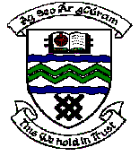

MEETING OF TALLAGHT AREA COMMITTEE MEETING (1)

Monday 21st May, 2007.

Question No. 11

Question: Councillor Marie Corr
To ask the Manager to arrange for a presentation/headed item in relation to Comhairle na bPaisti for the Tallaght Area Committee?"
Reply
This will be arranged for a forthcoming Tallaght Area Committee Meeting preferably after all examinations are completed.

