COMHAIRLE CONTAE ÁTHA CLIATH THEAS

SOUTH DUBLIN COUNTY COUNCIL

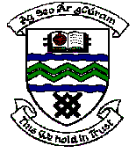

MEETING OF TERENURE/RATHFARNHAM AREA COMMITTEE (2)

Tuesday 8th May, 2007

Motion No. 17

Motion: Councillor S. Laing
That the Manager give an updated report on the ongoing discussions on the proposed Ballyroan Community Centre."

Report:

The drawings for a proposed Parish Centre in return for freehold ownership of the existing Community Facility are currently being finalised at the location agreed with Parish Priest and Parish Committee.

The Council has also instructed the Valuer to determine the estimated value of the Ballyroan Community Centre to ensure that the Council achieves value for money in any transfer arrangement. This valuation is awaited.

It is proposed to have a further on site meeting with the Committee within the next couple of weeks.

