COMHAIRLE CONTAE ÁTHA CLIATH THEAS
SOUTH DUBLIN COUNTY COUNCIL



MEETING OF TERENURE/RATHFARNHAM AREA COMMITTEE (1)

Tuesday, 1st May, 2007

HEADED ITEM No. 13

Report on the Templeogue Sculpture

In January 2005 it was agreed by Council, following a recommendation from the Terenure Rathfarnham Area Committee, to allocate funding from the Councillors Discretionary Fund to commission a sculptural artwork for Templeogue Village.

The commissioning process was facilitated by Caroline Orr, South Dublin County Council’s Per Cent for Art Co-ordinator, in conjunction with a working group, Chaired by Cllr Cait Keane and made up of public representatives from the Terenure Rathfarnham Area Committee, local business people and residents.

The site for the sculpture was selected by the working group in conjunction with local shopkeepers and with assistance from artist Louise Walsh and then SDCC Roads Engineer David Grant. This site is on the pavement outside Masseys Funeral Home at the Tallaght-end of Templeogue Village (see Appendices 1 and 2).

The commission was awarded to artist Rachel Joynt who has created a large bronze spherical sculpture about a metre in diameter, entitled Love All, (see Appendix 3 – work in progress). The bronze will be patinated green and from a distance the spherical sculpture will resemble a tennis ball. Nearer to, however, the sculpture will look more like a scaled down world with tiny detail of houses, roads, cars and people emerging from the textured green surface of the piece. The notion a globe of the world is further suggested by the fact that the piece will be mounted on an axle and will rotate slowly when pushed.

In coming up with the concept for Love All, Joynt was inspired by the location for the sculpture, close to Templeogue Lawn Tennis Club. Her idea was also greatly influenced by the significance of the Dodder River to the Village. This will be cleverly expressed in the sculpture where what appears to be the seam of the tennis ball turns out on closer inspection to represent the local river.

Roads Department, SDCC, is undertaking the preparation of the site for the installation of the sculpture. This preparation involves the relocation of two road signs, the moving of a lamp standard, the laying of foundations, the repaving of the surface of the site with bush hammered white granite, and the reinstatement of necessary bollards (see Appendices 4 and 5). The use of small uplighters located at the base of the sculpture is also being considered.

Appendix 2
Photographs of site
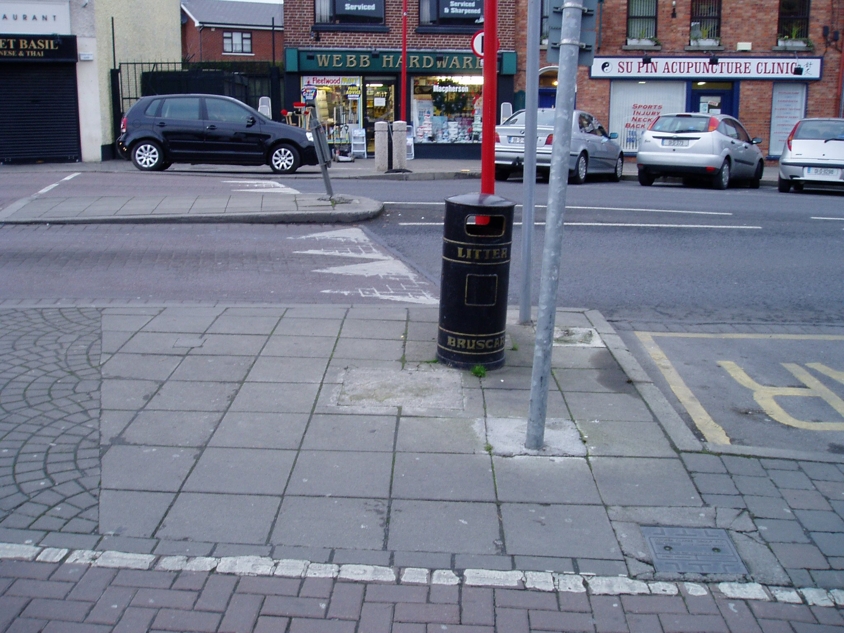
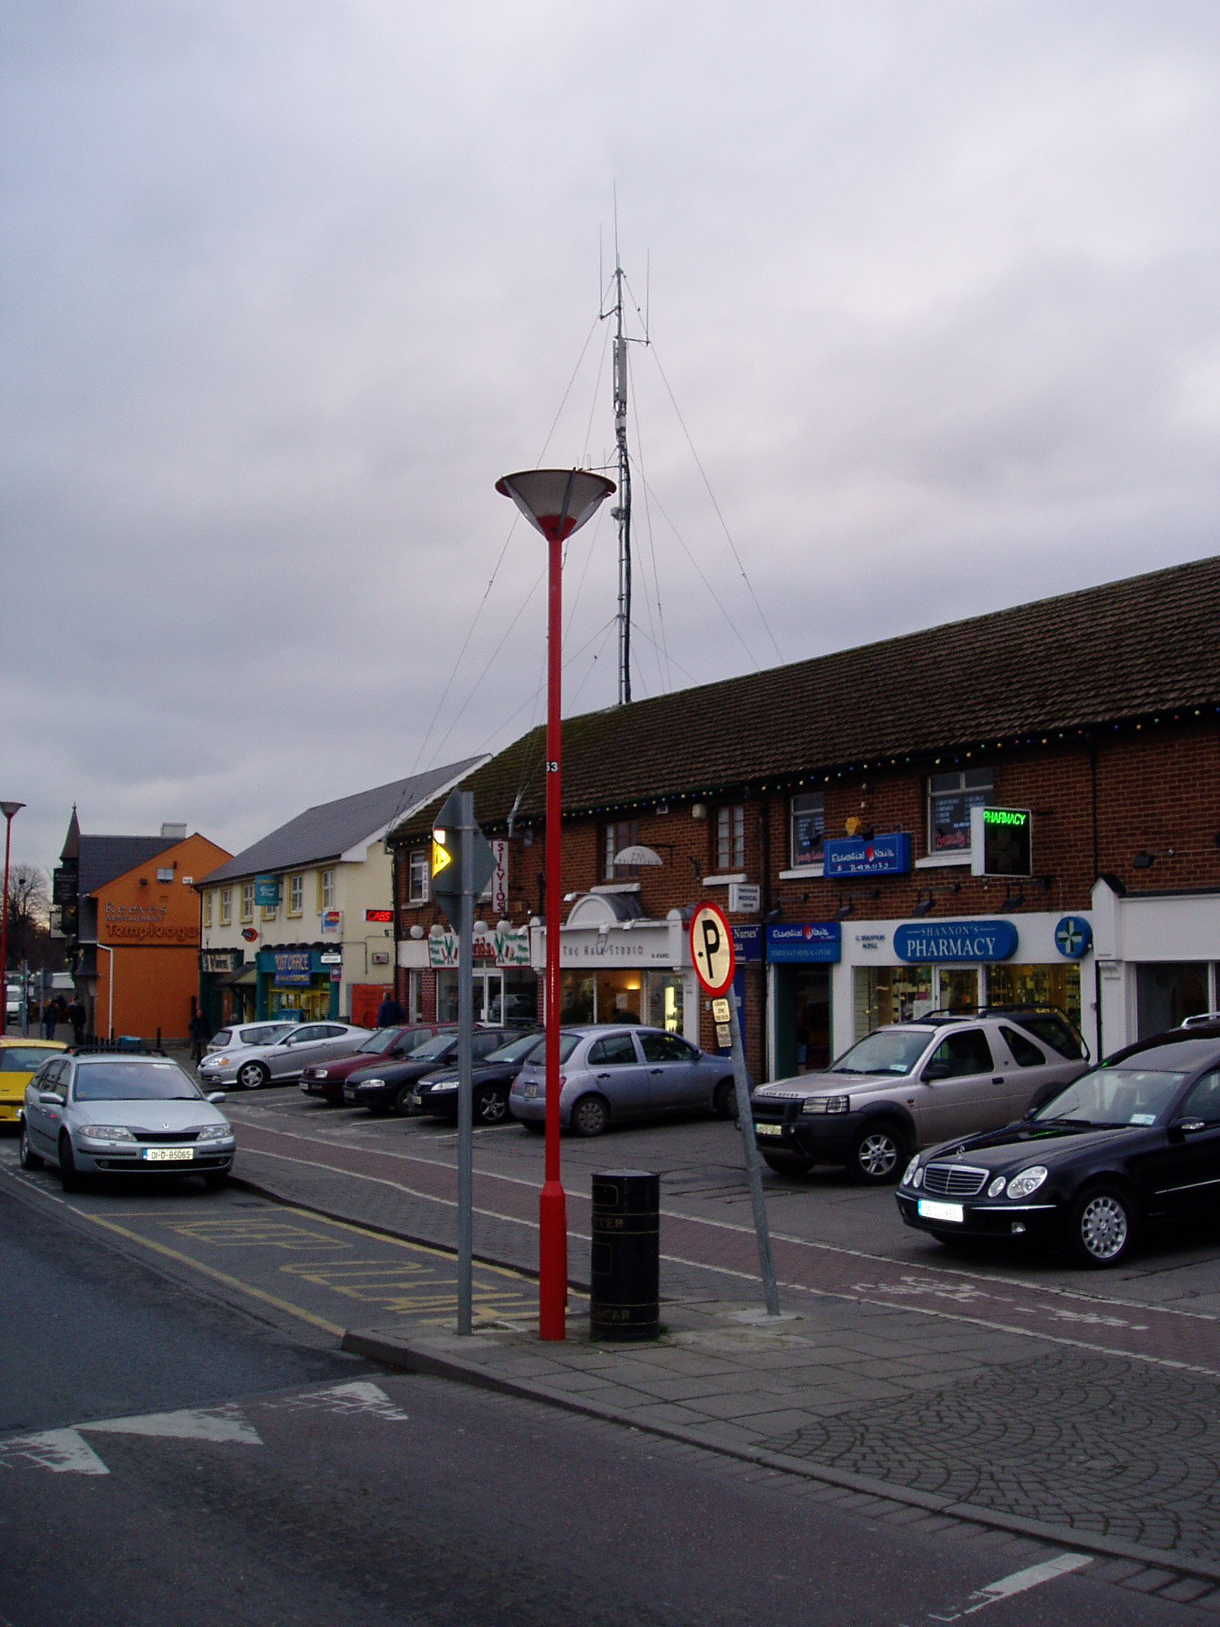
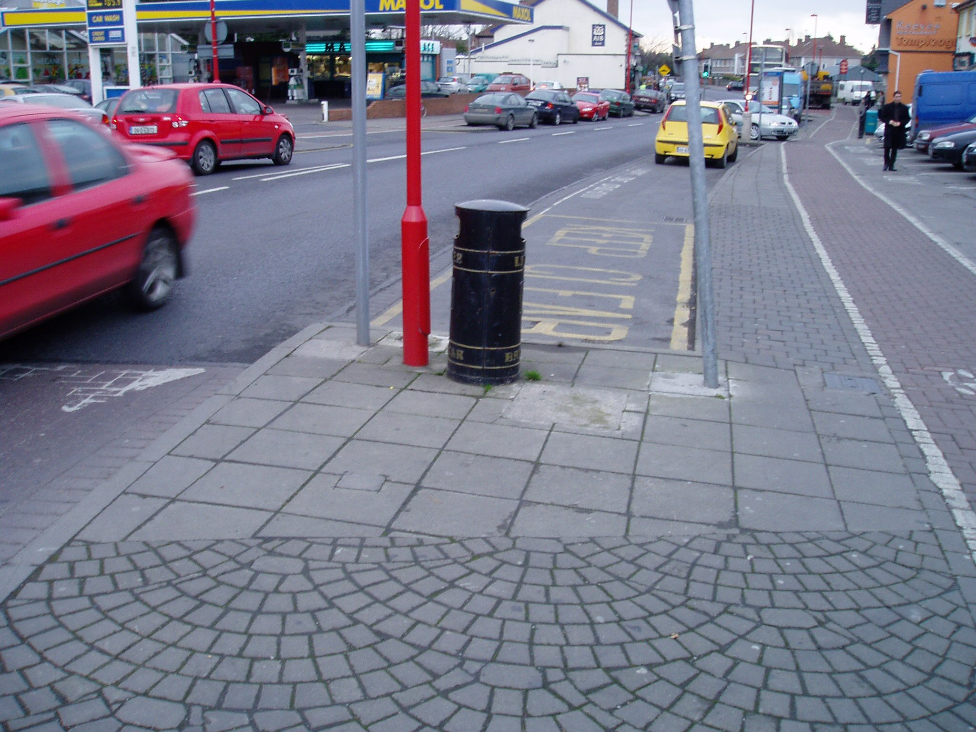
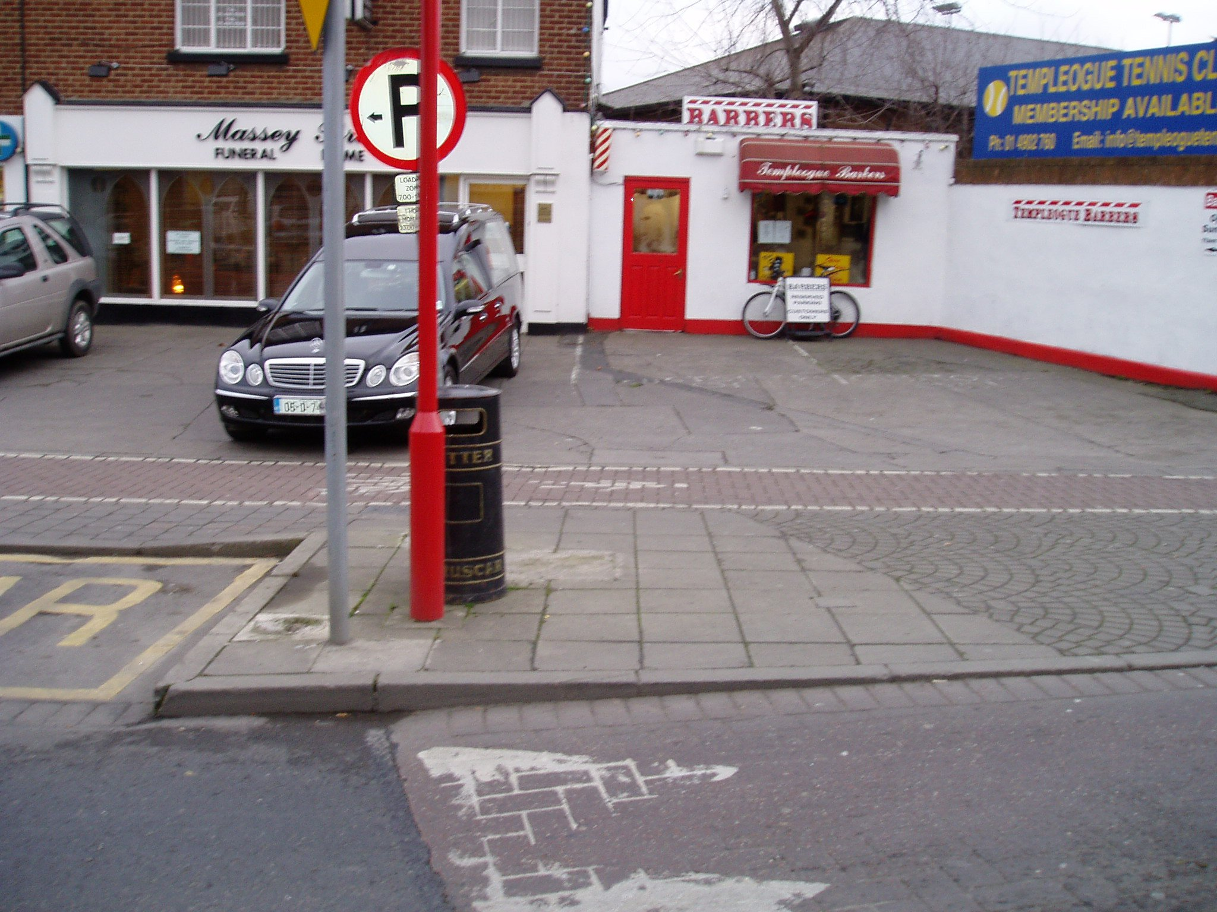
Appendix 3
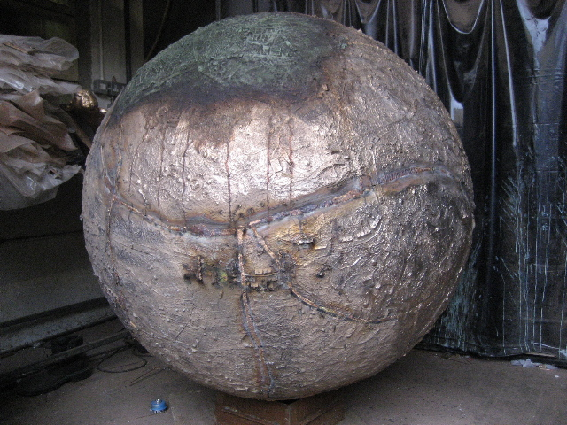

Love All, work in progress
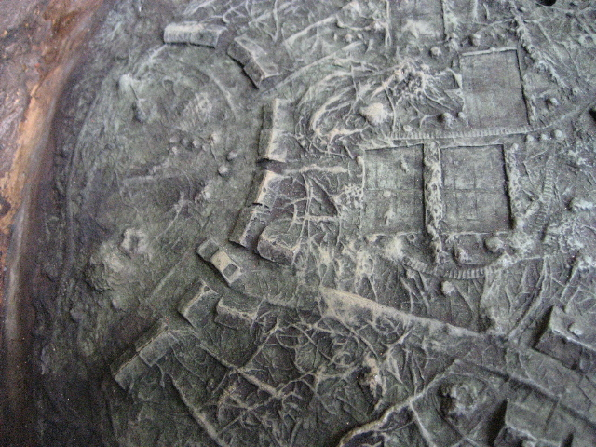

Love All, work in progress (detail)
Appendix 4
Appendix 5

