COMHAIRLE CHONTAE ATHA CLIATH THEAS

SOUTH DUBLIN COUNTY COUNCIL

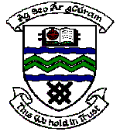

MEETING OF TERENURE/RATHFARNHAM AREA COMMITTEE (2)

Wednesday 11th April 2007

Motion No. 8

Motion: Councillor A. White
" That the Manager report to the committee on the Council's policy generally in relation to working with local residents and associations to improve the maintenance and appearance of estates such as Dargle Wood and Orlagh which could benefit from some additional shrubs and trees."
Report:

The Parks Department is keen to provide assistance in any way possible and to work jointly with residents and representative associations to enhance the maintenance and appearance of all residential areas throughout the county. Many very positive examples of joint initiatives between residents association and the Parks Department exist. The residents of Dargle Wood and Orlagh estates should contact the Parks Department to arrange meetings in order to discuss and explore opportunities to enhance the landscape treatment of their areas.

