COMHAIRLE CHONTAE ATHA CLIATH THEAS

SOUTH DUBLIN COUNTY COUNCIL

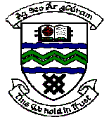

MEETING OF TERENURE/RATHFARNHAM AREA COMMITTEE (2)

Wednesday 11th April 2007

QUESTION No. 7

Question: Councillor T. McDermott

“To ask the Manager to explain why some mature trees, in good condition, have been removed in the Willington Park area, if there are plans to replace the trees removed and if there are plans to remove or replace any more and will he make a statement on the matter?"

Reply:

A small number of trees were removed from Willington Park as part of the current programme of Arboricultural Works for various reasons including one tree which was considered in a dangerous condition and another which has grown too large for its location and was causing damage to a footpath. However, a large number of new trees have been planted in the Willington area in recent months. Arrangements to plant further trees in the area will be made as part of the 2007/08 Arboricultural Programme which will be undertaken between November 2007 and March 2008.

