COMHAIRLE CHONTAE ATHA CLIATH THEAS

SOUTH DUBLIN COUNTY COUNCIL

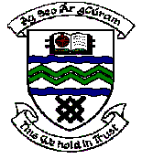

MEETING OF TERENURE/RATHFARNHAM AREA COMMITTEE (2)

Wednesday 11th April 2007

QUESTION No. 6

Question: Councillor T. McDermott

“To ask the Manager to immediately replace the tree that was blown down (and partly removed by the council) adjacent to 20 Prospect Grove, Prospect Manor?"

Reply:
This tree will be listed for replacement under the 2007/08 Arboricultural Programme which will be undertaken between November 2007 and March 2008. A contractor will be engaged in the near future to remove the stump as part of a tree stump removal programme.

