COMHAIRLE CHONTAE ATHA CLIATH THEAS

SOUTH DUBLIN COUNTY COUNCIL

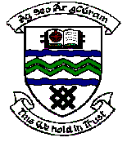

MEETING OF TERENURE/RATHFARNHAM AREA COMMITTEE (2)

Wednesday 11th April 2007

QUESTION No. 4

Question: Councillor J. Lahart
“To ask the Manager include Edmondstown Green in the next tree pruning programme with specific reference to house no. 35?"
Reply:

These trees are not considered a priority for pruning at the present time but will be considered in the draft schedule for 2007 / 2008 Arboricultural Programme.

