COMHAIRLE CHONTAE ATHA CLIATH THEAS

SOUTH DUBLIN COUNTY COUNCIL

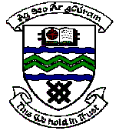

MEETING OF TERENURE/RATHFARNHAM AREA COMMITTEE (2)

Wednesday 11th April 2007

QUESTION No. 3

Question: Councillor M. Ardagh
“To ask the Manager to carry out a clean up of the Orwell Open Space as residents have expressed concern about broken glass and bottles in the area?"
Reply:

Broken glass has recently been removed from the pedestrian footpaths throughout Orwell open space. A further clean up of the open space is planned in advance of the commencement of seasonal grass cutting in the area which is scheduled to start within the next two weeks.

