COMHAIRLE CHONTAE ATHA CLIATH THEAS

SOUTH DUBLIN COUNTY COUNCIL

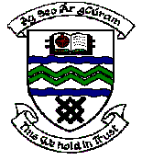

MEETING OF TERENURE/RATHFARNHAM AREA COMMITTEE (2)

Wednesday 11th April, 2007.

QUESTION No. 1

QUESTION: Councillor M. Ardagh

"To ask the Manager for a report on the works being carried out on Templeogue House and to indicate when the House will be available for community use?"

REPLY:

A detailed report has been sent to the Heritage Section of the Department of the Environment outlining the proposed works for the restoration of the House for full use. This report has followed a number of meetings held with the technical officials of that section whose approval we need before proceeding with the proposals and detailed surveys which are now completed accompanied the report.

The Department have indicated that they will respond by mid-April on the report.

The members will be kept informed of any progress on the matter.

