COMHAIRLE CHONTAE ATHA CLIATH THEAS

SOUTH DUBLIN COUNTY COUNCIL
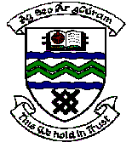

MEETING OF TERENURE / RATHFARNHAM AREA COMMITTEE MEETING (2)

Tuesday 13th March, 2007.

Headed Item No: H – I (7)

Application for Grants (Arts Act 2003)

Application for a grant under the Council’s Arts Grants Scheme has been received from the organisation listed below. Payment of this grant to this organisation, in accordance with the conditions of the Scheme, in the amount set out hereunder, is recommended for approval:-

Ref: | Group | Type of Application | Date of Application | Amount
AGF 567 | Holy Spirit Church Adult Choir, Ballyroan | Grant towards performances for 40th Anniversary Celebrations | 5/2/07 | €400

