COMHAIRLE CONTAE ÁTHA CLIATH THEAS

SOUTH DUBLIN COUNTY COUNCIL

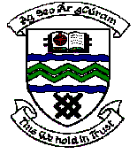

MEETING OF TERENURE/RATHFARNHAM AREA COMMITTEE (2)

Tuesday 13th March 2007

Motion No. 6

Motion: Councillor S. Laing

"That the Manager give an up to date statement on what work he intends to carry out in Glendoher Open Space and what finance has been allocated."

Report:

Significant improvement works have been completed in Glendoher Park over the past two years in conjunction with the residents association for the area. In recent weeks, bark mulch has been put in place for mulching of planted areas and arrangements have been made to clean and re-oil the existing bird boxes.

A tree planting project is being planned for local children to be undertaken during National the month of March and discussion is ongoing with the residents association in regard to planting of the boundary walls of the park with ivies. Any additional works at this location will be financed from capital funding.

