COMHAIRLE CONTAE ÁTHA CLIATH THEAS

SOUTH DUBLIN COUNTY COUNCIL

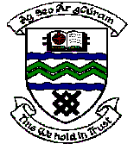

MEETING OF TERENURE/RATHFARNHAM AREA COMMITTEE (2)

Tuesday 13th March 2007

Motion No. 5

Motion: Councillor J. Lahart

"That the Manager report on any progress being made on my proposal some years ago about the idea for a boardwalk overlooking a stretch of the Dodder at Lr. Dodder Road."

Report:
Boardwalks along rivers are used in circumstances where conventional pedestrian access is otherwise unavailable.
While they can be of interest visually, they can also be an intrusion into ecological habitats and can disturb some wildlife.
In the case of the section of the River Dodder at Lower Dodder Road, there is an existing pathway almost at river level on the southern side of the river and this is considered adequate for public access.
However, we will examine other sections along the Dodder to determine where the placement of boardwalks are feasible and appropriate.

