COMHAIRLE CONTAE ÁTHA CLIATH THEAS

SOUTH DUBLIN COUNTY COUNCIL

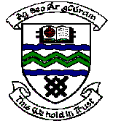

MEETING OF TERENURE/RATHFARNHAM AREA COMMITTEE (2)

Tuesday 13th March 2007

Question No. 14

Question: Councillor E. Walsh

“To ask the Manager, in view of the absence of destruction of planted items at the bus turning bay Limekiln Avenue, to plant shrubs, wall creepers and additional trees in order to enhance this location as it is a main focal point in the area and these works would help to develop the village concept that was started recently?"

Reply:

This location will be considered for further planting as part of the 2007/08 Arboricultural Programme.

