COMHAIRLE CHONTAE ATHA CLIATH THEAS

SOUTH DUBLIN COUNTY COUNCIL
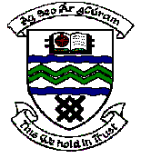

MEETING OF TERENURE-RATHFARNHAM AREA COMMITTEE (2)

Tuesday 13th March, 2007

Motion No. 10

Motion: Councillor S. Laing

That the manager give a full report on his recent visit to the Community Centre in Ballyroan?"

Report
A meeting was arranged, following request, to discuss the offer of the transfer of the Ballyroan Community Centre to the Council in return for the provision of a Pastoral Centre.
This meeting has now been held with the Committee at which a concept drawing was presented indicating a new extension to rear of the Community Centre which would be used as a dedicated Parish Pastoral centre but this proposal was rejected by the group who requested that the Parish Pastoral Centre be a separate building.
It was agreed to further consider this stand alone concept and drawings are currently being prepared.
A further meeting with the Committee will be held as soon as possible having considered the new drawings and cost implications.

