COMHAIRLE CONTAE ÁTHA CLIATH THEAS

SOUTH DUBLIN COUNTY COUNCIL

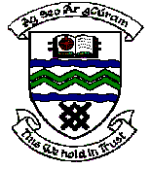

MEETING OF TERENURE/RATHFARNHAM AREA COMMITTEE (2)

Tuesday 13th March 2007

Question No. 7

Question: Councillor J. Lahart

"To ask the Manager to include the trees on Edmondstown Green, specifically outside no 35 to be included on the next tree pruning season?"

Reply:

These trees are not considered a priority for pruning at the present time but will be considered in 2007 / 2008 Arboricultural schedule.

