COMHAIRLE CHONTAE ÁTHA CLIATH THEAS
SOUTH DUBLIN COUNTY COUNCIL

South Dublin County Council
Monday 12th March 2007

Headed Item No. 4(d)(ii)

MINUTES OF MEETING OF ECONOMIC DEVELOPMENT AND PLANNING STRATEGIC POLICY COMMITTEE HELD on 22 November 2006

Present:

Councillors Sectoral Representatives

Trevor Gilligan
Billy Gogarty Justin Byrne
Cáit Keane Jim Fay
Joe Neville Deirdre Mooney
Shane O’Connor
Eamon Tuffy

Apology for inability to attend was received from Cllr Robert Dowds and Noel O’Connor.
Councillor E. Tuffy, Strategic Policy Committee Chairperson, presided.

Officials present:

Jim Walsh, Director of Economic Development
Tom Doherty, Director of Planning
Frank Nevin, Senior Executive Officer,
Paul Hogan, Senior Planner, Planning
Fionnuala Lennon, Senior Executive Planner.

Martin Judge, Senior Executive Officer,

Anne Reilly, Assistant Staff Officer

ITEM 1: Minutes
Minutes of meeting of 20th September 2006, which had been circulated, were proposed by Councillor E. Tuffy, seconded by Councillor C. Keane and APPROVED as a true record and signed.
ITEMS 2 & 3: Update on Liffey Valley and Balgaddy Masterplan & SDZ
Report:
Briefing on Balgaddy – Clonburris SDZ & Liffey Valley Centre
Paul Hogan and Fionnuala Lennon presented the report to the members and outlined the proposals therein. The members were updated on progress on the Balgaddy SDZ & the proposed Metro line.
There followed a discussion with contributions from E. Tuffy, S. O’Connor, C Keane, J. Byrne, J. Fay & D. Mooney.
P. Hogan & F. Lennon responded to members queries.
ITEM 4 : Further issues for SPC.
J. Walsh outlined the role of SPC and requested that members submit matters for consideration appropriate to the Economic Development and Planning SPC.

ITEM 5: Update from Sub Committee on Policy on maintaining existing residential Cul-De-Sacs.
ITEM 6 : Update from Anti-Social Behaviour Sub-Committee.
Eamon Tuffy, Chairman, indicated that he proposed to take the two items together as the committees had met in tandem. He paid tribute to the contribution made by Siobhan Duff and Patricia Devlin to the work of the Committee and outlined the discussions held. He indicated that the committees would meet again after Christmas and invited any members to join the Committee.
Item 5 Report:
“Committee Members Present:
10th October 2006 3.30pm to 5.00pm
Cllr. Eamon Tuffy (Chair of Sub Committee)
Cllr Joe Neville
Justin Byrne, Community Representative
Noel O’Connor (CIF)
Apologies: Cllr Cait Keene

Officials present:

Siobhan Duff, Senior Executive Planner
Patricia Devlin, Senior Executive Planner

Process
Members agreed to ‘Terms of Reference’ for the Sub Committees on anti-social behaviour and cul de sacs, and that the sub committees would meet together.

A report was drafted and discussed at a subsequent meeting of the sub-committee, which met on Monday 20th November 2006 to review the draft report prior to its presentation to the Strategic Policy Committee. Members of the sub-committee present at this meeting are listed below:

Committee Members Present:
20th November 2006 3.00pm – 430pm
Cllr. Eamon Tuffy (Chair of Sub Committee)
Cllr Billy Fogarty
Cllr Joe Neville
Cllr Robert Dowds
Cllr Mick Murphy
Noel O’Connor (CIF)
Deirdre Moroney

Apologies: Justin Byrne

Officials present:

Siobhan Duff, Senior Executive Planner
Patricia Devlin, Senior Executive Planner

Purpose of the Report
It was agreed that the purpose of the report on Cul de Sac Access, from this sub-committee, to the Economic Development and Planning Strategic Policy Committee, would address policies concerning the opening of existing sacs to facilitate development on adjoining, undeveloped, zoned lands.

- Issues to be Considered
A range of issues and opinions were expressed. These included:

Not all land should be built on. Other methods of access / egress should be investigated to gain access e.g. Jackson Lands, Tully Hall, and Hermitage Estates.
  - Existing residents in cul de sacs expect that the cul de sac amenity would be retained.

  - However another view considered that in the interests of sustainability, the full potential of the resource of zoned land should be utilised.

Could a specific levy to provide environmental or community improvements be imposed to compensate existing residents for the increased traffic? It was acknowledged that any proposed special levy would involve a statutory process under the Planning and Development Act 2000(as amended).

  - Estate layouts should be ‘permeable’ i.e. encourage linkage for pedestrians and cyclists.

- Progress Towards a Final Report
Members nominated locations as sample sites, i.e. estates with cul de sacs, to provide a basis for examining the issues and options. Two sites were discussed -
Corbally/Verschoyle in Citywest and Tullyhall in Lucan.

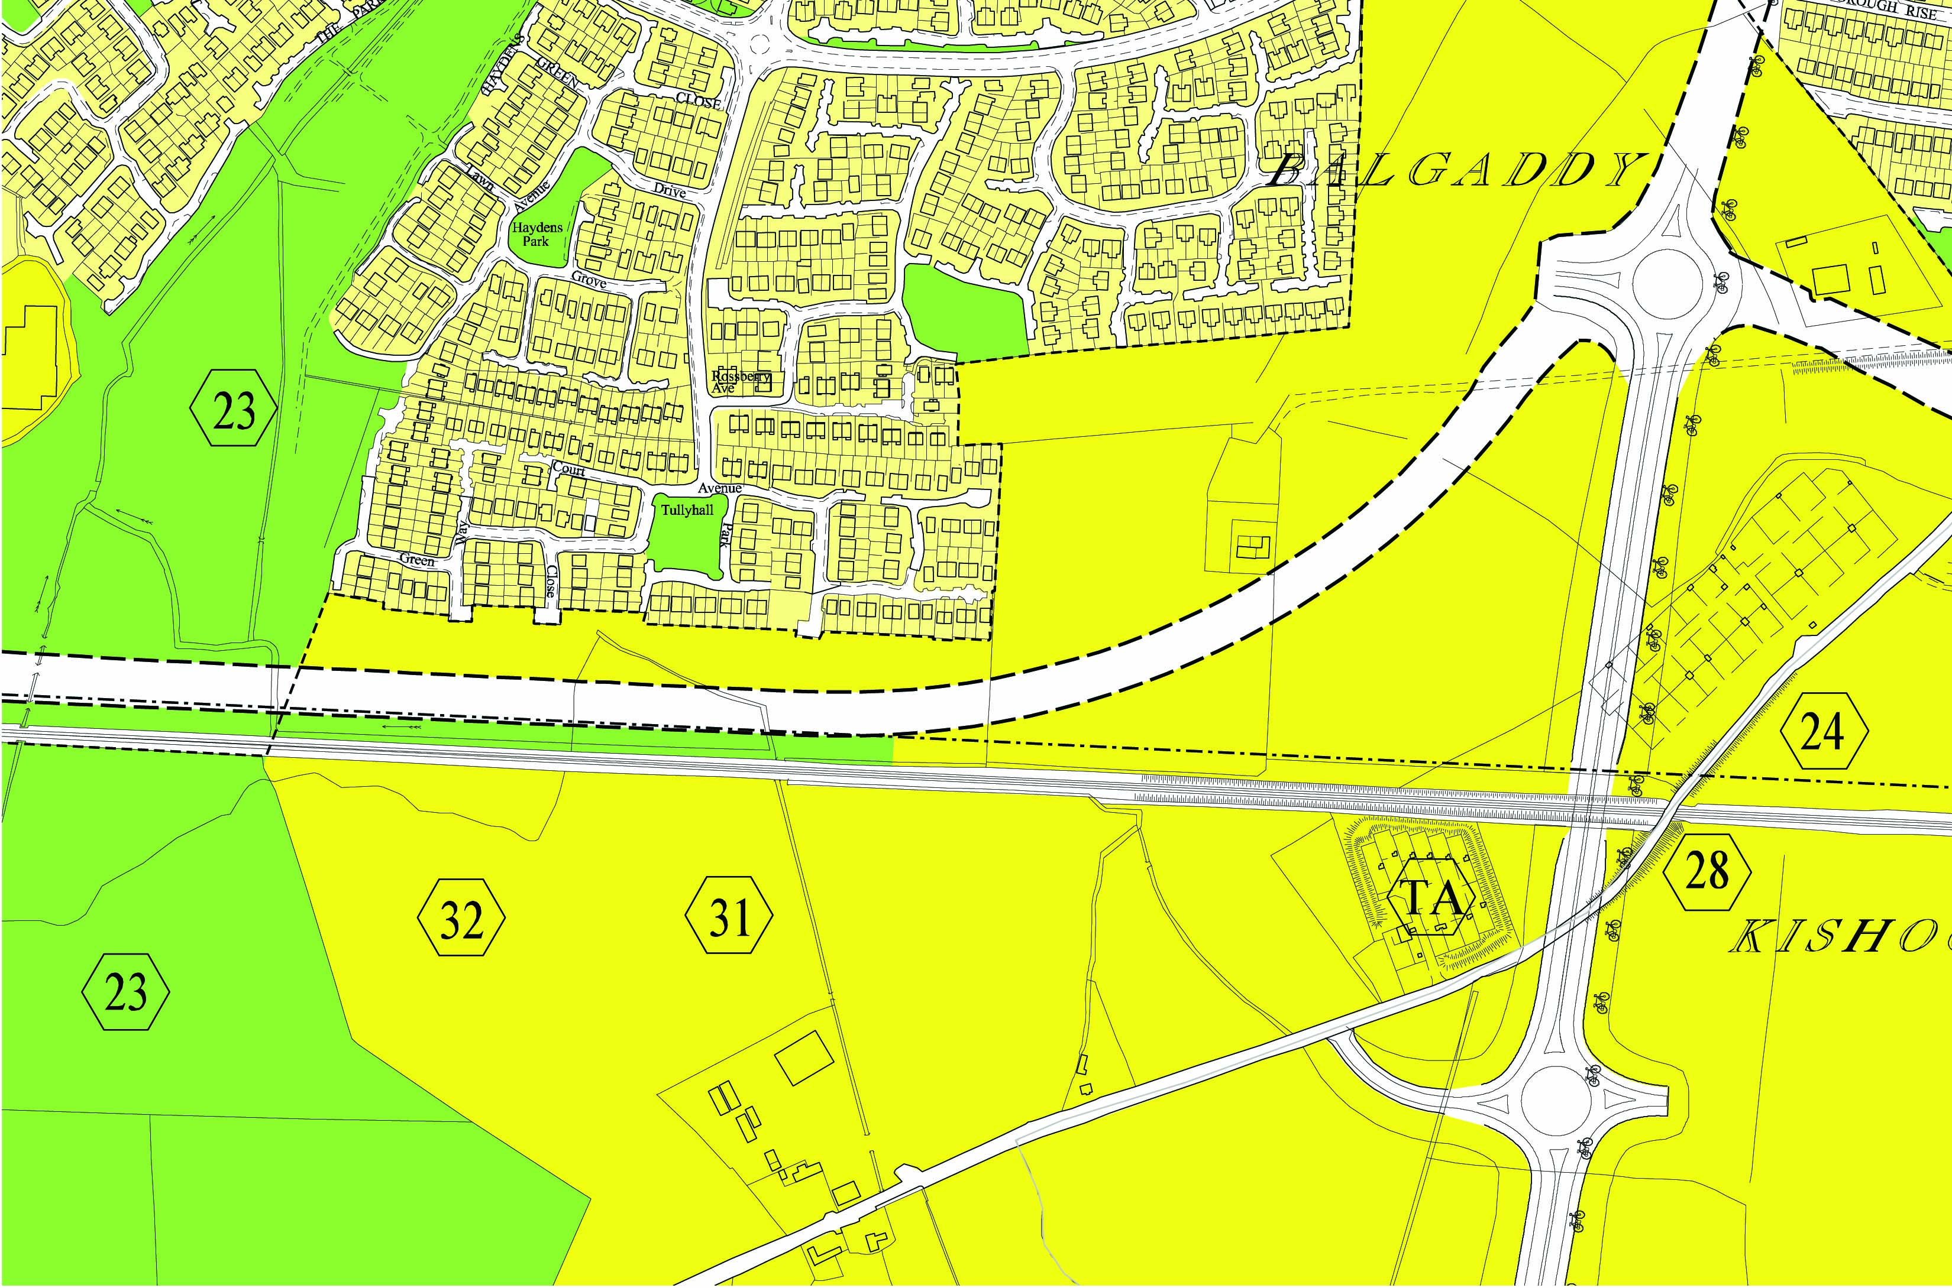
Tullyhall Estate, Lucan

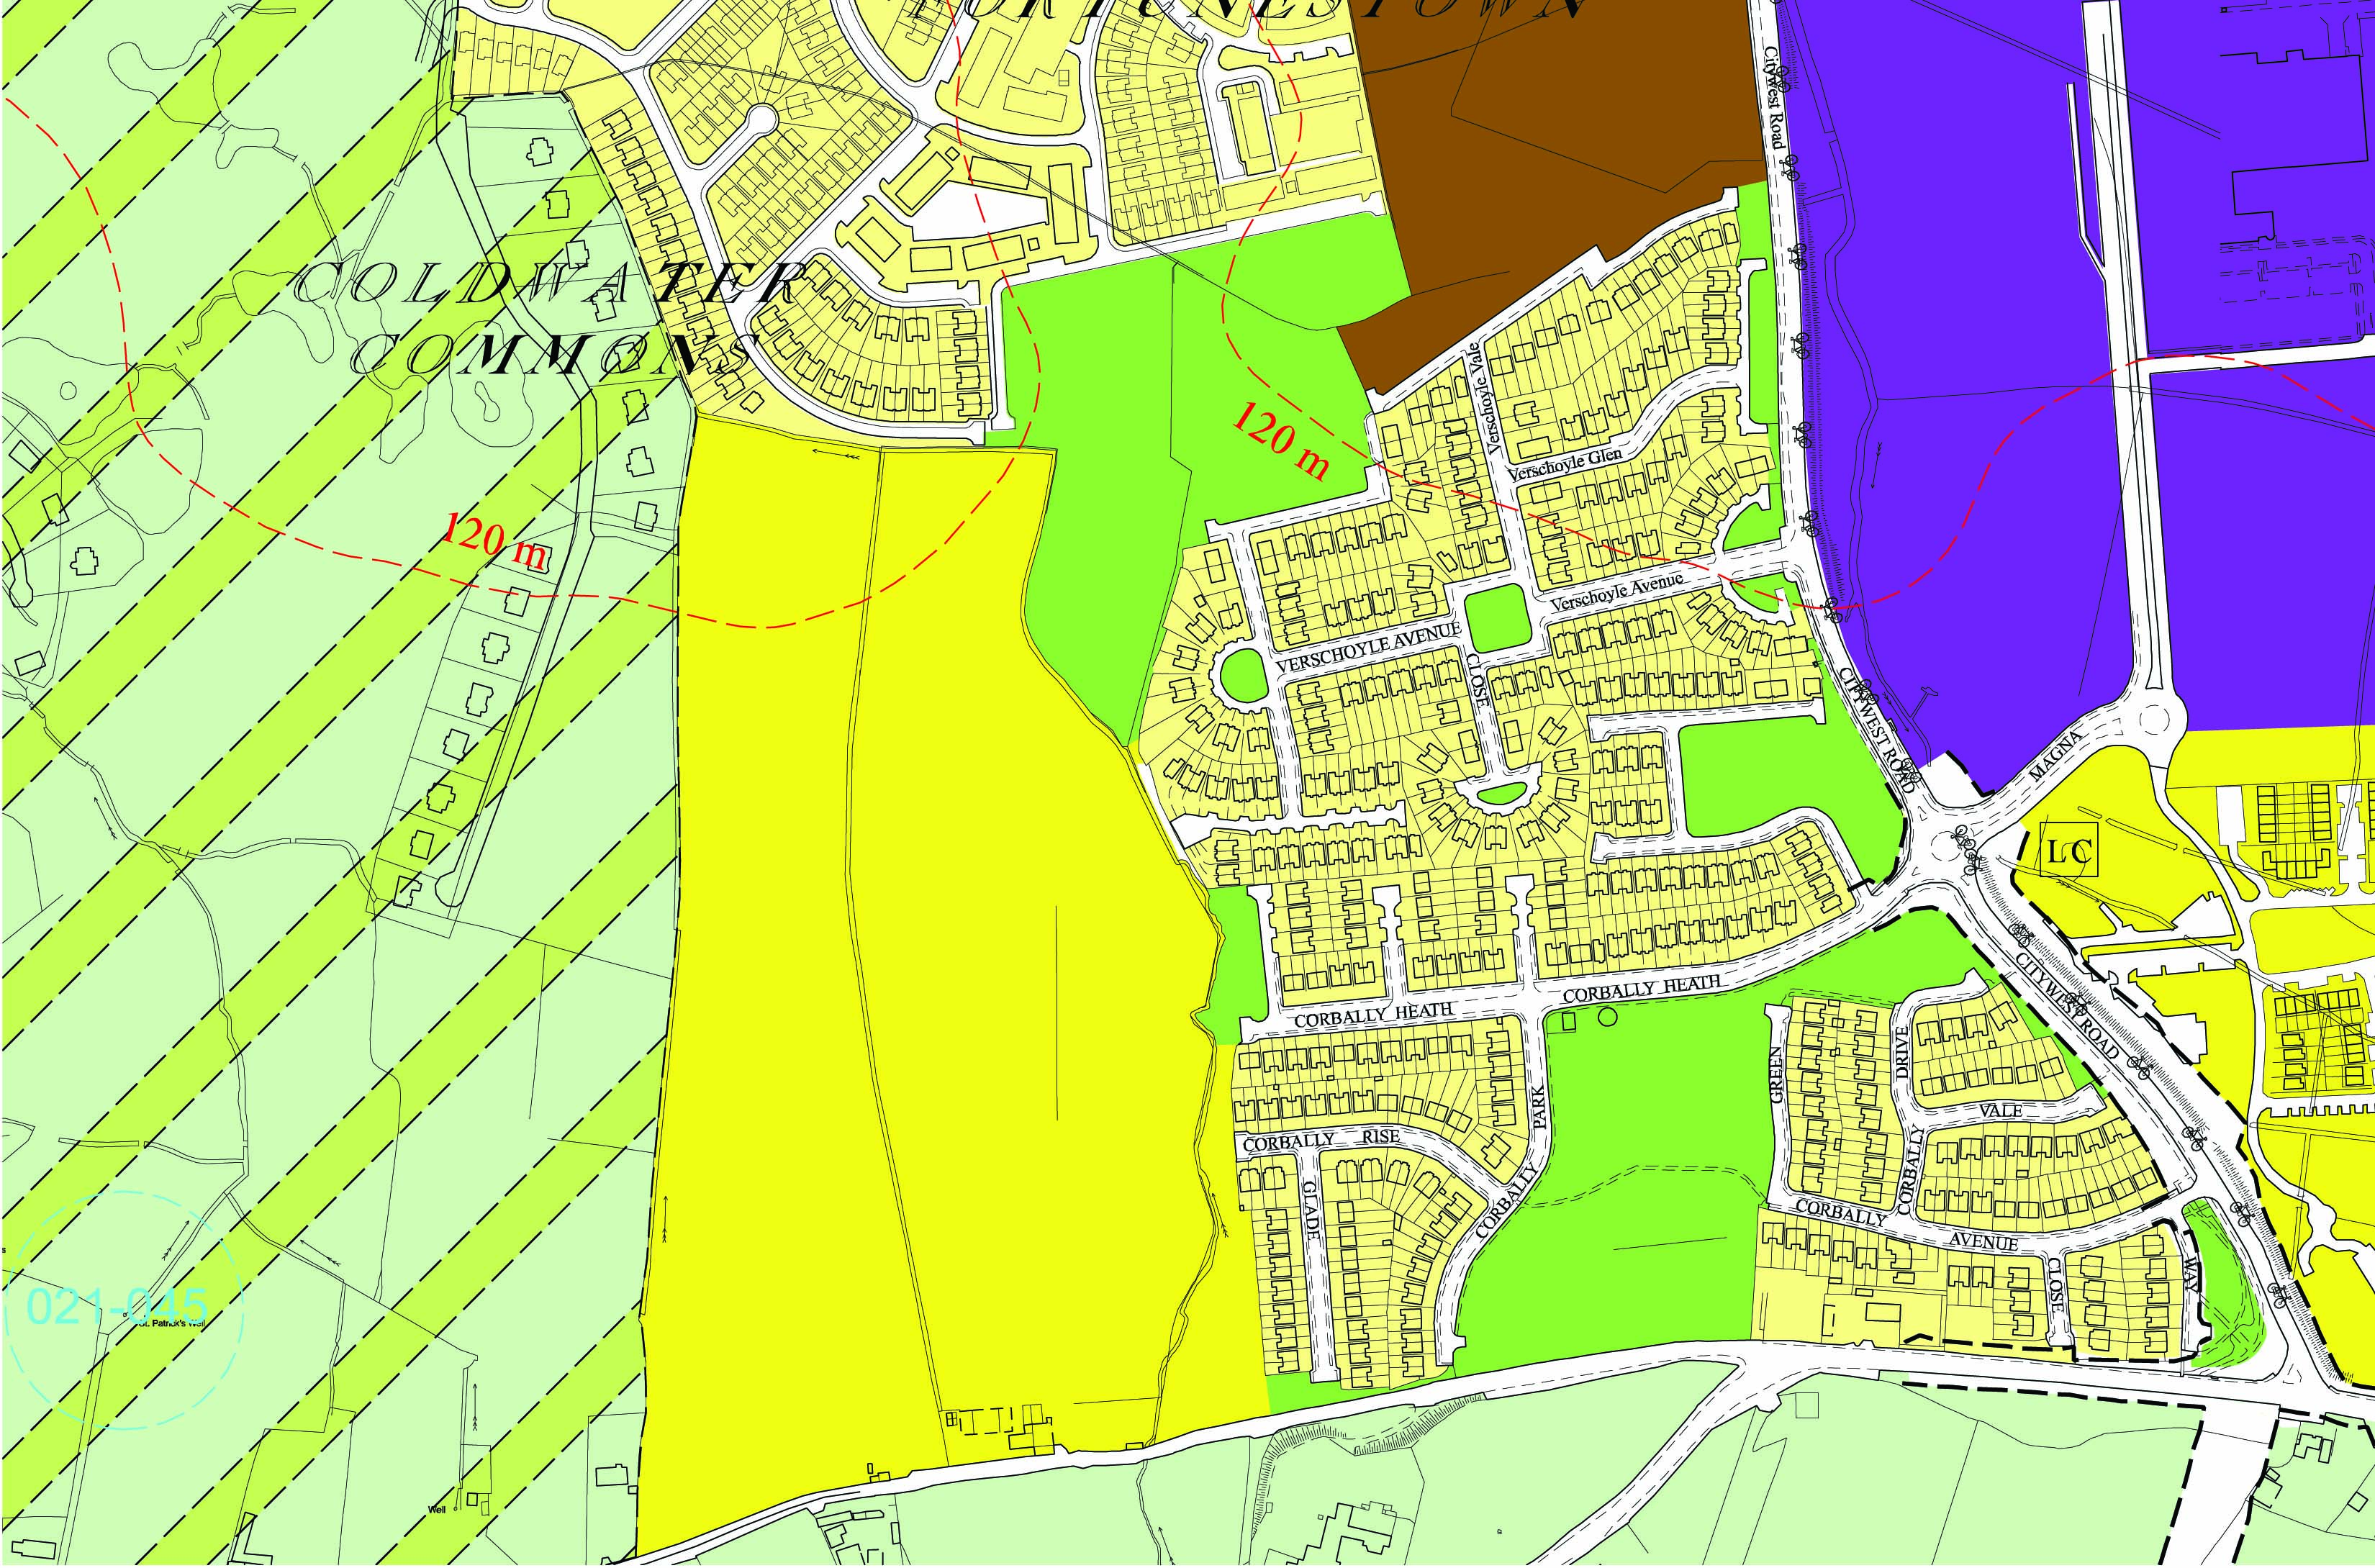
Corbally/Verschoyle Estate, Citywest

Members have nominated the following factors to be considered in the assessment of access through existing cul de sacs:

- New Roads
It is considered that the first priority for providing access to zoned lands with development potential should be through the construction of new roads or the extension of existing public roads.

- Multiple Accesses
It is considered that new estates should be designed with a number of access points into the wider network, in order to avoid the repetition of traffic congestion where large estates have only a single access onto the road network e.g. Ballycullen.

- Road Safety
It is considered that access through suitable cu de sac/s should only be considered where access from a proposed development onto an existing road would constitute a traffic safety hazard.

- Design of Existing Cul de Sacs
Cul de sacs surrounded by 6 to 10 houses, where the width of the road is less than 5.5/6 metres and where the road surface material includes coloured, stamped tar macadam or paviors, are constructed as permanent layouts. However, estate roads, which terminate at, or near, the boundary of an estate, adjoin undeveloped land, are constructed with widths of 5.5/6 metres or greater and include footpaths on both sides, may not be designed as ‘permanent’ cul de sacs.

It is considered that only cul de sacs, which have been designed to facilitate adjoining development, or to accommodate widening works where the verge is wider enough, should be used for access to development lands. In every case, the front garden amenity of the housing units on the existing ‘cul de sac’ should be maintained.

d) Boundary Treatment
It is considered that the boundary treatment, e.g. block walls matching the boundary walls of back gardens, located at the end of ‘temporary cul de sacs’, should not be permitted to be constructed in permanent materials. Such construction, where a future access to adjoining lands is intended, creates an expectation of permanence. Rather, any required site barrier should be constructed as a type of palisade fence allowing clear views into the adjoining fields. This would prevent the false visual impression to prospective purchasers that the ‘cul de sac’ was intended to be permanent.

- Safety Principles and Mitigation Measures
It is considered that the following safety principles and/or methods of mitigating undesirable impacts should be applied in the design of the ‘new access road’ i.e. through a suitable existing cul de sac:
- Retain the existing traffic safety amenity of the cul de sac design – this would mean the inclusion of traffic calming measures to maintain low speeds.
- Replace the amenity, which is lost through the conversion of a cul de sac to an access road, in particular the loss of the additional parking spaces provided by a hammerhead at the end of a cul de sac.
- Replace any incidental playing areas of green space, or mitigate the impact of the loss of these spaces.

Next Step
it is envisaged by the sub-committee that the final drafting for a report could be concluded at its next meeting in February 2007.”

Item 6 Report:
“Committee Members Present:

Cllr. Eamon Tuffy (Chair of Sub Committee)
Cllr Joe Neville
Justin Byrne, Community Representative
Noel O’Connor (CIF)
Officials present:

Patricia Devlin, Senior Executive Planner, Planning Department, South Dublin County Council
Siobhan Duff, Senior Executive Planner, Planning Department, South Dublin County Council

1. PROCESS
Members agreed to ‘Terms of Reference’ for the Sub Committees and that the sub committees had agreed to meet together.
2. PURPOSE OF REPORT
- To examine ways in which anti-social behaviour can be reduced through
the Planning process.
- To develop methods of assessing access to new residential
development through existing cul de sacs. This matter is dealt with in a
separate report.

3. ANTI-SOCIAL BEHAVIOUR – ISSUES RAISED AT SUB-COMMITTEE MEETING

(i) Older developments based on the cul-de-sac pattern have resulted in ‘pockets’ of unsupervised areas where teenagers gather. Teenagers tend to be automatically vilified, often for no reason. Options for these areas and poorly located open space can be addressed through infill developments. However, the resultant increased densities and loss of open space can create other problems for residents including noise through inadequate insulation.

(ii) Management of areas not owned by Council e.g. Old Bawn & Kilnamanagh – privately owned open space, too small to develop, difficult to ascertain ownership.

Council-Built Development – Anti-social behaviour devices e.g. galvanized steel shutters, are included in schemes built by Council. While this approach can be positive in security terms, it may send out a signal that ‘trouble is expected’.

Communal Car Parking - Example cited of development where affordable housing development is beside existing older development where communal (pool) car parking provided for the new development is being used by the older neighbouring development, creating conflicts between the neighbours.

Playgrounds

What happens in time when they’re not used i.e. when age profile of area changes?

Creative landscaping instead of formal playgrounds has been used in some new developments.

South Dublin County Council Play Policy has been adopted.

Developers can be reluctant to install play facilities due to maintenance concerns – how it will look in a few years time.

Oregon (USA) – this example was cited where small playgrounds are provided in new housing developments.

Support for mobile coffee docks in parks (as proposed by Cllr. Hannon).

Innovative “playground” areas for teenagers to gather.

Shelters provided for teenagers as a focal point in some UK estates.

(vi) Comments on how planning can address anti-social behaviour included layout of developments, design of residential units, mixed land uses, elimination of unsupervised areas, the avoidance of cul-de-sacs and laneway patterns of access in lower density developments. High density developments, such as the Tallaght Masterplan indicate access from internal courtyards and malls rather than external off street or laneway access.

(vii) Issues Raised in General Discussion
- Sound insulation with timber framed construction.
- Residential amenity and security in multi-storey apartment blocks.
- Overlooking – passive surveillance desirable.
- Differences in Estate Management/ Control – taking in charge / private.
- Council built housing: too much regard for security, while private developments appear not to be built with enough awareness of security.
- Front gardens should not be walled - open plan preference e.g. Monastery Park, Clondalkin.
- Organic development of new and old developments desirable.
- Adaptable housing desirable for a mixture of age groups avoiding a “life cycle” on estates.
- Supervision, insurance and maintenance issues in relation to play equipment. Landscaped play features overcome these issues.
- Need for management companies to take responsibility.

4. ANTI-SOCIAL BEHAVIOUR REPORT

A verbal synopsis of the report on Anti-Social Behaviour that was considered at the meeting of the Economic Development and Planning SPC on 17th May 2006 and that led to the setting up of this Sub-Committee, was given at the Sub-Committee meeting. The following summary covers the issues raised:

Synopsis of ‘Report on Planning Policies and Design Approaches to Reduce Anti-Social Behaviour’ considered at Economic Development and Planning SPC on 17th May 2006.

Good design of the built environment has the potential to reduce anti-social behaviour, while poor design can facilitate it. The Planning Department has produced many documents containing policies and objectives which have implications for anti-social behaviour. Some of these policies/objectives are explicit in relation to designing out crime and anti-social behaviour, while others contain general design approaches which are good practice in planning terms and which may also promote safety and security. In addition, during the Development Control process, relevant planning applications are assessed to ensure that proposed designs do not encourage anti-social behaviour.

General Issues
- Need for passive surveillance in open spaces and lanes
- Need for lighting of laneways, open spaces and car parks
- Ensuring planting beside laneways and footpaths does not give cover for anti-social behaviour
- Ensuring there are no secluded corners or bends, etc. in laneways
- Permeability of layouts
- Diversity of uses
- General design quality
- Pedestrian priority and speed restraint measures
- Provision of recreational facilities.

Policies and objectives contained in the Development Plan which would contribute to the alleviation of anti-social behaviour include:
- The Sustainable Placemaking Model: All planning applications for new residential development are assessed in accordance with this model which envisages a lively and interconnecting network of streets and spaces fronted by varied and interesting buildings and a mix of residential, commercial, public and community uses together with quieter, primarily residential areas, all in close proximity.
- Infill Development: The development of small scale infill development on lands in Council ownership which are no longer considered appropriate for retention as open space and/or recreational areas (i.e. lands subject to zoning objective ‘F’). The policy specifically refers to the fact that open spaces which are not overlooked can become the focus for anti-social behaviour. As such, implementation of this policy has the potential to reduce this problem.
- Social Inclusion: The implementation of policies which seek to promote social inclusion, counteract social segregation and which target investment in disadvantaged areas potentially contribute to the reduction of anti-social behaviour.
- Local Centres: In the upgrading of existing local centres and the design of new local centres, Development Plan policy SCR7 sets out a number of elements which should be incorporated including ‘design which results in a safe, informally-supervised environment’.
- Open Space and Recreation: The Development Plan contains several policies relating to the provision of open space, recreational facilities and play facilities. Paragraph 4.5.8.ii states ‘The lack of facilities for children and young people is a major concern in the County. This is considered by many to contribute to anti-social behaviour and crime’. Policies SCR21 and SCR23 seek the provision of recreational facilities and play facilities, respectively, concurrent with new residential developments. In addition, Policy SCR 20 supports the development of recreational facilities in general, while Policy SCR 22 resolves to provide children’s play facilities in regional parks and other suitable locations.
- Pedestrian Links: Policy SCR 25 ‘Pedestrian Links and Public Rights-of-Way’ seeks to preserve links which contribute to amenity and that are not a source of anti-social behaviour. In order to avoid this, it is stated that the Council ‘will ensure that proposed pedestrian links are directly overlooked by housing, are well-lit and are not enclosed by high walls or dense planting’.
- ‘Joyriding’: Anti-social behaviour involving ‘joyriding’ is a problem in some parts of the County. Chapter 11 of the Development Plan recommends measures to help alleviate the ‘joyriding’ problem by making it more difficult to speed. Devices include entry treatment, shared surfaces, carriageway narrowings and chicanes, speed reduction bends, speed control islands, traffic islands and speed tables/cushions. In addition, good urban design in general, as proposed in the Sustainable Placemaking Model referred to earlier, can help to reinforce the need to reduce speed and reduce the dominance of traffic, particularly in residential areas. Design devices include careful positioning of buildings, ensuring frontage directly onto streets, perpendicular parking, landscaping and use of different materials.
- Local Plans: There are eleven local plans/studies covering various parts of the South Dublin County area. Most of these plans/studies do not make explicit reference to anti-social behaviour. However, all contain strategies for local areas involving good layout and design and elements which would promote safety and security and inhibit anti-social behaviour. Measures include –
  - Pedestrian permeability including linkages/connections between existing main streets and development land
  - Passive surveillance
  - Lighting
  - Additional shopping and recreational facilities
  - Speed restraint measures
  - Concierge service for and CCTV (Draft Tallaght Town Centre Plan)

    - Development Management: During the development management process, all planning applications are assessed in accordance with policies and objectives contained in the Development Plan, including policies and objectives relevant to anti-social behaviour as set out above. In addition, in the assessment of larger commercial and residential applications, issues of security and safety are taken into consideration in a number of other ways:
- In some cases, major development proposals are referred to the Garda Crime Prevention Design Advisor for comment.
- The recommendations contained in a 2002 report by An Garda Síochána entitled ‘Crime Prevention Through Environmental Design – Housing’ are considered in the assessment of relevant planning applications.
- Planning applications with proposals for new parks or open space or implications for existing parks or open space are referred to the Parks Department for comment. In some cases, issues are raised in relation to anti-social behaviour, safety and security.

5. WAY FORWARD ON ANTI-SOCIAL BEHAVIOUR

Draft a reference document based on the above report, setting out ways in which the planning process can seek to ameliorate anti-social behaviour. This document would contain a checklist in order to ‘proof’ planning applications and local area plans/masterplans/planning studies against anti-social behaviour.”

Tom Doherty indicated that it was proposed that the Committees would report to second SPC meeting in 2007.

ITEM 7 : Green Routes in South Dublin County
Report:
“The report below was presented to the members of the SPC in September 2005.:

“In compliance with Policy 7.8 of the County Development Plan 2004 -2010:

Policy – Cycling and Walking
“It is the policy of the Council to promote and facilitate the development of cycling and walking facilities in the County and to ensure that all development facilitate access by foot and bicycle to public transport facilities and local services”

the Manager has set up an inter-departmental group from within the Council to examine a network of strategic cycle tracks and pedestrian routes throughout South Dublin County.

This group recommends a primary spine green route throughout the County consisting of 3 orbital routes and 3 radial routes with secondary routes linking places of employment, schools and leisure activities. The spine route is primarily a green pedestrian and cycle route.

Following agreement on the Spine Route it is intended to talk to Waterways Ireland to agree design details along the canal banks and to identify a location for a pilot project to demonstrate how best to develop the route.

Map indicating recommended Green Route circulated herewith.”

In the interim progress has been made on the proposed routes :

- Grand Canal – Grange Castle to Inchicore

South Dublin County Council, ESB, Waterways Ireland and Dublin City Council have agreed a joint approach to examining the feasibility of bringing a power line from the ESB works at Inchicore to Grange Castle in tandem with an environmental upgrade along the canal including the development of footpath/cycle paths & CCTV along the route. A topographical survey has been completed and is currently being examined by consultants.

- Griffeen to Canal.

Part 8 complete. Work commenced on phase 1 - Esker Prk/Griffeen Valley Park (from Lucan Sports and Leisure to Griffeen Avenue).

- Dodder Route - Old Bawn Road to County Boundary

Green Pedestrian and Cycle Routes Report being finalised at present.”

Jim Walsh presented the report and confirmed that a complete report will issue to members before end 2006 for discussion at the SPC in early 2007.
He indicated that in relation to the Grand Canal the feasibility and cost of the project will require particular careful examination.
ITEM 8 : Economic Strategy for South Dublin County (with Chamber of Commerce)
Report:

“Members will be aware that an economic audit for South Dublin County was published in 2005. Following on that publication it is intended to prepare an economic strategy for the County in conjunction with the South Dublin Chamber of Commerce. A number of meetings have been held and are planned with the Chamber and consultants in order to advance the preparation of the Strategy.”

Jim Walsh outlined the report and confirmed that the strategy will be progressed with the South Dublin Chamber.

ITEM 9 : AOB.
There was no business under this heading.

As this was the final meeting of the SPC for 2006 Eamon Tuffy thanked all the members for their contribution to the work of the Committee during the year and wished them a happy Christmas.

The meeting concluded at 7.30 pm.

