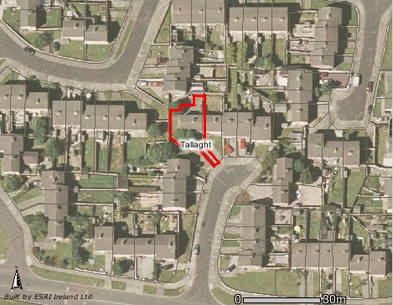

Map of 100 Killinarden Heights, Tallaght, Dublin 24

