COMHAIRLE CHONTAE ATHA CLIATH THEAS

SOUTH DUBLIN COUNTY COUNCIL
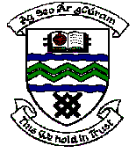

MEETING OF TERENURE-RATHFARNHAM AREA COMMITTEE (2)

Tuesday 13th February, 2007.

Headed Item No: H-I (8)

Application for Grants (Arts Act 2003)

Application for grant under the Council’s Arts Grants Scheme have been received from the organisation listed below. Payment of this grant, in accordance with the conditions of the scheme, in the amount set out hereunder, is recommended for approval.

Ref: | Group | Type of Application | Date of Application | Amount  €
AGF 561 | Templeogue Orchestral Performance Summer School | Grant towards a classical concert performance | 5/1/07 | €600

