COMHAIRLE CHONTAE ATHA CLIATH THEAS

SOUTH DUBLIN COUNTY COUNCIL

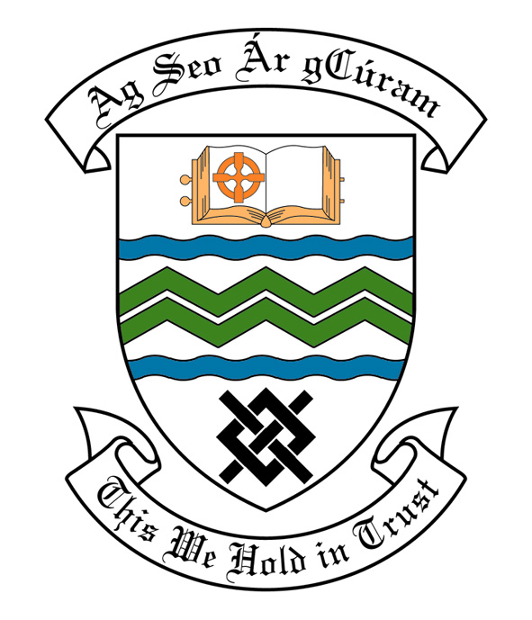

MEETING OF SOUTH DUBLIN COUNTY COUNCIL

MONDAY 12th February, 2007

MEETING OF THE LUCAN/ CLONDALKIN AREA COMMITTEE(2)

Tuesday 23rd January, 2007

HEADED ITEM NO: H-I (2) ( f )

Application for Grants

Application for a grant under the Council’s Community Grants Scheme has been received from the organisation listed below. Payment of this grant to this organisation, in accordance with the conditions of the scheme, in the amount set out hereunder, is recommended for approval:-

Ref: | Group | Type of Application | Date of Application | Amount
GF 1491 | Elaine Kavanagh School of Irish Dancing | Countywide Community Activity Event with a Countywide Interest | 03/10/06 | €1,500

Application for Grants (Arts Act 2003)

Application for a grant under the Council’s Arts Grants Scheme has been received from the organisation listed below. Payment of the following grant to this organisation, in accordance with the conditions of the scheme, in the amount set out hereunder, is recommended for approval:-

Ref: | Group | Type of Application | Date of Application | Amount  €
AGF 558 | Lucan Community College | Grant towards arts workshops | 9/11/06 | €700

A contribution is being made to the following group:-

Group | Type of Application | Amount
Clondalkin Camera Club | Contribution towards the launch of annual exhibition | €500

It was proposed by Councillor R. Dowds, and seconded by Councillor T. Ridge and RESOLVED:

“That this Committee recommends that South Dublin County Council approve payment of the above grants as recommended in the foregoing report”

