COMHAIRLE CHONTAE ÁTHA CLIATH THEAS

SOUTH DUBLIN COUNTY COUNCIL

TERENURE RATHFARNHAM AREA
COMMITTEE MEETING (1)

Minutes of Terenure/Rathfarnham Area Committee Meeting (1), (dealing with Roads, Planning, Development and Corporate Services business) held on 5th December 2006.

PRESENT

Councillors
M. Ardagh
C. Keane
S. Laing
J. Lahart
T. McDermott
E. Walsh
A. White

An Cathaoirleach, Councillor T.McDermott presided.

OFFICIALS PRESENT
Senior Executive Officers | E.Cunningham, M. Judge, P. Murphy
Senior Engineers | M.OKeeffe, J. McLoughlin,T.O’Grady
Senior Planners | M. Kenny, C. Ryan
Administrative Officers | T. Curtin, P. McNamara, M. Hunt, M. Kelly
Senior Executive Engineers | S. Daly
Senior Executive Planners | P. Devlin
Staff Officer | N. Fitzgibbon
Clerical Officer | A. Shaw

TR/839/06 CONFIRMATION AND RE-AFFIRMATION OF MINUTES

HEADED ITEM (1)

Minutes of meeting of Terenure/Rathfarnham Area Committee (1) dealing with Corporate Services, Roads, Planning and Development business, held on 7th November 2006, which had been circulated were submitted, APPROVED as a true record and signed.

It was proposed by Councillor T. McDermott, seconded by Councillor M. Ardagh and RESOLVED:

“That the recommendations contained in the Minutes of the Terenure/ Rathfarnham Area Committee Meeting (1) held on 7th November 2006 be ADOPTED and APPROVED.”

ROADS BUSINESS

TR/840/06 QUESTIONS

It was proposed by Councillor T. McDermott, seconded by Councillor S. Laing and RESOLVED:

“That pursuant to Standing Order No. 13, questions numbered 1-13 inclusive be ADOPTED and APPROVED.”

TR/841/06 SEVERE FLOODING AFTER HEAVY RAINFALL

QUESTION (1): Councillor M. Árdagh
"To ask the Manager when the problems causing severe flooding after heavy rainfall at (details provided) which has been raised previously, will be addressed?"

REPLY:
This problem is associated with the overall drainage system for the area and the Drainage Department have a scheme in place which should commence on site in 2007.

TR/842/06 UPGRADE OF PUBLIC LIGHTING IN THE CYRPESS DOWNS

QUESTION (2): Councillor M. Árdagh
"To ask the Manager to upgrade the public lighting in The Court, Cypress Downs to the same standard as the work carried out on The Drive last year?"

REPLY:
Public Lighting upgrade will be prioritised, as resources permit. It should be noted that there is a major increase in energy costs with the result that upgrading works will be curtailed.

TR/843/06 TRAFFIC CALMING MEASURES ON ACCESS ROAD TO TEMPLEOGUE WOOD

QUESTION (3): Councillor M. Árdagh
"To ask the Manager install ramps or other traffic calming measures on the access road to Templeogue Wood to prevent motorists speeding in the estate which is of concern to the residents?"

REPLY:
In response to a large number of requests for traffic calming measures throughout the Council’s administrative area the Council’s Transportation Strategic Policy Committee at its meeting on the 11th May 2006 adopted a new Traffic Calming programme comprising of four schemes in each of the Council’s five electoral areas. The selection of each individual scheme will be made by the relevant Area Committee.
The Main Access Road in Templeogue Wood is on the traffic calming request list for the Terenure/Rathfarnham electoral area.
The Terenure/Rathfarnham Area Committee will consider the selection of locations for traffic calming early next year.

TR/844/06 RESURFACE RATHFARNHAM ROAD

QUESTION (4): Councillor J. Lahart
"To ask the Manager to report on when the Council proposes to resurface Rathfarnham Road from the Village to the Dodder?"

REPLY:
Funding has been approved for this scheme and the work will be carried out in early 2007.

TR/845/06 ELECTRONIC GATES AT PINE GROVE

QUESTION (5): Councillor J. Lahart
"To ask the Manager to agree to meet with residents of Pine Grove who, having had the entrance to their development changed, wish to have electronic gates fitted to any new entrance being constructed as a consequence of the re-alignment of the Knocklyon Road?

REPLY:
There is no objection to meeting the residents of Pine Grove and contact should be made with Council's Road officals. It is understood that a management company is responsible for the maintenance of Pine Grove estate. It does not have electronic gates at its present entrance.

TR/846/06 FOOTPATH HILLSIDE PARK/BALLYROAN RD

QUESTION (6): Councillor S. Laing
"To ask the Manager to tarmacadam the footpath between the houses at the end of Hillside Park connecting Ballyroan Road open space?"

REPLY:
The surfacing of the laneway at Hillside Park has not been included in 2006 works list. However, this work will be considered for inclusion in our 2007 works schedule subject to resources & priorities.

TR/847/06 EXITING WILLBROOK LAWN

QUESTION (7): Councillor S. Laing
"To ask the Manager to state what action he is taking to assist Willbrook Lawn in exiting their Estate on lower Whitechurch since the last Deputation Meeting?"

REPLY:
Double Yellow Lines and Warning Signs have been installed. Other measures for Whitechurch Road are dependant on recommendations in forthcoming Consultants Report for improvements to this road.

TR/848/06 HOUSE NOS IN PEARSE BROS/PALMER ESTATE

QUESTION (8): Councillor T. McDermott
“To ask the Manager to arrange for the provision of signage indicating the house numbers of rows of houses at strategic points in the Pearse Bros. and Palmer Estates, as the original scheme of numbering is confusing to visitors?”

REPLY:
Numbering of individual houses is a matter for the householder concerned and is not undertaken by the Roads & Traffic Department. It is not clear what additional street name plates are required given that the existing estates are currently identified. Contact will be made with the residents association to determine what they have in mind.

TR/849/06 LIGHTING IN PALMER/PEARSE BROS ESTATES

QUESTION (9): Councillor T. McDermott
“To ask the Manager to arrange for the installation of adequate street lighting in the Palmer and Pearse Bros. Estates to provide security for residents and also deter dumpers. A street light is urgently needed, for example, beside the E.S.B. sub-station?”

REPLY:
The public lighting in Palmer and Pearse Bros. Estates will be examined in the next two weeks and should work be necessary, funding will be sought.

TR/850/06 PILLARS AT MOYVILLE LAWN

QUESTION (10): Councillor T. McDermott
“To ask the Manager to investigate the construction of pillars at the top of Moyville Lawns to give more privacy and emphasise its residential nature (e.g. the entrances to Woodfield Estate, Scholarstown Road and to Prospect Manor, Stocking Lane)?”
REPLY:
It is not Council policy to construct pillars at the entrance to estates. In some instances developers erect such a feature.

TR/851/06 MOTOR-BIKES USING CYCLE LANES IN RATHFARNHAM

QUESTION (11): Councillor A.White
"To ask the Manager to deal with the problem whereby motor-bikes are constantly using the cycle lane/footpath access from Rathfarnham Road to The Falls/Dodder Park Drive causing serious invonvenience and danger to local residents?"

REPLY:
This location will be inspected to ascertain the extent of the above problems and the feasibility of measures which might be taken to reduce them. The matter will also be referred to the Gardai.

TR/852/06 HOUSE & ROAD NOS IN PALMER PARK/PEARSE BROS PARK

QUESTION (12): Councillor A.White
"To ask the Manager to provide clear signage of house numbers and roads in Palmer Park/Pearse Brothers Park?"

REPLY:
Numbering of individual houses is a matter for the householder concerned and is not undertaken by the Roads & Traffic Department. It is not clear what additional street name plates are required given that the existing estates are currently identified. Contact will be made with the residents association to determine what they have in mind.

TR/853/06 ROAD MARKINGS RATHFARNHAM VILLAGE

QUESTION (13): Councillor A.White
"To ask the Manager to re-paint the road marking at the southern end of Rathfarnham village indicating "no entry" to the village?"

REPLY:
The "No Entry" markings will be replaced as soon as possible.

TR/854/06 DECLARATION OF ROADS TO BE PUBLIC ROADS

H-I (2)
It was NOTED that there was no business under this heading.

TR/855/06 PROPOSED INITIATION OF EXTINGUISHMENT OF PUBLIC RIGHT OF WAY

H-I (3)

PROPOSED EXTINGUISHMENT OF PUBLIC RIGHT OF WAY AT THE REAR OF 1-14 LIMEKILN GREEN, WALKINSTOWN, DUBLIN 12 - MAP REF: RE 0620

The following report was submitted to the Terenure/ Rathfarnham Area Committee on the 5th September, 2006
“Proposed extinguishment of public right of way at the rear of 1-14 Limekiln Green, Walkinstown, Dublin 12

An application has been received from Development Department and the residents of 11 Limekiln Green and 61 Limekiln Avenue to formally extinguish the public right-of-way at the rear of 1-14 Limekiln Green, Walkinstown, due to antisocial behaviour and to affect the closure by means of incorporation into their gardens.”

Following consideration of the report, it was agreed to initiate the procedure.

The proposal to extinguish the public right-of-way was advertised in the Echo on Thursday, 21st September, 2006 and signs were erected on site in accordance with Section 73 of the Roads Act, 1993. The latest date for receipt of objections, representations and requests for an oral hearing was 6th November, 2006.

The following is a breakdown of the submissions received in response to the public advertisement/notice:-

In Favour | Objections | Requests for Oral Hearing
5 | 16 | 16

Bord Gais, Eircom and NTL have stated that they have no objections to the proposed extinguishment.

ESB has no objections to the proposed extinguishment but they require contact be made with them in advance of any works taking place.

Public Lighting Section has no objection to the proposed extinguishment, however, it would necessitate the disconnection and removal of 2 No. Public Lighting columns and associated cabling.

Water & Drainage Sections have no objections to the proposed extinguishment.

The decision regarding the extinguishment of a public right-of-way and the granting of an oral hearing is a reserved function of the Council.

Any recommendation of the Committee will be brought to the attention of the Council.

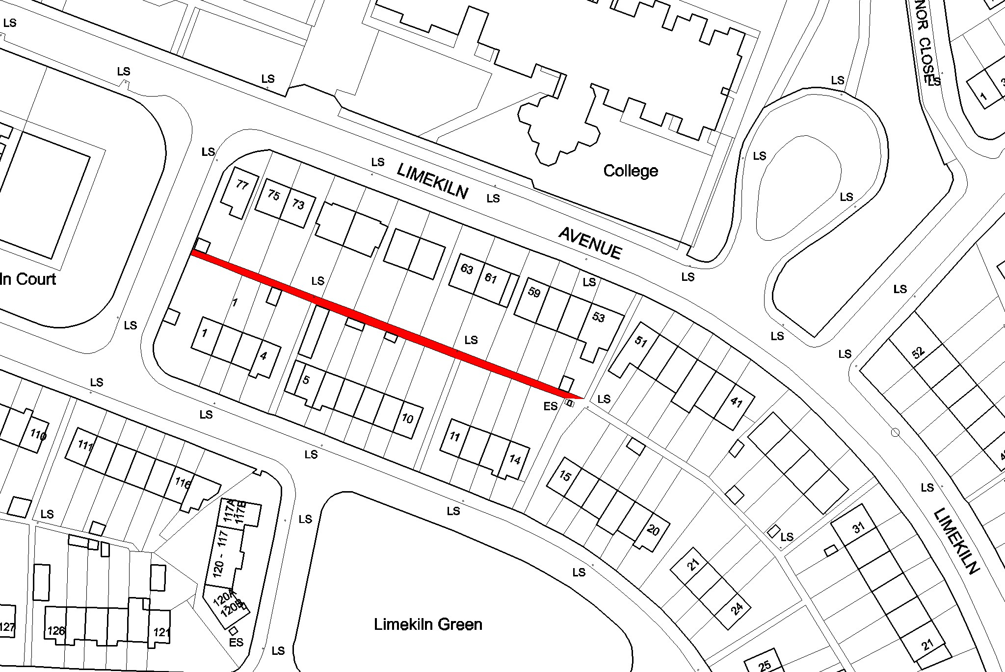

Following contributions from Councillors, M. Ardagh, C. Keane, E. Walsh and S. Laing, Mr. E. Cunningham responded to queries raised and it was AGREED to hold an oral hearing.

TR/856/06 TRAFFIC CALMING AT WILLOWBANK DRIVE

H-I (4)

The following report by the Manager was CONSIDERED:

REPORT UNDER SECTION 38 OF THE ROAD TRAFFIC ACT 1994

PROPOSED TRAFFIC CALMING MEASURES ON WILLOWBANK DRIVE

INTRODUCTION:

Section 38 of the Road Traffic Act 1994 empowers a Roads Authority to provide traffic calming measures in respect of public roads in their charge. The proposed traffic calming measures as circulated to the residents of Willowbank Drive and Orchardton are as follows:-

DESCRIPTION OF SCHEME
The proposed works consist of the following:
- The installation of three standard traffic calming ramps on Willowbank Drive in lieu of the construction of a roundabout at the junction of Willowbank Drive and Orchardton.

CONSULTATION PROCESS:
Details of the proposed Traffic Calming Scheme for Willowbank Drive were distributed to all households on Willowbank Drive and Orchardton. The closing date for submissions was 4.30 p.m. on Friday 27th October, 2006.

SUBMISSIONS RECEIVED
Six (6) submissions were received, one of which was received after the closing date.

A schedule of the submissions is attached to this report and a file containing the submissions is available at the meeting.

ISSUES RAISED AND ROADS DEPARTMENT REPLIES TO THE SUBMISSIONS:

Concerns
Expressed Submission by Resident (1)
1. | Submission | Welcomes the scheme.  Requesting an additional ramp on Willowbank Drive on the Butterfield Park side of the bend.
1. | Response | It is considered that 3 ramps are sufficient for this road. However, the matter will be kept under review.
 | Submission by: Resident (2)
2. | Submission | Opposed to the installation of these ramps as he has never seen any evidence neither in terms of traffic speed or volume
2. | Response | Comments noted. However, submissions (4) and (5) below have highlighted the issue of speeding on Willowbank Drive. Accordingly it is proposed to proceed with the installation of the 3 traffic calming ramps on Willowbank Drive.
Submission by: Resident (3)
Residents Association (6)
3. | Submission | Supporting the scheme.
3. | Response | Noted.
 | Submission by: Resident (4) (5)
4. | Submission | Supporting the scheme due to speeding on Willowbank Drive.
4. | Response | Noted.
RECOMMENDATION:
It is recommended that the scheme as circulated be implemented.
The recommendation of the Committee will be brought to the County Council for decision.

LIST OF SUBMISSIONS

NAME ADDRESS

1. Tom and Kathleen Carroll, 10 Orchardton
2. John F. Wright 34 Orchardton
3. J.F. Langan 7 Willowbank Drive
4. Enda Kavanagh 18 Willowbank Drive
5. Patricia Hand 8 Willowbank Drive
6. Butterfield District Residents Association c/o 144 Butterfield Park

It was recommended that the scheme as circulated be implemented.

TR/857/06 NEW WORKS

H-I (5)
It was NOTED that there was no business under this heading.

TR/858/06 CORRESPONDENCE

Cor (1)
It was NOTED that there was no business under this heading.

TR/859/06 CATHAOIRLEACH’S BUSINESS

THROUGH TRAFFIC ON ROADS IN TERENURE/RATHFARNHAM

It was proposed by Councillor T. McDermott and seconded by Councillor S. Laing

MOTION (1)
"That this committee discuss the volumes of "through traffic" on each of the roads in Terenure/Rathfarmham, both historic and forecast, and the traffic management initiatives proposed by the manager to address the issues arising."

The following report by the Manager, which had been circulated, was READ:
“The Draft Final Report on the Countywide Modelling Study will be completed before end-December, following which the Consultants will be requested to assess the above issues in light of the Study's conclusions and the Local Area Model devised in relation to same, and to present a report on the findings to the Committee at the earliest opportunity.”
Following contribution from Councillor T. McDermott, Mr. E. Cunningham, Senior Executive Officer responded to queries raised and the report was NOTED.

TR/860/06 RIGHT HAND TURN A TEMPLEOGUE & SPRINGFIELD AVENUE

It was proposed by Councillor S. Laing and seconded by Councillor C. Keane

MOTION (2)
"That the Manager consider the deletion of the no right hand turn at the junction of Templeogue and Springfield Avenue as a number of Residents Associations have requested this since the M.V.A. report as it is felt it would relieve the situation at the Terenure junction."

The following report by the Manager, which had been circulated, was READ:
“Dublin City Council is the relevant authority responsible for the management and control of traffic at Terenure junction and no representations have been received from them to date in relation to existing arrangements at Springfield, either in the context of the MVA study or otherwise.
It may be noted, however, that the right turn bans at Springfield (inbound & outbound directions) were introduced as part of the Tallaght to City Centre QBC scheme and are designed to facilitate movement of buses through Templeogue Village. There is no evidence from CCTV monitoring or traffic count data that traffic volumes have increased or congestion worsened as a result of these measures but that the opposite is in fact the case and the original QBC objectives are being achieved along the route. This Council is committed to the policies and objectives of the DTO Strategy, A Platform for Change, including the development and enhancement of the Quality Bus Network. Deletion of the ban at Springfield as suggested would have a detrimental effect on the QBC performance, and also on traffic movement through Templeogue Village and is therefore not recommended.”
It was AGREED to take Motion Nos. 5 and 7 in the names of Councillor T. McDermott and S. Laing respectively in conjunction with the above.
MOTION (5) TRAFFIC CONGESTION TERENURE/TEMPLEOGUE AREA

It was proposed by Councillor T. McDermott and seconded by Councillor S. Laing

"That this committee agree, with the aid of a detailed report from the manager, those recommendations from the "MVA Report" on traffic congestion in the Terenure/Templeogue area that are feasible and desirable for implementation."

The following report by the Manager, which had been circulated, was READ:
“A report, including recommendations, on the MVA Review of Traffic Management Arrangements in the Terenure-Templeogue-Rathfarmnham Area was adopted by the Terenure-Rathfarnham Area Committee at its meeting of 7th March 2006. The Committee directed that the report be advised to Dublin City Council and this was done on 15th March 2006. Based on the generally negative reaction to recommendations in the MVA Study from the public and elected representatives in both authorities, it is the Roads & Traffic Department's understanding that there are no plans by D.C.C . to proceed any further with the matter at the present time. As the main issues to be addressed are within the D.C.C. area, there is little that this Council can do on its own in the circumstances. The overall situation will continue to be monitored by both authorities, however, in the context of agreed regional traffic management
arrangements.”
MOTION (7) MVA CONSULTANTS REPORT

It was proposed by Councillor S. Laing and seconded by Councillor T. McDermott

"That the Manager give an update on the M.V.A. Consultants report."

The following report by the Manager, which had been circulated, was READ:
“A report, including recommendations, on the MVA Review of Traffic Management Arrangements in the Terenure-Templeogue-Rathfarmnham Area was adopted by the Terenure-Rathfarnham Area Committee at its meeting of 7th March 2006. The Committee directed that the report be advised to Dublin City Council and this was done on 15th March 2006. Based on the generally negative reaction to recommendations in the MVA Study from the public and elected representatives in both authorities, it is the Roads & Traffic Department's understanding that there are no plans by DCC to proceed any further with the matter at the present time. As the main issues to be addressed are within the DCC area, there is little that this Council can do on its own in the circumstances. The overall situation will continue to be monitored by both authorities, however, in the context of agreed regional traffic management arrangements.”
Following contributions from Councillors, S. Laing. T. McDermott, C. Keane, M. Ardagh and A. White, Mr. E. Cunningham, Senior Executive Officer and Mr. M. O’Keeffe, Senior Engineer responded to queries raised and the reports were NOTED.

TR/861/06 RIGHT HAND FILTER - ST. AGNES RD TO CROMWELLSORT RD

It was proposed by Councillor M. Árdagh and seconded by Councillor C. Keane

MOTION (3)
"That the Manager design a plan with the Roads Department in South Dublin County and the Roads Department in Dublin City Council to provide for, as soon as possible, a right-hand filter light from St. Agnes Road to Cromwellsfort Road to facilite motorists turning right in safety."

The following report by the Manager, which had been circulated, was READ:
“Dublin City Council will be contacted again about the feasibility of acquiring land off the AIB car park. This land take is necessary should it be decided to proceed with the construction of the proposed right-hand filter light.”
Following contributions from Councillors, M. Ardagh and T. McDermott the report was NOTED.

TR/862/06 WHITECHURCH STREAM LIGHTING & PAVING

It was proposed by Councillor J. Lahart and seconded by Councillor T. McDermott

MOTION (4)
"That the Manager address the issue of public lighting and paving in the context of the Taking-In-Charge works at Whitechurch Stream."

The following report by the Manager, which had been circulated, was READ:
“Public Lighting is due to be completed on November 30th 2006 and paving has been completed. Parks Department propose to install a fence around the stream.”
Followng a contribution from Councillor J. Lahart, Mr. E. Cunningham, Senior Executive Officer responded to queries raised and the report was NOTED.

TR/863/06 PAY & DISPLAY FOR RESIDENTS IN RATHFARNHAM VILLAGE

It was proposed by Councillor A. White and seconded by Councillor J. Lahart

MOTION (6)
"That the Manager furnish a report regarding the queries/objections raised by residents of St Mary's Avenue and of Dodder Dale on the implications for them of the pay-and-display system in the village, and how the Manger proposes to deal with same."

The following report by the Manager, which had been circulated, was READ:
“Current arrangements provide for free all day parking on an unrestricted basis. The proposed introduction of Pay and Display Parking includes time and cost restrictions while allowing for residential parking. It is acknowledged that St Mary's Avenue is narrow and constricted. Following a number of recent submissions by residents of St Mary's Avenue on the proposed layout consideration is being given to allowing parking on one side only and the appropriate inclusion of limited yellow lines. It is not intended to commence Pay and Display parking in this section of Rathfarnham until the new year.”
Following contributions from Councillors, A. White, C. Keane, J. Lahart and S. Laing, Mr. E. Cunningham, Senior Executive Officer responded to queries raised and the report was NOTED.

TR/864/06 BOUNDARY WALL TREATMENT AT RERE OF LANDSOWNE

The following motion in the name of Councillor J. Lahart was NOT MOVED

MOTION (8)
"That the Manager reassures the Committee that the boundary wall treatment at the rere of Lansdowne in the context of the re-alignment project will be of masonary quality equivalent to the wall constructed adjacent to Woodlawn in Firhouse recently."

PLANNING BUSINESS

TR/865/06 QUESTIONS

It was proposed by Councillor T. McDermott, seconded by Councillor S. Laing and RESOLVED

“That pursuant to Standing Order No. 13, questions numbered 14-15 inclusive be ADOPTED and APPROVED

TR/866/06

QUESTION (14): Councillor M. Árdagh
"To ask the Manager to take in charge the parking bay and footpath in front of the shops on Whitehall Road (details supplied)?"

REPLY:
The Council has not received a request for the taking-in-charge of this parking bay and footpath. The owners of the shops affected must collectively request that South Dublin County Council take this portion of roadway etc in charge, as indicated on the attached drawing.

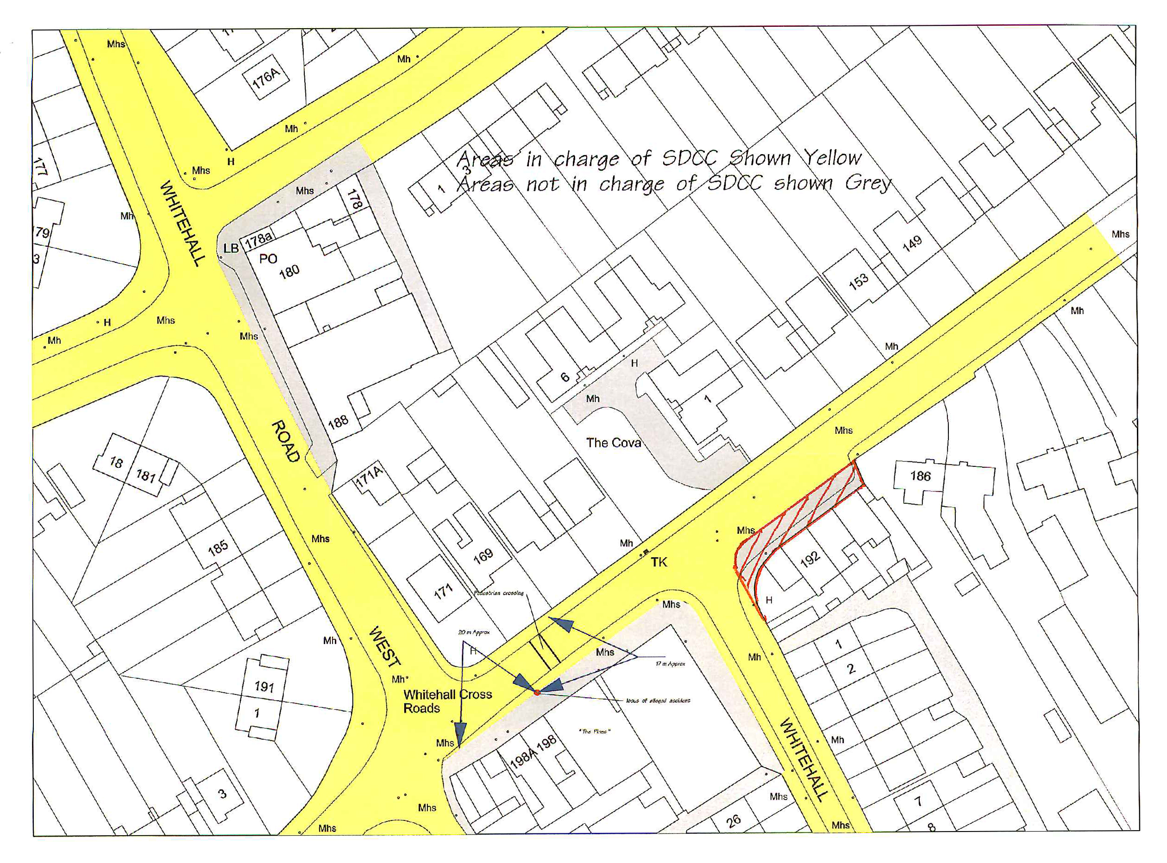

TR/867/06

QUESTION(15): Councillor M. Árdagh
"To ask the Manager for an update on the Enforcement Proceedings in relation to file No. S4754?"

REPLY:
Written complaints were received by Planning Enforcement in relation to an alleged unauthorised development taking place on lands adjacent to the Walkinstown Roundabout, in that a Van Sales business was operating on the lands without the benifit of planning permission.
In this regard, a Warning Letter dated 24th August 2006 pursuant to Section 152 of the Planning and Development Act, 2000 was served on the owner and occupier of the lands.
Futher complaints were received alleging that run off water from the washing of vehicles by the occupiers of the lands was discharging into public drains. This particular matter was referred to the Environmental Health Officer and Environmental Services for investigation. The Water Pollution Engineer has reported that no evidence of car washing or run-off water could be found during an inspection of the lands.
The lands have been reinspected and the Planning Inspector's report and recommendation is currently under consideration. A decision on the service of an Enforcement Notice will be made shortly.
The Councillor will be kept informed as this investigation progresses.

TR/868/06 PLANNING FILES

The following report by the Manager, which had been circulated, was NOTED

H-I (6)

- Large applications under consideration

List of live applications at 30/11/06 – Director of Planning Level
Terenure-Rathfarnham Area
Reg. Ref. Application Details

SD06A/0953 | Reg. Date:  09-Nov-2006  Applicant’s Name:  Curved Space Ltd.  Submission Type:  New Application | Location:  1 and 2, Wellington Cottages & Site Between 1 Wellington Cottages & 45 Wellington Lane, Dublin 6W.  Proposed Development:  Demolition of 1 & 2 Wellington Cottages and Filling Station and construction of 1 three storey, and 1 part 2, part 3 storey apartment buildings containing 15 two bedroom units and one three bedroom unit, with surface carpark and associated landscape works.  Decision Due on or before:  02-Jan-2007

- Files requested by members

South Dublin County Council
Terenure / Rathfarnham Area Committee Meeting

05/12/2006
Cllr. Tony McDermott :

SD06A/0525
Applicant: | The Millhouse Partnership
Date Received: | 31-Oct-2006
Location: | The Millhouse, Whitechurch Road, Rathfarnham, Dublin 14.
Development: | (1) Construction of 5 own-door apartments in a building of three storey's (max height 8.7m from St. Patrick's Cottages street level and 11.6m from Whitechurch Road street level) over garden-level car park; new vehicular access from Whitechurch Road to 7 car spaces, 12 bicycle spaces, storage spaces and bin storage; new vehicular access off St. Patrick's Cottages to two car spaces; pedestrian access from both roads to own door entrances at St. Patrick's Cottages level to living accommodation of five three-bedroom triplex apartments each with balconies at first and second floor level to Whitechurch Road and balconies at second floor level to St. Patrick's Cottages from which external stairs access roof gardens which are screened and landscaped; (2) Conservation works to the Protected Structure including demolition of existing porch and rear extension, re-rendering of external facade in lime-render, repairs and replacement with re-made originals of existing windows, installation of bathrooms at second floor level; rearrangement of lightweight partitions of second floor level; repairs to internal plasterwork; (3) Removal of some trees including protected trees and replanting.
Decision Due: | 27-Nov-2006
Decision Details: | Further Information Requested: | , 15-Aug-2006
 | Further Information Received: | 04-Aug-2006, 31-Oct-2006
 | Decision: | REFUSE PERMISSION
 | Decision Date: | 27-Nov-2006
 | Final Grant Issued:
 | Appeal Decision:
 | Appeal Decision Date:

The above Planning File was NOTED.

TR/869/06 NEW WORKS

H-I (7)
It was NOTED that there was no business under this heading

TR/870/06 CORRESPONDENCE - Planning Fees for Solar Panels

Cor (2)

Letter to Dept. of Environment, Heritage & Local Government dated 4.10.2006

Reply from Dept. of Environment, Heritage and Local Government dated 13.10.2006
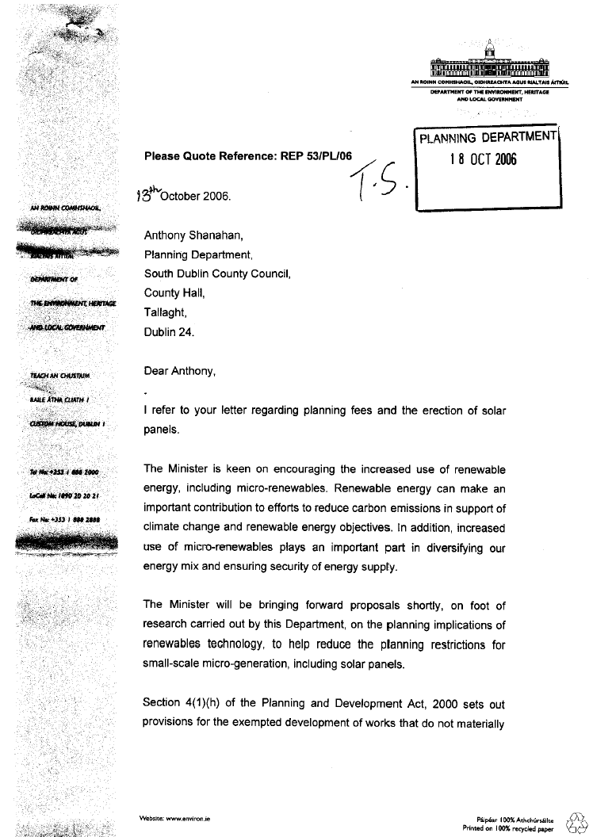

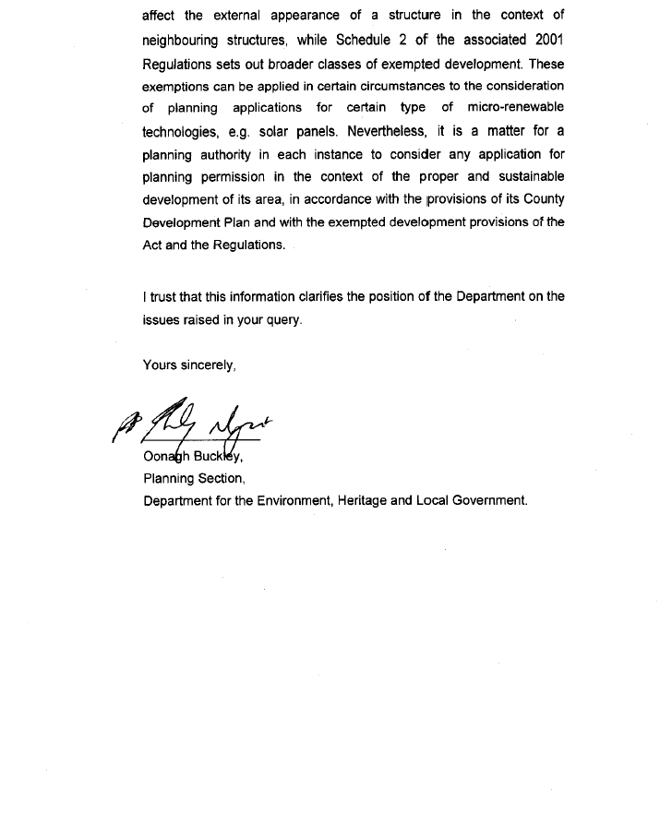The above correspondence was NOTED.

TR/871/06 CATHAORILEACH'S BUSINESS

MOTION (9)
It was NOTED that there was no business received under this heading

TR/872/06 TAKING IN CHARGE OF STONE PARK ABBEY

MOTION (10)
It was proposed by Councillor J. Lahart and seconded by Councillor T. McDermott

"That the Manager take all steps necessary to ensure, once and for all, the taking-in-charge of Stone Park Abbey."

The following report by the Manager, which has been circulated, was READ
Stonepark Abbey, Rathfarnham was developed by Messrs. M & N Grady Ltd.
“The “as constructed” drawings in respect of the roads and services have been submitted by the developer and are at present being checked by the Council’s Building Control Section. The developer has also informed the Council, on 02nd October 2006, that he has referred the matter of the taking in charge of the roads and services to his solicitor, for his attention.
A Section 180 request has also been received from the residents of Stonepark Abbey, on 01st November 2006, requesting that the Council initiate the procedures under Section 11 of the Roads Act 1993, for the taking in charge of the estate. The plebiscite submitted by the residents of Stonepark Abbey is being verified against the current Voters Register.
The taking in charge drawings and schedule are at present being prepared by the Council and when they have been completed an advertisement will be placed in the public press to initiate the statutory taking in charge process, under Section 11 of the Roads Act 1993.”
Following contributions from Councillors, J. Lahart, C.Keane and T. McDermott, Mr. P. McNamara, Administrative Officer responded to queries raised and the report was NOTED.

TR/873/06 BUILDERS PROVIDERS YARD – MUCKROSS

MOTION (11)
It was proposed by Councillor M. Árdagh and seconded by Councillor C. Keane

"That the Manager put in place arrangements to close down the Builders Providers Yard in Muckross."

The following report by the Manager, which has been circulated, was READ

“Complaints alleging a possible unauthorised use of the yard/lands to the rear of Muckross Grove/Avenue, Perrystown, Dublin 12 were received in March 2005. The alleged unauthorised use consisted of the establishment of a builders providers business trading as SLM Providers Ltd.

The lands were inspected on 1st April 2005, at which time it was noted that they had previously been used as a depot/yard by a civil engineering contractor, Chatham Pipelines Ltd., for the storage of materials to be used in civil engineering contracts, for the storage of excavated materials from such works, the parking and keeping of vehicles needed in connection with such contracts, the carrying out of mechanical repairs to such vehicles and the running of such business.

A Warning Letter dated 29th April 2005 was served on the directors of SLM Providers Ltd concerning the use of the land as a builder’s providers.

Further research showed that Enforcement proceedings were taken against Chatham Pipelines Ltd in 1989. The company were convicted and fined £800 in the District Court. This conviction was appealed to the Circuit Court. At the same time a Reference under Section 5 of the Local Government Act, 1963 was made to An Bord Pleanála contending that the lands had been used as a builders depot since before October 1964 and that the Planning Authority were precluded from taking enforcement action. An Bord Pleanála decided in favour of the applicant and ruled that no change of use had taken place which would require planning permission.

A submission was received from Maguire McErlean Solicitors on behalf of their client SLM Providers Ltd. In this submission SLM Providers Ltd denies that there has been any change of use in relation to the above lands and that the current use by SLM Providers Ltd is that of a builder’s yard/depot.

Following a review of the entire file, having regard to the history of this site and the lack of hard evidence that a material change of use of the lands has taken place, it appears that no further enforcement action is open to the Planning Authority in relation to this matter at this time.
However, a meeting has been scheduled for December 1st with representatives of the Residents Association to discuss this matter further.”
It was AGREED to take Motion 13 in the name of Councillor M. Ardagh in conjunction with the above.
MOTION (13) CHANGE OF USE OF BUILDERS PROVIDERS YARD – MUCKROSS

It was proposed by Councillor M. Árdagh and seconded by Councillor C. Keane

"That the Manager bring enforcement proceedings in relation to the change of use as documented by the residents of the area against the Builders Providers Yard in Muckross and to give a report on the matter. Enf. File. S4183."

The following report by the Manager, which has been circulated, was READ

“Complaints alleging a possible unauthorised use of the yard/lands to the rear of Muckross Grove/Avenue, Perrystown, Dublin 12 were received in March 2005. The alleged unauthorised use consisted of the establishment of a builders providers business trading as SLM Providers Ltd.
The lands were inspected on 1st April 2005, at which time it was noted that they had previously been used as a depot/yard by a civil engineering contractor, Chatham Pipelines Ltd., for the storage of materials to be used in civil engineering contracts, for the storage of excavated materials from such works, the parking and keeping of vehicles needed in connection with such contracts, the carrying out of mechanical repairs to such vehicles and the running of such business.
A Warning Letter dated 29th April 2005 was served on the directors of SLM Providers Ltd concerning the use of the land as a builder’s providers.
Further research showed that Enforcement proceedings were taken against Chatham Pipelines Ltd in 1989. The company were convicted and fined £800 in the District Court. This conviction was appealed to the Circuit Court. At the same time a Reference under Section 5 of the Local Government Act, 1963 was made to An Bord Pleanála contending that the lands had been used as a builders depot since before October 1964 and that the Planning Authority were precluded from taking enforcement action. An Bord Pleanála decided in favour of the applicant and ruled that no change of use had taken place which would require planning permission.
A submission was received from Maguire McErlean Solicitors on behalf of their client SLM Providers Ltd. In this submission SLM Providers Ltd denies that there has been any change of use in relation to the above lands and that the current use by SLM Providers Ltd is that of a builder’s yard/depot.
Following a review of the entire file, having regard to the history of this site and the lack of hard evidence that a material change of use of the lands has taken place, it appears that no further enforcement action is open to the Planning Authority in relation to this matter at this time.
However, a meeting has been scheduled for December 1st with representatives of the Residents Association to discuss this matter further.”
Following contributions from Councillors, M. Ardagh, C. Keane, S. Laing, E. Walsh and T. McDermott, Mr. M. Kenny, Senior Planner responded to queries raised and the reports were NOTED.

TR/874/06 KINGSTON COURT RE-ZONING OF LAND

MOTION (12)

The following motion was proposed by Councillor J. Lahart and as it was not seconded the motion fell.

"That the Terenure-Rathfarnham Area Committee: in recognition of the major loss of amenity space as a consequence of the Ballyboden Village Plan; and recognising its close proximity to protected structures: recommends to the full Council the re-zoning of the lands in the ownership of the Council, or otherwise, at Kingston Court, to facilitate a Village Garden to be developed for the community to form a historical and central heritage focal point of the new Ballyboden Village."

It was AGREED to suspend Standing Orders in order to take the following
Emergency motion in the name of Councillors C. Keane, M. Ardagh and S. Laing.

"That this committee agrees to deletetion of Block P (5 person 3 B/R - 1.5. storey building) i.e. the block on the northern end of the site at Kingston Court , Taylor’s Lane, Rathfarnham i.e. infill housing map of Oct 2006; thereby leaving more of the site for a formal garden, and the construction of 4 units only for re-housing the residents of the flats at Pears/Palmer Pk."

Following contributions from Councillors, C. Keane, S. Laing and M. Ardagh the following Emergency Motion was proposed by Councillors T. McDermott and A. White.

“That the Manager, having regard to the particular historical, natural and cultural significance of the Kingston Court Green site and its close proximity to a protected structure — Newbrook House, prepares a plan incorporating a formal Public Garden; That he together with the other relevant departments presents this plan to a special meeting of the Terenure / Rathfarnham Area Committee before the end of February 2007.”

Following contributions from Councillors, T. McDermott, A. White, J. Lahart, C.Keane, S. Laing, M. Ardagh and E. Walsh the following two amendments were proposed.

It was proposed by Councillors C. Keane, M. Ardagh and S. Laing

“That the Manager, having regard to the particular historical, natural and cultural significance of the Kingston Court Green site and its close proximity to a protected structure — Newbrook House, prepares a plan incorporating a formal Public Garden; That he together with the other relevant departments presents this plan to a special meeting of the Terenure / Rathfarnham Area Committee before the end of February 2007 and that the plan incorporates social housing.”

It was proposed by Councillors, A. White, T. McDermott and E. Walsh

“That the Manager, having regard to the particular historical, natural and cultural significance of the Kingston Court Green site and its close proximity to a protected structure — Newbrook House, prepares a plan incorporating a formal Public Garden. That he together with the other relevant departments presents this plan to a special meeting of the Terenure/Rathfarnham Area Committee before the end of February 2007.

The Committee further requests the Housing Department to prepare a design for housing on the site which fully respects and is consistant with the proposed public garden and that this outline design for housing units also be presented to the Area Committee before the end of February 2007.”

Following contributions from Councillors, M. Ardagh, C. Keane, J. Lahart, S. Laing, T. McDermott, E. Walsh and A. White, Mr. P. Murphy, Senior Executive Officer responded to queries raised. It was AGREED that a further report would be presented under Housing business to the February 2007 meeting of this Committee.

DEVELOPMENT BUSINESS

TR/875/06 QUESTIONS

It was proposed by Councillor T. McDermott, seconded by Councillor S. Laing and RESOLVED

“That pursuant to Standing Order No. 13, question numbered 16 be ADOPTED and APPROVED

TR/876/06 LANEWAY AT WILLBROOK PARK

QUESTION (16): Councillor J. Lahart
"To ask the Manager to consider allowing residents of Willbrook Park take the lanway (involving no right-of-way) into their rere gardens which is an eyesore and constitutes a public health issue?"

REPLY:
The laneway in question provides a rear access to a number of dwellings at Willbrook Park. The Council’s Environment Section has confirmed that a watermain runs through the centre of the laneway and a telemetery outstation is also positioned at this location. Accordingly it would not be possible to allow the laneway to be incorporated into the rear gardens of the adjoining houses.

Arrangements will be made to have the laneway inspected and cleaned as soon as possible.

TR/877/06 NEW WORKS

H-I (8)
It was NOTED that there was no business under this heading

TR/878/06 CORRESPONDENCE

COR (3)
It was NOTED that there was no business under this heading

TR/879/06 CATHAOIRLEACH'S BUSINESS

MOTION (14)
It was NOTED that there was no business received under this heading

TR/880/06 PURCHASE OF SITE FOR SCHOOL ON THE DISUSED OLD KNOCKLYON ROAD

It was proposed by Councillor M. Árdagh and seconded by Councillor C. Keane

MOTION (15)
"That the Manager give an update on the registration of the draft affidavit prepared by the Council with the Land Registry in relation to the site on the disused Old Knocklyon Road to enable the Department of Education complete purchase the site for the school."

The following report by the Manager, which had been circulated, was MOVED without discussion.

REPORT:

“The Council has completed an affidavit in relation to the registration of title of a section of the old Knocklyon Road, which lies within a site which it is proposed to dispose of the Department of Education, for the provision of a school building for Gaelscoil Chnoc Liamhna. This affidavit has been lodged in Land Registry by the Council’s Solicitor with a view to having the Council registered as owner of the site.

A meeting has also taken place with officials from the Department of Education and Science recently to discuss this site. The Department has been requested to finalise terms with the Council for the acquisition of the site in order that a report on the proposed disposal of the site may be presented to the Council for its statutory approval.”

CORPORATE SERVICES BUSINESS

TR/881/06 QUESTIONS

It was NOTED that there was no business under this heading
TR/882/06 NEW WORKS

H-I (9)
It was NOTED that there was no business under this heading

TR/883/06 CORRESPONDENCE

Cor (4)
It was NOTED that there was no business under this heading

TR/884/06 CATHAOIRLEACH'S BUSINESS

It was proposed by Councillor T. McDermott and seconded by Councillor S. Laing

MOTION (16)
"That the committee discuss, with the aid of a detailed report from the Manager, changes arising from the review of the Register of Electors - including details of the enteries removed and added with their locations by Electoral District. "

The following report by the Manager, which had been circulated, was MOVED without discussion

“The Draft Register of Electors 2007/2008 has been compiled following an intensive fieldwork campaign carried out in accordance with the revised guidelines and instructions issued by the Department of the Environment, Heritage and Local Government.

As a result of fieldwork campaign 21,831 electors were added to the Register and 40,903 were deleted. The total number of electors on the Draft Register is 163,338. A breakdown of these figures by constituency, local electoral area and polling district is available on membersnet at this link.

The Draft Register has been available since 1st November for inspection by the general public at local authority offices, Libraries, Post Offices and Garda Stations and online at www.sdcc.ie and www.checktheregister.ie

The Department of the Environment Heritage and Local Government has undertaken an extensive publicity and awareness campaign at national level including TV, Radio, Press and outdoor advertising. This campaign has been complemented at local level by local press advertising and awareness initiatives. These initiatives involve stands at shopping centres and co-operation with local voluntary efforts by Tallaght Partnership, Dublin 12 Women’s Action Group, and An Cosán.

Following an announcement by the Minister for the Environment on 21st November, all claims for amendment to the Draft Register received by 9th December 2006 (extended from 25th November) will be incorporated into the final Register which will come into effect on 15th February 2007.

We will continue to work on the compilation process making every effort to encourage the public to co-operate and engage with the process to ensure that the Register of Electors 2007/2008 will be as accurate and comprehensive as possible.”

The meeting concluded at 5.45 p.m.

Siniú ________________ Dáta ________________
An Cathaoirleach

