COMHAIRLE CHONTAE ATHA CLIATH THEAS

SOUTH DUBLIN COUNTY COUNCIL

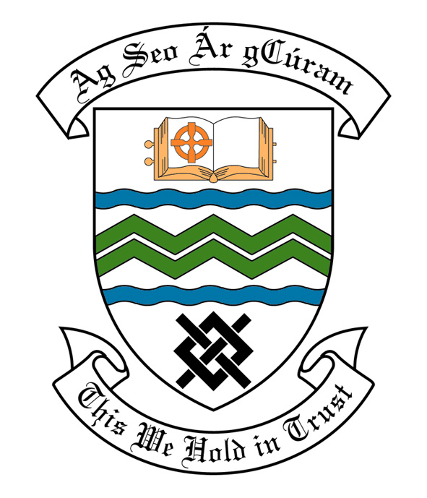

MEETING OF SOUTH DUBLIN COUNTY COUNCIL

MONDAY 8TH JANUARY, 2007

HEADED ITEM NO: H- 1 (2) (f)

MEETING OF THE LUCAN/ CLONDALKIN AREA COMMITTEE(2)

Tuesday 19th December, 2006

HEADED ITEM NO: H-1 (4)

Application for Grants

Application for a grant under the Council’s Community Grants Scheme has been received from the organisation listed below. Payment of this grant to this organisation, in accordance with the conditions of the scheme, in the amount set out hereunder, is recommended for approval:-

Ref: | Group | Type of Application | Date of Application | Amount
GF 1477 | Bawnogue Community Games | Start Up Costs | 17/08/06 | €500

Application for Grants (Arts Act 2003)

Application for a grant under the Council’s Arts Grants Scheme has been received from the organisation listed below. Payment of the following grant to this organisation, in accordance with the conditions of the scheme, in the amount set out hereunder, is recommended for approval:-

Ref: | Group | Type of Application | Date of Application | Amount  €
AGF 557 | Muintir Chrónáin | Grant towards the cost of a nativity play | 16/11/06 | €1200

A contribution is being made to the following group:-

Group | Type of Application | Amount
Rowlagh Baton Twirlers Group | Contribution towards the cost of coaching | €500

It was proposed by Councillor R. Dowds and seconded by Councillor T. Ridge and RESOLVED:

“That this Committee recommends that South Dublin County Council APPROVE the grants as recommended in the foregoing report”.

