COMHAIRLE CHONTAE ÁTHA CLIATH THEAS

SOUTH DUBLIN COUNTY COUNCIL

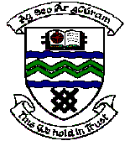

MEETING OF TERENURE/RATHFARNHAM AREA COMMITTEE (2)

Tuesday 12th December, 2006.

Headed Item No: H.1 (5)

Application for Grants

Application for grants under the Council’s Community Grants Scheme have been received from the organisations listed below. Payment of these grants to these organisations, in accordance with the conditions of the Scheme, in the amounts set out hereunder, is recommended for approval:-

Ref: | Group | Type of Application | Date of Application | Amount
GF 1500 | Palmer Park/ Pearse Bros Park Residents Association | Start Up Costs for Community Group | 06/11/06 | €600

