COMHAIRLE CHONTAE ATHA CLIATH THEAS

SOUTH DUBLIN COUNTY COUNCIL

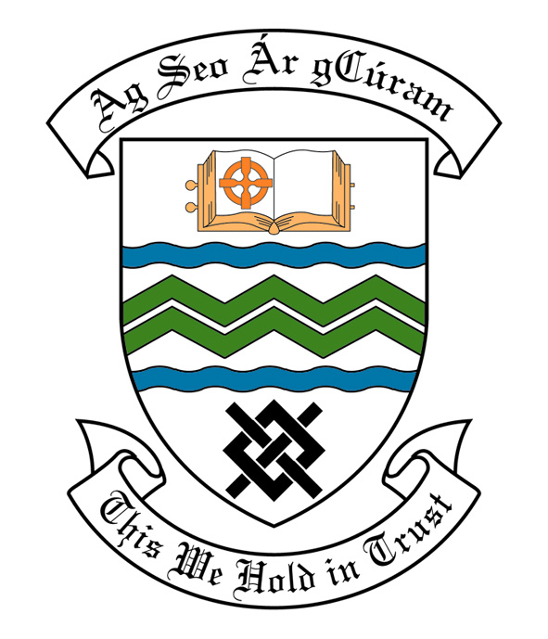

MEETING OF SOUTH DUBLIN COUNTY COUNCIL

MONDAY 11TH DECEMBER, 2006

MEETING OF THE LUCAN/ CLONDALKIN AREA COMMITTEE(2)

Tuesday 28th November, 2006

HEADED ITEM NO: H- I (2) (g)

A Contribution is being made to the following groups:-

Group | Type of Application | Date of Application | Amount
Clondalkin School of Karate | Contribution | 17/10/06 | €500
Beech Park Football Club | Contribution | 07/11/06 | €600

Application for Grants (Arts Act 2003)

Application for a grant under the Council’s Arts Grants Scheme has been received from the organisation listed below. Payment of the following grant to this organisation, in accordance with the conditions of the scheme, in the amount set out hereunder, is recommended for approval:-

Ref: | Group | Type of Application | Date of Application | Amount  €
AGF 555 | Quarryvale Community House CDP | Grant towards engaging a choreographer to support Christmas Performance | 26/10/06 | €400

It was proposed by Councillor T. Gilligan, seconded by Councillor T. Ridge and RESOLVED:

“That this Committee recommends that South Dublin County Council approve payment of the above grants as recommended in the foregoing report”.

