COMHAIRLE CHONTAE ATHA CLIATH THEAS

SOUTH DUBLIN COUNTY COUNCIL
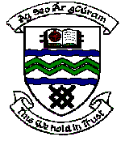

MEETING OF TALLAGHT AREA COMMITTEE MEETING (1)

Monday 4th December, 2006.

Headed Item No: H- I (11)
Application for Grants

Applications for grants under the Council’s Community Grants Scheme have been received from the organisations listed below. Payment of these grants, in accordance with the conditions of the scheme, in the amounts set out hereunder, is recommended for approval.

Ref: | Group | Type of Application | Date of Application | Amount
GF 1504 | Kilnamanagh AFC | Equipment Grant | 02/11/06 | €3,000
GF 1505 | Castleview Ladies Club | Start Up Costs | 16/11/06 | €400

A contribution is being made to the following group:-

Ref: | Group | Type of Application | Amount
 | Tallaght Volunteer Bureau | Contribution | €5,000

