COMHAIRLE CHONTAE ATHA CLIATH THEAS
SOUTH DUBLIN COUNTY COUNCIL

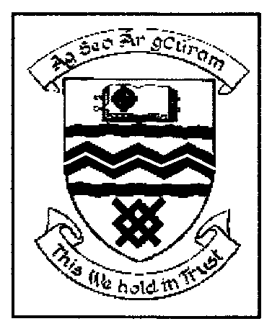

MEETING OF TALLAGHT AREA COMMITTEE (2)

MONDAY 27TH NOVEMBER, 2006

ITEM NO. H-I (11)

Report on The Belfry Housing Development

Building Control Section has investigated the complaint at the above address and instigated certain measures to determine if a health and safety issue existed as a result of blocked drains etc. This series of measures taken to date are as follows:

- Cleaning out all main drains in the vicinity of the apartment complex.
- Cleaning all the adjacent service drains serving the apartment complex.
- The removal of vent grills and ensuring thorough under floor ventilation.
- The builder (Durkan Homes) provided a report on the quality of indoor air at the properties.

The results of these measures are inconclusive and further investigation will be required.
The Council will continue to monitor the situation.

