COMHAIRLE CHONTAE ATHA CLIATH THEAS

SOUTH DUBLIN COUNTY COUNCIL
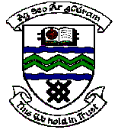

MEETING OF TALLAGHT AREA COMMITTEE MEETING (1)

Monday 20th November, 2006.

Question 2

Question: Councillor John Hannon

"To ask the Manager to report on his efforts to ensure that the new sports hall at Firhouse Community College will be available to the local community?"

Reply:

Following a number of meetings recently between the Department of Education and Science, VEC and South Dublin County Council progress has been made to advance the opening of the Sports Hall at Firhouse Community College.

The recruitment of the necessary staff of the Halls at both Firhouse and Collinstown Community Colleges was advertised on Sunday 12th November 2006.

Every effort will be made to facilitate the opening of the Halls for the wider community use at the earliest possible date.

