COMHAIRLE CHONTAE ÁTHA CLIATH THEAS
SOUTH DUBLIN COUNTY COUNCIL

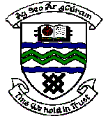

MEETING OF TERENURE/RATHFARNHAM AREA COMMITTEE (2)

Tuesday 14th November, 2006.

Motion No. 14

Motion: Cllr. Alex White

“That the Manager carry out a comprehensive pruning and clearing programme in Palmer Park/Pearse Brothers where many trees and shrubs have become very overgrown despite the best efforts of local residents who have recently undertaken a voluntary ‘clean-up day’.”

Report:

In response to recent correspondence received on this matter arrangements are being made to meet with the Palmer Park/Pearse Brothers Residents Association to discuss and examine the extent and feasibility of pruning works that can be incorporated into the forthcoming Arboricultural Programme.

