COMHAIRLE CHONTAE ÁTHA CLIATH THEAS
SOUTH DUBLIN COUNTY COUNCIL

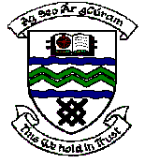

MEETING OF TERENURE/RATHFARNHAM AREA COMMITTEE (2)

Tuesday 14th November, 2006.

Motion No. 11

Motion: Cllr. Cáit Keane

“That this committee compliments the Parks Department on the pro-active response to the request from Orwell Residents Association re Bonfire ban.”

Report:

The Parks Department welcomes the support and co-operation received from the Orwell Residents Association and the Gardai in ensuring that a bonfire did not take place this Halloween on the Orwell open space.

