COMHAIRLE CHONTAE ÁTHA CLIATH THEAS
SOUTH DUBLIN COUNTY COUNCIL

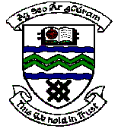

MEETING OF TERENURE/RATHFARNHAM AREA COMMITTEE (2)

Tuesday 14th November, 2006.

Motion No. 8

Motion: Cllr. Alex White

“That the Manager furnish a report on any action which he proposes to take to address the poor and unsightly condition of landmark structures close to and adjacent to Main Street, Rathfarnham as these structures if properly maintained or even cleaned could enhance the visual amenity of the area."

Report:

The matter will be examined to determine the extent of works required on the various structures with a view to undertaking improvement works in 2007.
In particular, the entrance arch and wall of the old Rathfarnham Cemetery will be examined in liaison with the Environmental Services Department who are responsible for the cemetery.
The Committee will be informed in due course of any specific proposals for improvement works.

