COMHAIRLE CHONTAE ÁTHA CLIATH THEAS
SOUTH DUBLIN COUNTY COUNCIL
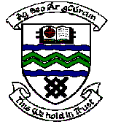

MEETING OF TERENURE/RATHFARNHAM AREA COMMITTEE (2)

Tuesday 14th November, 2006.

Question No. 19

Question: Cllr. Eamonn Walsh

“To ask the Manager to make arrangements to have the open space at the cul de sac in St. Mels Avenue, Greenhills cleaned up?”

Reply:

Arrangements will be made for a clean up of this area within the next two weeks.

