COMHAIRLE CHONTAE ÁTHA CLIATH THEAS
SOUTH DUBLIN COUNTY COUNCIL

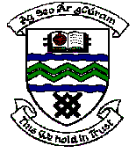

MEETING OF TERENURE/RATHFARNHAM AREA COMMITTEE (2)

Tuesday 14th November, 2006.

Question No. 16

Question: Cllr. Stanley Laing

“To ask the Manager to carry out tree pruning in Orwell Park Way-Green as these areas are well overdue?”

Reply:

A number of locations in Orwell Park Green have been listed for tree pruning in the forthcoming Arboricultural Programme.

Orwell Park Way will be listed for examination and consideration for tree pruning.

