COMHAIRLE CHONTAE ATHA CLIATH THEAS

SOUTH DUBLIN COUNTY COUNCIL

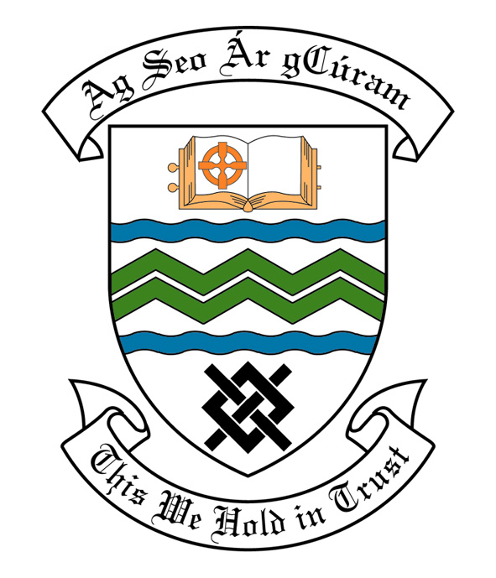

MEETING OF SOUTH DUBLIN COUNTY COUNCIL

MONDAY 13TH NOVEMBER, 2006.

MEETING OF THE LUCAN/ CLONDALKIN AREA COMMITTEE(2)

Tuesday 24th October, 2006

HEADED ITEM NO. 3 (f)

Application for Grants

Application for a grant under the Council’s Community Grants Scheme has been received from the organisation listed below. Payment of this grant to this organisation, in accordance with the conditions of the scheme, in the amount set out hereunder, is recommended for approval:-

Ref: | Group | Type of Application | Date of Application | Amount
GF 1456 | Beacon of Light Counselling Services | Equipment Grant | 03/07/06 | €3,000

Application for Grants (Arts Act 2003)

Application for a grant under the Council’s Arts Grants Scheme has been received from the organisation listed below. Payment of the following grant to this organisation, in accordance with the conditions of the scheme, in the amount set out hereunder, is recommended for approval:-

Ref: | Group | Type of Application | Date of Application | Amount  €
AGF 553 | Griffeen Valley Educate Together National School | Arts Grant | 16/10/06 | €600

It was proposed by Councillor R. Dowds, seconded by Councillor G. O’ Connell and RESOLVED:

“That this Committee recommends that South Dublin County Council approve payment of the above grants as recommended in the foregoing report”.

